TweetID : 1651569761506017285

UserID : [Gyan_Consulting](https://twitter.com/Gyan_Consulting)

Profession: Organization

Tweet :

With the use of [#Blockchain](https://twitter.com/hashtag/Blockchain?src=hashtag_click), the pharmaceutical industry can ensure the authenticity of drugs, prevent counterfeit products, and improve patient safety. [#enterpriseblockchaindevelopment](https://twitter.com/hashtag/enterpriseblockchaindevelopment?src=hashtag_click) [#pharma](https://twitter.com/hashtag/pharma?src=hashtag_click) [#drugsupplychain](https://twitter.com/hashtag/drugsupplychain?src=hashtag_click) [#gyanconsulting](https://twitter.com/hashtag/gyanconsulting?src=hashtag_click)

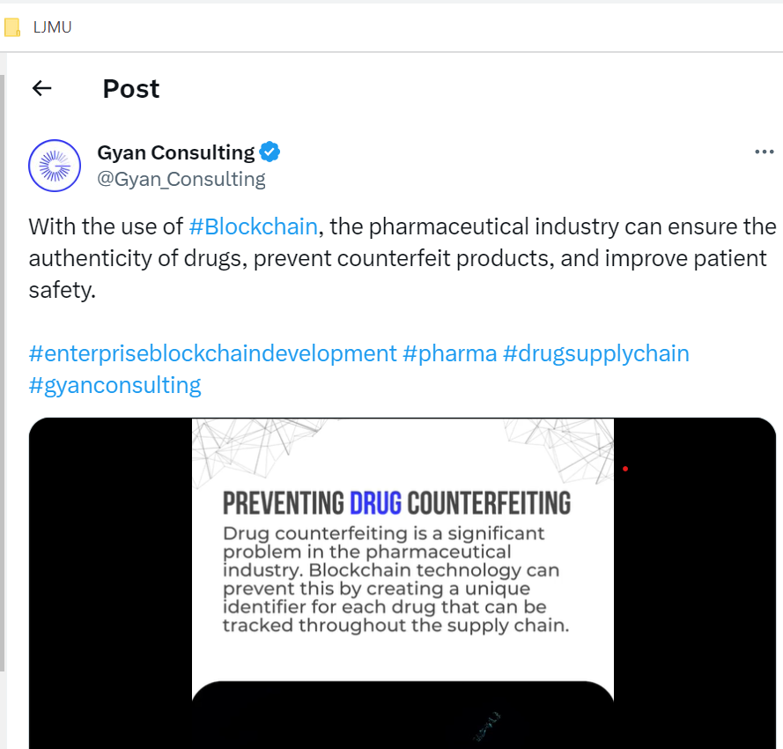

TweetID : 1237545019432505345

UserID : [EvanKirstel](https://twitter.com/EvanKirstel)

Profession: Industry Expert

Tweet : .[@IBM](https://twitter.com/IBM) [@Oracle](https://twitter.com/Oracle) [@EUBlockchain](https://twitter.com/EUBlockchain) & [@mediledger](https://twitter.com/mediledger) are using [#blockchain](https://twitter.com/hashtag/blockchain?src=hashtag_click) to transform [#drug](https://twitter.com/hashtag/drug?src=hashtag_click) [#supplychain](https://twitter.com/hashtag/supplychain?src=hashtag_click) and fake  drugs [@PositiveBlock](https://twitter.com/PositiveBlock) via [@enricomolinari](https://twitter.com/enricomolinari) [#ehealth](https://twitter.com/hashtag/ehealth?src=hashtag_click) [@IrmaRaste](https://twitter.com/IrmaRaste) [@eViRaHealth](https://twitter.com/eViRaHealth) [@contextlabsbv](https://twitter.com/contextlabsbv) [@chris_rezendes](https://twitter.com/chris_rezendes) [#healthtech](https://twitter.com/hashtag/healthtech?src=hashtag_click) [#pharma](https://twitter.com/hashtag/pharma?src=hashtag_click) [#AI](https://twitter.com/hashtag/AI?src=hashtag_click) [#fintech](https://twitter.com/hashtag/fintech?src=hashtag_click)

As an immutable ledger technology that can decentralise coordination, blockchain could help supply chain more transparent

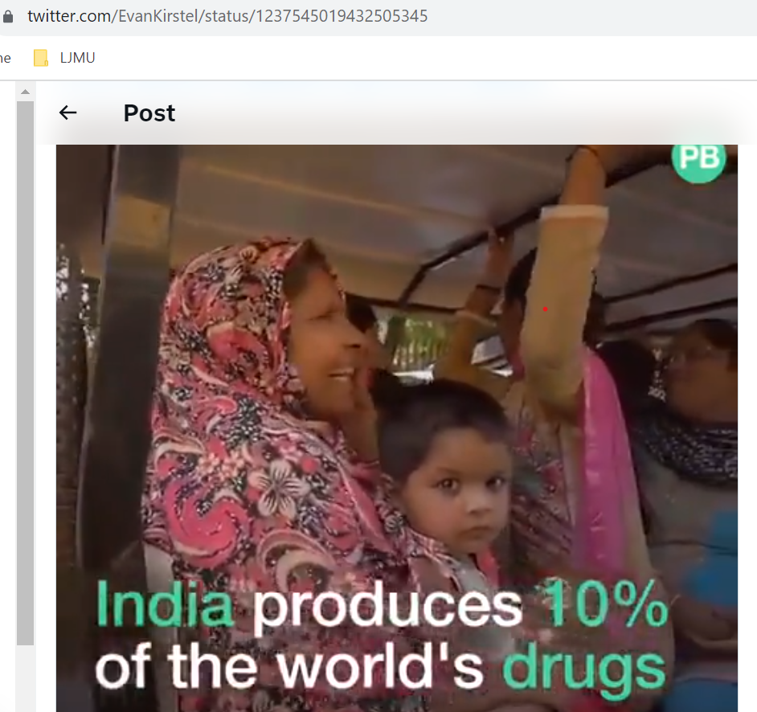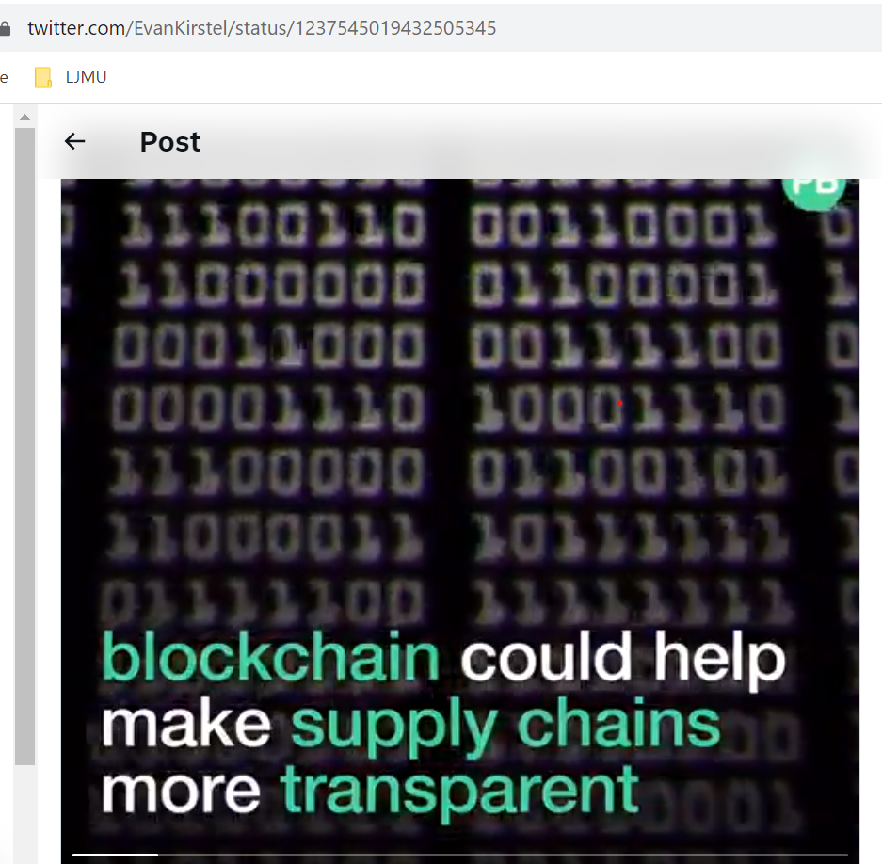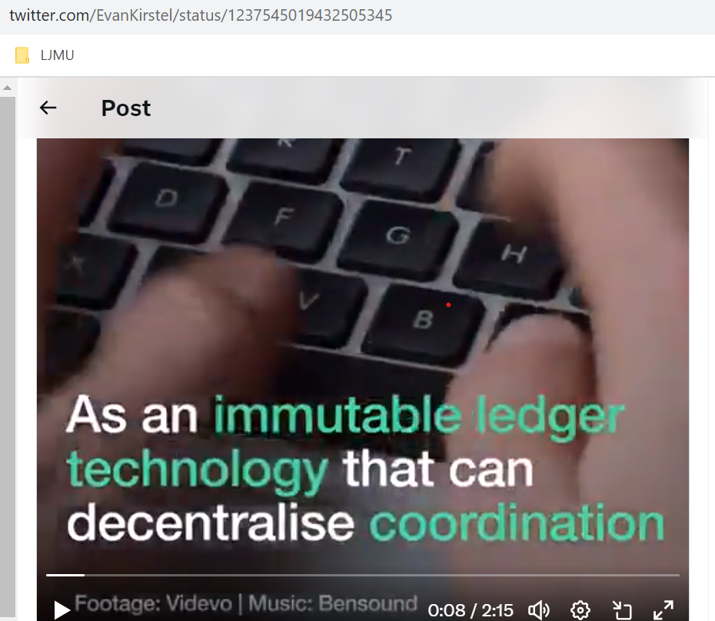

TweetID : 1254267442211192832

UserID : [ZingHR](https://twitter.com/ZingHR)

Profession: Organization

Tweet : Are You Ready For [#Blockchain](https://twitter.com/hashtag/Blockchain?src=hashtag_click) ? via [@ravikikan](https://twitter.com/ravikikan) [@Gartner_inc](https://twitter.com/Gartner_inc) [#Crypto](https://twitter.com/hashtag/Crypto?src=hashtag_click) [#cryptocurrency](https://twitter.com/hashtag/cryptocurrency?src=hashtag_click) [#pharma](https://twitter.com/hashtag/pharma?src=hashtag_click) [#defstar5](https://twitter.com/hashtag/defstar5?src=hashtag_click) [#makeyourownlane](https://twitter.com/hashtag/makeyourownlane?src=hashtag_click) [#HRTech](https://twitter.com/hashtag/HRTech?src=hashtag_click) [#HRMS](https://twitter.com/hashtag/HRMS?src=hashtag_click) [#Healthtech](https://twitter.com/hashtag/Healthtech?src=hashtag_click) # [#btc](https://twitter.com/hashtag/btc?src=hashtag_click) [#bitcoin](https://twitter.com/hashtag/bitcoin?src=hashtag_click) [#100DaysOfCode](https://twitter.com/hashtag/100DaysOfCode?src=hashtag_click) [#bigdata](https://twitter.com/hashtag/bigdata?src=hashtag_click) [#cybersecurity](https://twitter.com/hashtag/cybersecurity?src=hashtag_click) [#MachineLearning](https://twitter.com/hashtag/MachineLearning?src=hashtag_click) [#RT](https://twitter.com/hashtag/RT?src=hashtag_click) [#smartcontracts](https://twitter.com/hashtag/smartcontracts?src=hashtag_click) [#fintech](https://twitter.com/hashtag/fintech?src=hashtag_click) [#healthcare](https://twitter.com/hashtag/healthcare?src=hashtag_click) [#tech](https://twitter.com/hashtag/tech?src=hashtag_click)

Benefits and Cost Stack up discussed.

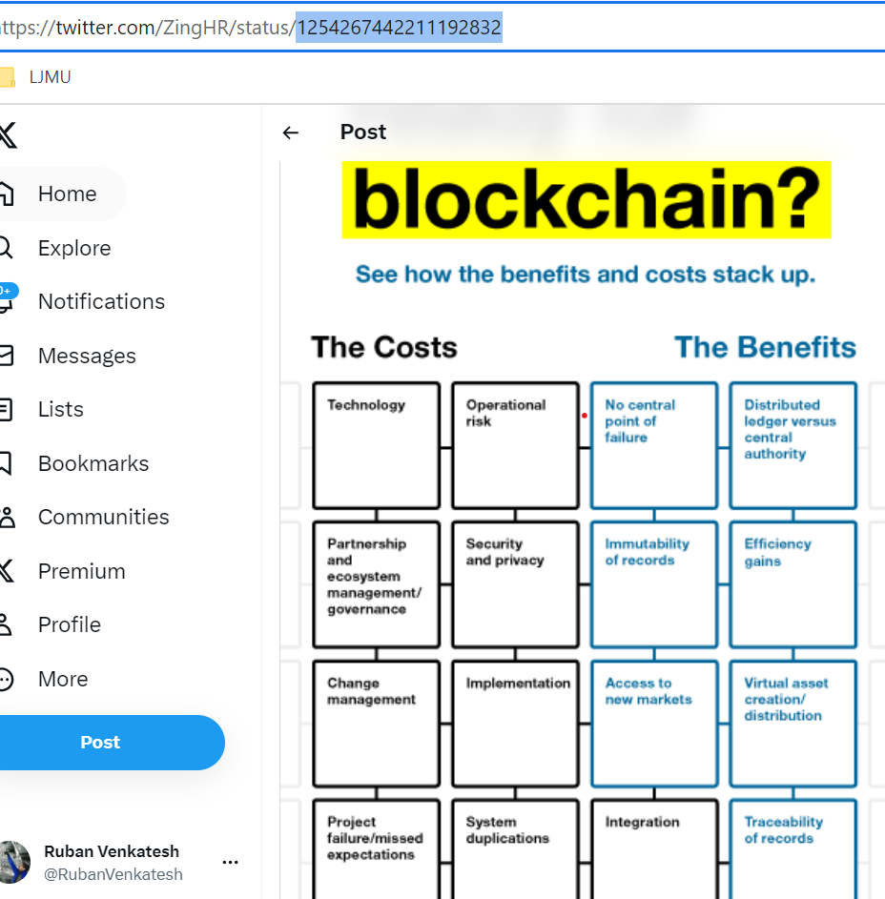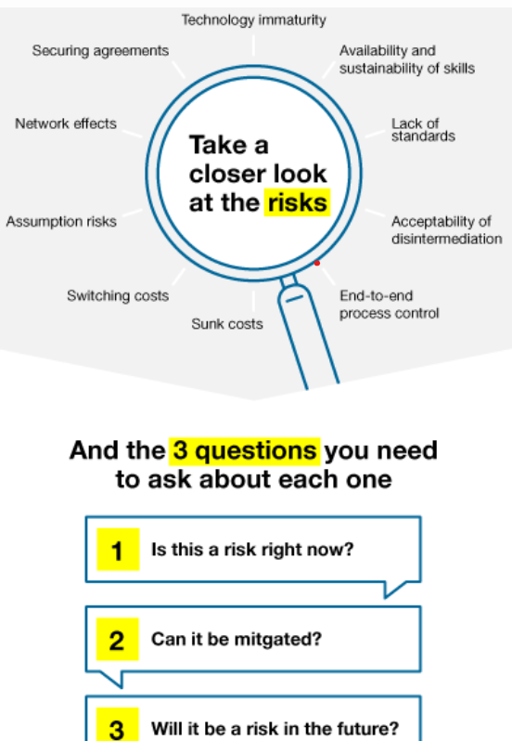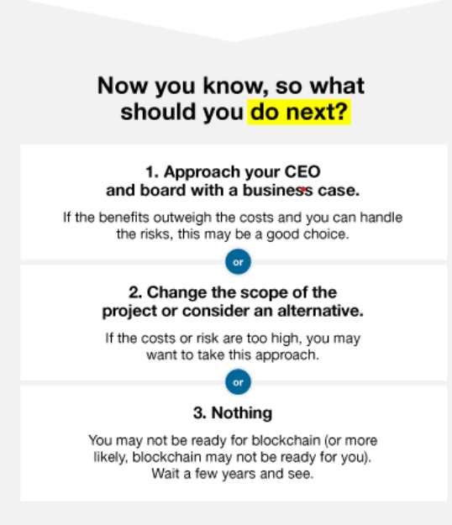

TweetID : 1613167877237923840

UserID : [Gyan_Consulting](https://twitter.com/Gyan_Consulting)

Profession: Organization

Tweet : Many Pharma companies have already started on their digital transformation journeys with cybersecurity initiatives and adopting new technologies such as additive manufacturing, robotics, analytics, and mobility. [#pharma](https://twitter.com/hashtag/pharma?src=hashtag_click) [#digitaltransformation](https://twitter.com/hashtag/digitaltransformation?src=hashtag_click) [#ai](https://twitter.com/hashtag/ai?src=hashtag_click) [#blockchain](https://twitter.com/hashtag/blockchain?src=hashtag_click) [#digitalhealth](https://twitter.com/hashtag/digitalhealth?src=hashtag_click)

TweetID : 1097992887613165569

UserID : Engineer

Profession: Organization

Tweet : Wonderful time at [#HIMSS](https://twitter.com/hashtag/HIMSS?src=hashtag_click) with the @HS_Blox team. It was very exciting to see the interest for blockchain in Revenue Cycle Management and Clinical Trial Management [#corda](https://twitter.com/hashtag/corda?src=hashtag_click) [#blockchain](https://twitter.com/hashtag/blockchain?src=hashtag_click) [#hsblox](https://twitter.com/hashtag/hsblox?src=hashtag_click) [#r3](https://twitter.com/hashtag/r3?src=hashtag_click) [#pharma](https://twitter.com/hashtag/pharma?src=hashtag_click) [#healthcare](https://twitter.com/hashtag/healthcare?src=hashtag_click)

TweetID : 1612783398916956166

UserID : [eisenreich](https://twitter.com/eisenreich)

Profession: Industry Expert

Tweet : VeChain x Pharmaceutical Supply Chain Michele M, Supply Chain Manager [@DNV_Group](https://twitter.com/DNV_Group), breaks down [#Blockchain](https://twitter.com/hashtag/Blockchain?src=hashtag_click) for [#Pharma](https://twitter.com/hashtag/Pharma?src=hashtag_click) and shares how VeChain can improve data security and traceability, reducing the risk of data tampering.  [#VeChain](https://twitter.com/hashtag/VeChain?src=hashtag_click) [$VET](https://twitter.com/search?q=%24VET&src=cashtag_click) [#Business](https://twitter.com/hashtag/Business?src=hashtag_click) [#Technology](https://twitter.com/hashtag/Technology?src=hashtag_click) [#IoT](https://twitter.com/hashtag/IoT?src=hashtag_click) [#Tech](https://twitter.com/hashtag/Tech?src=hashtag_click)

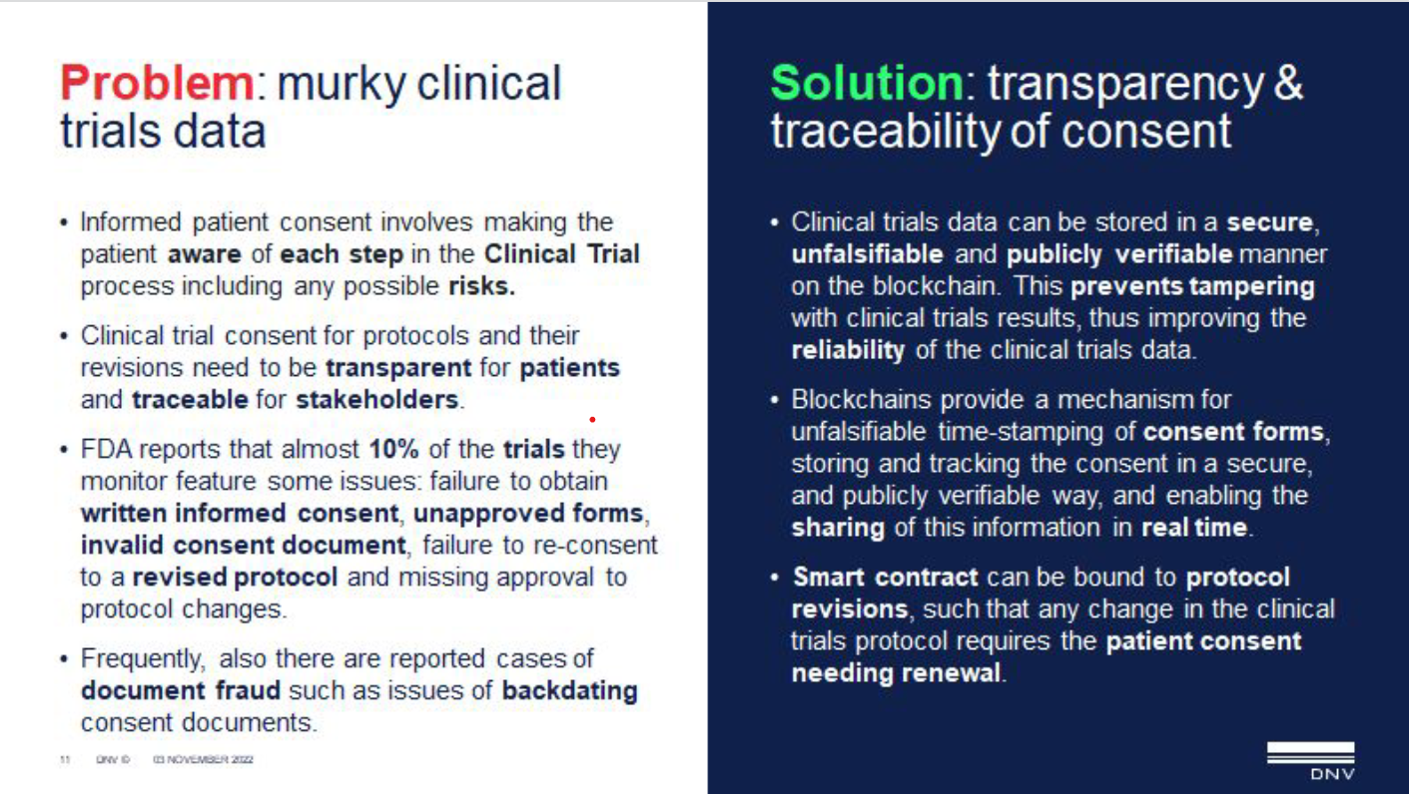

TweetID : 1129180565364781056

UserID : [aventureralicia](https://twitter.com/aventureralicia)

Profession: Industry Expert

Tweet :

Need a way to tag items in your [#supplychain](https://twitter.com/hashtag/supplychain?src=hashtag_click) to reduce [#fraud](https://twitter.com/hashtag/fraud?src=hashtag_click)? [@dlabvc](https://twitter.com/dlabvc) co [@Helixworks](https://twitter.com/Helixworks) can create a molecular identifier AT SCALE. Founder [@nimeshchandrap](https://twitter.com/NimeshChandraP) explains how it works - for [#pharma](https://twitter.com/hashtag/pharma?src=hashtag_click), [#food](https://twitter.com/hashtag/food?src=hashtag_click), [#textiles](https://twitter.com/hashtag/textiles?src=hashtag_click), or other goods. [#DNA](https://twitter.com/hashtag/DNA?src=hashtag_click) [#blockchain](https://twitter.com/hashtag/blockchain?src=hashtag_click) [#biotech](https://twitter.com/hashtag/biotech?src=hashtag_click)

TweetID : 1210749144219803649

UserID : SupplyChainWrld

Profession: Community

Tweet : Using [#Blockchain](https://twitter.com/hashtag/Blockchain?src=hashtag_click) to Transform Drug [#Supplychain](https://twitter.com/hashtag/Supplychain?src=hashtag_click) & Avoid Fake Medicine   [@PositiveBlock](https://twitter.com/PositiveBlock)  [@IBM](https://twitter.com/IBM) [@oracle](https://twitter.com/Oracle) [@EUBlockchain](https://twitter.com/EUBlockchain) [@mediledger](https://twitter.com/mediledger) via [@TheMegaTrends](https://twitter.com/TheMegaTrends) TY, MT [@enricomolinari](https://twitter.com/enricomolinari) [@HeinzVHoenen](https://twitter.com/HeinzVHoenen) [#pharma](https://twitter.com/hashtag/pharma?src=hashtag_click) [#AI](https://twitter.com/hashtag/AI?src=hashtag_click) [#scm](https://twitter.com/hashtag/scm?src=hashtag_click) [#pharmaceuticals](https://twitter.com/hashtag/pharmaceuticals?src=hashtag_click)



TweetID : 1352323966799663119

UserID : [KingsFtF](https://twitter.com/KingsFtF)

Profession: Content Creation Page

Tweet : “Blockchain use in pharma supply chains A way to reducing counterfeit, boosting consumer confidence.” The Financial Express [#fakemeds](https://twitter.com/hashtag/fakemeds?src=hashtag_click) [#blockchain](https://twitter.com/hashtag/blockchain?src=hashtag_click) [#supplychain](https://twitter.com/hashtag/supplychain?src=hashtag_click) [#supplychainsolutions](https://twitter.com/hashtag/supplychainsolutions?src=hashtag_click) [#counterfeit](https://twitter.com/hashtag/counterfeit?src=hashtag_click) [#pharma](https://twitter.com/hashtag/pharma?src=hashtag_click)

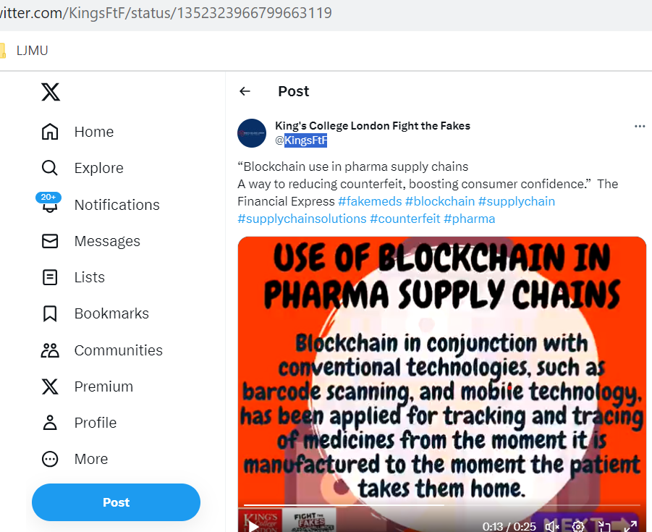

TweetID : 1057655598827888644

UserID : [alexpeters](https://twitter.com/alexpeters)

Profession: Industry Expert

Tweet : Another great presentation by Susanne Somerville from [@ChronicledInc](https://twitter.com/ChronicledInc) - total leaders in the blockchain supply chain space - at [#BlockchainMemphis18](https://twitter.com/hashtag/BlockchainMemphis18?src=hashtag_click) on improving transparency and reducing counterfeit in [#pharma](https://twitter.com/hashtag/pharma?src=hashtag_click) supply chains. Exciting to see the leaps they are making. [#blockchain](https://twitter.com/hashtag/blockchain?src=hashtag_click)

TweetID : 1381909363762343937

UserID : [EBlockchainCon](https://twitter.com/EBlockchainCon)

Profession: Organization

Tweet : Thank you Xenia Beltran Jaunsarás for your interesting insights about [@PharmaLedger](https://twitter.com/PharmaLedger) project [#ebc](https://twitter.com/hashtag/ebc?src=hashtag_click) [#EBCvirtual](https://twitter.com/hashtag/EBCvirtual?src=hashtag_click) [#5thedition](https://twitter.com/hashtag/5thedition?src=hashtag_click) [#pharmaledger](https://twitter.com/hashtag/pharmaledger?src=hashtag_click) [#pharma](https://twitter.com/hashtag/pharma?src=hashtag_click) [#blockchain](https://twitter.com/hashtag/blockchain?src=hashtag_click)

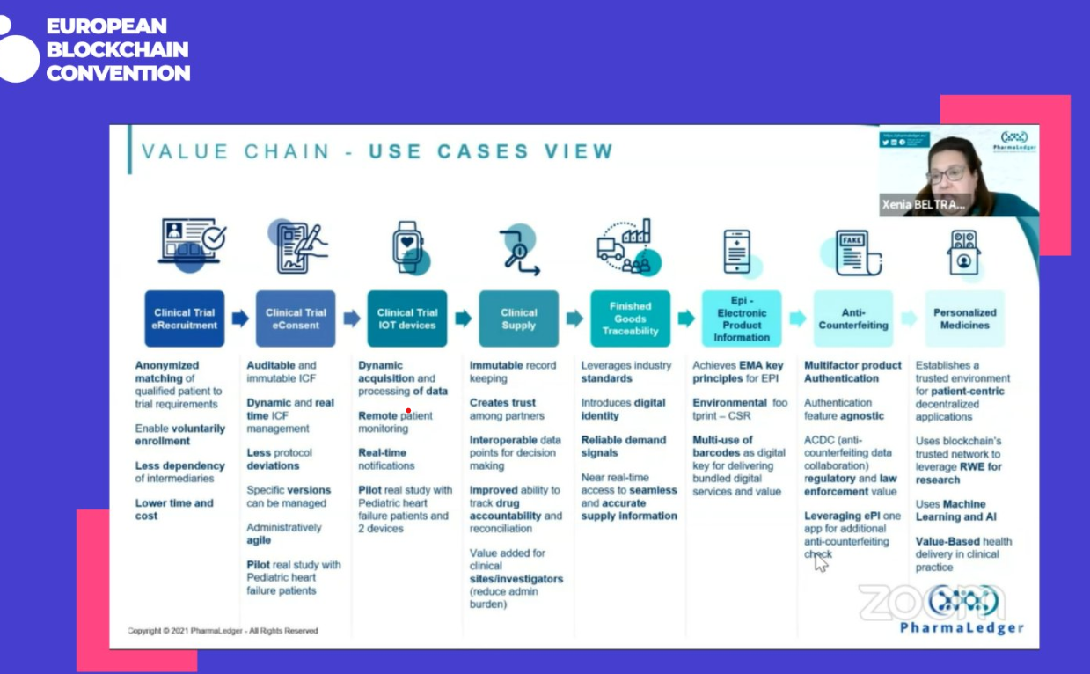

TweetID : 1238690489634672640

UserID : Dr [Omkar_Raii](https://twitter.com/Omkar_Raii)

Profession: Industry Expert

Tweet : [#Blockchain](https://twitter.com/hashtag/Blockchain?src=hashtag_click) can bring revolutionary changes in the [#pharma](https://twitter.com/hashtag/pharma?src=hashtag_click) sector by enabling enterprises expedite R&D while collaborating with other companies, accelerating GTM, optimising supply chain and warranting quality assurance across the manufacturing cycle.

TweetID : 1633352693245788162

UserID : [dHealth_Network](https://twitter.com/dHealth_Network)

Profession: Organization

Tweet : [#Pharma](https://twitter.com/hashtag/Pharma?src=hashtag_click) companies have much [#data](https://twitter.com/hashtag/data?src=hashtag_click) stored on their servers collected from clinical trials and real-world data of their products. But instead of sending it around to their competitors, they would send their [#algorithm](https://twitter.com/hashtag/algorithm?src=hashtag_click), train it on the data, then send it back. [#dHealth](https://twitter.com/hashtag/dHealth?src=hashtag_click) [#blockchain](https://twitter.com/hashtag/blockchain?src=hashtag_click)

TweetID : 1330901344643899396

UserID : [EvanKirstel](https://twitter.com/EvanKirstel)

Profession: Industry Expert

Tweet :

Using [#blockchain](https://twitter.com/hashtag/blockchain?src=hashtag_click) to monitor the COVID-19 vaccine  supply chain [http://bit.ly/36VESn4](https://t.co/a1VpRopdbB) [@wef](https://twitter.com/wef) [@HealthcareLdr](https://twitter.com/HealthcareLdr) [#CovidVaccine](https://twitter.com/hashtag/CovidVaccine?src=hashtag_click) [#DigitalHealth](https://twitter.com/hashtag/DigitalHealth?src=hashtag_click) [#supplychain](https://twitter.com/hashtag/supplychain?src=hashtag_click) [#hospitals](https://twitter.com/hashtag/hospitals?src=hashtag_click) [#Pharmaceutical](https://twitter.com/hashtag/Pharmaceutical?src=hashtag_click) [#pharma](https://twitter.com/hashtag/pharma?src=hashtag_click) [@IrmaRaste](https://twitter.com/IrmaRaste) [@eViRaHealth](https://twitter.com/eViRaHealth)

TweetID : 1318634346757132289

UserID : [MNWSupplyChain](https://twitter.com/MNWSupplyChain)

Profession: Organization

Tweet :

A Blockchain and Machine Learning-Based Drug Supply Chain Management and Recommendation System for Smart Pharmaceutical Industry<https://buff.ly/34cy9VJ>

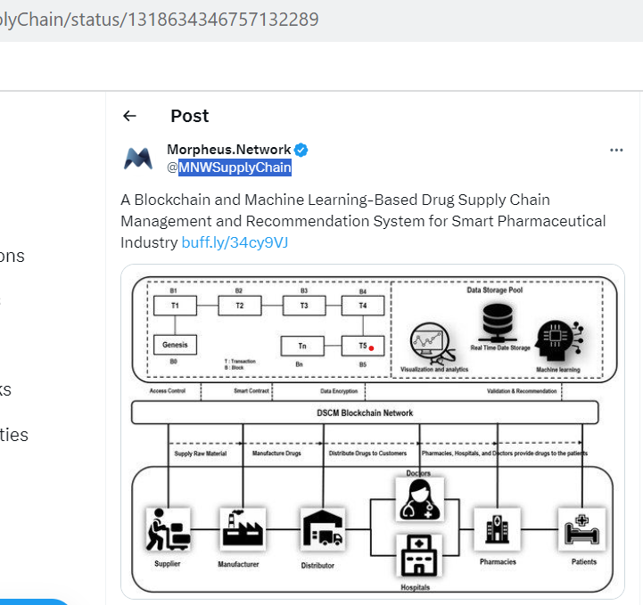

TweetID : 1229895647836409856

UserID : [AustinDLTHealth](https://twitter.com/AustinDLTHealth)

Profession: Organization

Tweet :

Join [#healthIT](https://twitter.com/hashtag/healthIT?src=hashtag_click) peers on Feb 26th for the [#Blockchain](https://twitter.com/hashtag/Blockchain?src=hashtag_click) and [#DigitalTransformation](https://twitter.com/hashtag/DigitalTransformation?src=hashtag_click) in Health 2020 Symposium [https://bit.ly/2V0SEjT](https://t.co/rkufvJ9Da3) Attend the Business Track: Using Blockchain to Secure and Enhance Visibility for [#Pharmaceutical](https://twitter.com/hashtag/Pharmaceutical?src=hashtag_click) Supply Chains [#AustinBlockchainHealth](https://twitter.com/hashtag/AustinBlockchainHealth?src=hashtag_click) [#pharma](https://twitter.com/hashtag/pharma?src=hashtag_click) [#SCM](https://twitter.com/hashtag/SCM?src=hashtag_click)

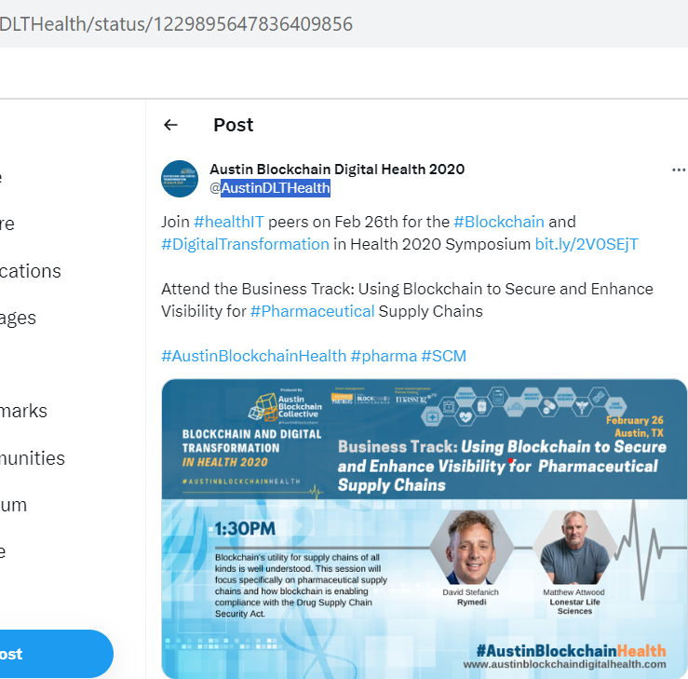

TweetID : 1366748503255506952

UserID : [jnasr](https://twitter.com/jnasr)

Profession: Industry Expert

Tweet : What is the future of [#blockchain](https://twitter.com/hashtag/blockchain?src=hashtag_click) in [#pharma](https://twitter.com/hashtag/pharma?src=hashtag_click) post pandemic? Looking forward to speaking at [#SCOPE2021](https://twitter.com/hashtag/SCOPE2021?src=hashtag_click) at 11:45 am EST today. [https://scope.us2.pathable.com/meetings/virtual/KsTxPWCBDc5EJLymC…](https://t.co/ziLzGP9HHb) [#DLT](https://twitter.com/hashtag/DLT?src=hashtag_click) [#lifesciences](https://twitter.com/hashtag/lifesciences?src=hashtag_click) [#transparency](https://twitter.com/hashtag/transparency?src=hashtag_click) [#interoperability](https://twitter.com/hashtag/interoperability?src=hashtag_click) .[@SCOPEsummit](https://twitter.com/SCOPEsummit) [@acoerco](https://twitter.com/acoerco) [@lee_disa](https://twitter.com/lee_disa) [@LedgerDomain](https://twitter.com/LedgerDomain) [@Novartis](https://twitter.com/Novartis)

TweetID : 1323268896707796992

UserID : [OmniversalisDAO](https://twitter.com/OmniversalisDAO)

Profession: Organization

Tweet :

Providing [#tech](https://twitter.com/hashtag/tech?src=hashtag_click) solutions to [#pharma](https://twitter.com/hashtag/pharma?src=hashtag_click) [#biotech](https://twitter.com/hashtag/biotech?src=hashtag_click) & [#healthcare](https://twitter.com/hashtag/healthcare?src=hashtag_click) cnies to improve their profits in the best interest of the patient  [https://tradepharma.network/product-lines](https://t.co/T10BptN7XL) [#marketplace](https://twitter.com/hashtag/marketplace?src=hashtag_click) [#trading](https://twitter.com/hashtag/trading?src=hashtag_click) [#medicines](https://twitter.com/hashtag/medicines?src=hashtag_click) [#pharmasolutions](https://twitter.com/hashtag/pharmasolutions?src=hashtag_click) [#ai](https://twitter.com/hashtag/ai?src=hashtag_click) [#blockchain](https://twitter.com/hashtag/blockchain?src=hashtag_click) [#3dprinting](https://twitter.com/hashtag/3dprinting?src=hashtag_click) [#IoT](https://twitter.com/hashtag/IoT?src=hashtag_click) [#b2b](https://twitter.com/hashtag/b2b?src=hashtag_click) [#innovation](https://twitter.com/hashtag/innovation?src=hashtag_click) [#tradepharmanetwork](https://twitter.com/hashtag/tradepharmanetwork?src=hashtag_click)

TweetID : 1484620213937184773

UserID : [acoerco](https://twitter.com/acoerco)

Profession: Organization

Tweet : In this [@DarshanTalks](https://twitter.com/DarshanTalks) podcast our CEO [@jnasr](https://twitter.com/jnasr) talks about the adoption of [#DLT](https://twitter.com/hashtag/DLT?src=hashtag_click) in pharma and what changes that can bring. Listen below to learn more: [https://youtu.be/SD97V1fzlZM](https://t.co/lIUmnsKYKB) [#blockchain](https://twitter.com/hashtag/blockchain?src=hashtag_click) [#hederahashgraph](https://twitter.com/hashtag/hederahashgraph?src=hashtag_click) [#HBAR](https://twitter.com/hashtag/HBAR?src=hashtag_click) [#pharma](https://twitter.com/hashtag/pharma?src=hashtag_click) [#healthcare](https://twitter.com/hashtag/healthcare?src=hashtag_click)

TweetID : 1322847276780441608

UserID : [davidgerard](https://twitter.com/davidgerard)

Profession: Community

Tweet : An Open Letter To Blockchain Vendors: Please Pay More Attention (2018). "your understanding of the needs of the US pharma supply chain was so elementary … most of the presenters were making the simplest, most superficial assumptions about them."

TweetID : 1267815854797799427

UserID : [ArwedK](https://twitter.com/ArwedK)

Profession: Community

Tweet : .@spherityproject manager [#EricHolst](https://twitter.com/hashtag/EricHolst?src=hashtag_click) [@holstblock](https://twitter.com/holstblock) at the [@Blockchain_HH](https://twitter.com/Blockchain_HH) [#webinar](https://twitter.com/hashtag/webinar?src=hashtag_click) about use cases + [#trust](https://twitter.com/hashtag/trust?src=hashtag_click) with [#blockchain](https://twitter.com/hashtag/blockchain?src=hashtag_click) technology for identities and [#digital](https://twitter.com/hashtag/digital?src=hashtag_click) twins in the [#pharma](https://twitter.com/hashtag/pharma?src=hashtag_click) world + the 4th [#industrial](https://twitter.com/hashtag/industrial?src=hashtag_click) [#revolution](https://twitter.com/hashtag/revolution?src=hashtag_click). And thanks to moderator [#MoritzSchildt](https://twitter.com/hashtag/MoritzSchildt?src=hashtag_click) [@SchildtMoritz](https://twitter.com/SchildtMoritz).-P4

TweetID : 1452565675856343042

UserID : [MyEvidenZ](https://twitter.com/MyEvidenZ)

Profession: Community

Tweet : [@IfisGroupe](https://twitter.com/IfisGroupe) has several certifications guarantee by [@myevidenz](https://twitter.com/MyEvidenZ)  VisaePharma™ certification assess the general level of mastery of the standard: [#GMP](https://twitter.com/hashtag/GMP?src=hashtag_click) Good Manufacturing Practices for medicinal products.  [#blockchain](https://twitter.com/hashtag/blockchain?src=hashtag_click) [#credential](https://twitter.com/hashtag/credential?src=hashtag_click) [#formation](https://twitter.com/hashtag/formation?src=hashtag_click) [#pharma](https://twitter.com/hashtag/pharma?src=hashtag_click) [#newpartner](https://twitter.com/hashtag/newpartner?src=hashtag_click) [#BCDT](https://twitter.com/hashtag/BCDT?src=hashtag_click)

TweetID : 1422069237447741446

UserID : [cdnsolutions](https://twitter.com/cdnsolutions)

Profession: Organization

Tweet : "IT Solutions For [#Pharma](https://twitter.com/hashtag/Pharma?src=hashtag_click) Industry" With Automation All Over The Place, The Software Solution For [#Pharmaceuticals](https://twitter.com/hashtag/Pharmaceuticals?src=hashtag_click) Industry Is Now Embracing The Wave. Explore us at: [http://cdnsol.com/pharmaceuticals](https://t.co/SMoZJsG6Fk) [#digitalhealth](https://twitter.com/hashtag/digitalhealth?src=hashtag_click) [#retail](https://twitter.com/hashtag/retail?src=hashtag_click) [#IoT](https://twitter.com/hashtag/IoT?src=hashtag_click) [#AI](https://twitter.com/hashtag/AI?src=hashtag_click) [#blockchain](https://twitter.com/hashtag/blockchain?src=hashtag_click) [#MachineLearning](https://twitter.com/hashtag/MachineLearning?src=hashtag_click) [#100DaysOfCode](https://twitter.com/hashtag/100DaysOfCode?src=hashtag_click) [#data](https://twitter.com/hashtag/data?src=hashtag_click) [#code](https://twitter.com/hashtag/code?src=hashtag_click)

TweetID : 1184301537046097920

UserID : [TanjahPartners](https://twitter.com/TanjahPartners)

Profession: Entrepreneur

Tweet : Thrilled to announce my book [#Enterprise](https://twitter.com/hashtag/Enterprise?src=hashtag_click) [#Blockchain](https://twitter.com/hashtag/Blockchain?src=hashtag_click) Has Arrived with my co-author & colleague [@jwoods_57](https://twitter.com/jwoods_57) is live! Pre-order on Amazon [http://amzn.to/2Bi7g3b](https://t.co/OTwOwXp3jB) [#decentralizedidentity](https://twitter.com/hashtag/decentralizedidentity?src=hashtag_click) [#fintech](https://twitter.com/hashtag/fintech?src=hashtag_click) [#banking](https://twitter.com/hashtag/banking?src=hashtag_click) [#SupplyChain](https://twitter.com/hashtag/SupplyChain?src=hashtag_click) [#logistics](https://twitter.com/hashtag/logistics?src=hashtag_click) [#DigitalHealth](https://twitter.com/hashtag/DigitalHealth?src=hashtag_click) [#lifesciences](https://twitter.com/hashtag/lifesciences?src=hashtag_click) [#pharma](https://twitter.com/hashtag/pharma?src=hashtag_click) [#dataprivacy](https://twitter.com/hashtag/dataprivacy?src=hashtag_click) [#Web3](https://twitter.com/hashtag/Web3?src=hashtag_click)

TweetID : 1503308495122227205

UserID : [smponline](https://twitter.com/smponline)

Profession: Community

Tweet : From tomorrow: Pharma Supply Chain and Security World (15-16 March) [https://bit.ly/35jajdN](https://t.co/GaWZGifmPW). Tap into the latest [#IoT](https://twitter.com/hashtag/IoT?src=hashtag_click), [#AI](https://twitter.com/hashtag/AI?src=hashtag_click) and [#ML](https://twitter.com/hashtag/ML?src=hashtag_click) & [#Blockchain](https://twitter.com/hashtag/Blockchain?src=hashtag_click) pharma innovations at the [@corvusglobal](https://twitter.com/corvusglobal) event [#ad](https://twitter.com/hashtag/ad?src=hashtag_click) [#PSW](https://twitter.com/hashtag/PSW?src=hashtag_click) [#PharmaSecurityWorld](https://twitter.com/hashtag/PharmaSecurityWorld?src=hashtag_click) [#pharma](https://twitter.com/hashtag/pharma?src=hashtag_click) [#pharmaconference](https://twitter.com/hashtag/pharmaconference?src=hashtag_click) [#SCM](https://twitter.com/hashtag/SCM?src=hashtag_click) [#supplychain](https://twitter.com/hashtag/supplychain?src=hashtag_click)

TweetID : 1396882567882813443

UserID : TraceLabsHQ

Profession: Community

Tweet : We proudly contribute to making [#pharma](https://twitter.com/hashtag/pharma?src=hashtag_click) supply chains work by helping [@BSI_UK](https://twitter.com/BSI_UK) build resilience & trust into distribution of pharmaceuticals and vaccines. [#Together](https://twitter.com/hashtag/Together?src=hashtag_click) [@origin_trail](https://twitter.com/origin_trail) [#blockchain](https://twitter.com/hashtag/blockchain?src=hashtag_click) [#Multichain](https://twitter.com/hashtag/Multichain?src=hashtag_click)

TweetID : 1492073808991293441

UserID : EUBlockchain

Profession: Community

Tweet : [#EUBOF](https://twitter.com/hashtag/EUBOF?src=hashtag_click)’s new Thematic Report on Blockchain Applications for Healthcare is out! Are you interested in the ways the [#blockchain](https://twitter.com/hashtag/blockchain?src=hashtag_click) ecosystem intersects with the [#healthcare](https://twitter.com/hashtag/healthcare?src=hashtag_click) sector  & [#pharma](https://twitter.com/hashtag/pharma?src=hashtag_click) industries? Find the report here  [https://bit.ly/3HHvJje](https://t.co/ud9JelLgPI) [#EU4Blockchain](https://twitter.com/hashtag/EU4Blockchain?src=hashtag_click)

TweetID : 1288755169329590272

UserID : Solve_Care

Profession: Organization

Tweet : Today, at 2:30 pm UTC, Pradeep will share his ‘healthcare on blockchain’ expertise with pharmacists, academics, practitioners, medical specialists, and other attendees at the Pharmaceuticals 2020 Conference. Register here: [https://bit.ly/3134kUG](https://t.co/Ozb8HPZ9Nj) [#blockchain](https://twitter.com/hashtag/blockchain?src=hashtag_click) [#pharma](https://twitter.com/hashtag/pharma?src=hashtag_click) [$solve](https://twitter.com/search?q=%24solve&src=cashtag_click)

TweetID : 1080905646747176960

UserID : IrmaRaste

Profession: Industry Expert / Influencer

Tweet : Transforming The [#LifeSciences](https://twitter.com/hashtag/LifeSciences?src=hashtag_click) [#SupplyChain](https://twitter.com/hashtag/SupplyChain?src=hashtag_click) Through [#Blockchain](https://twitter.com/hashtag/Blockchain?src=hashtag_click) via [@worldpharma2day](https://twitter.com/worldpharma2day) & [@AccentureLifSci](https://twitter.com/AccentureLifSci) [@evankirstel](https://twitter.com/EvanKirstel) [@eViRaHealth](https://twitter.com/eViRaHealth) [@glfceo](https://twitter.com/glfceo) [@JohnNosta](https://twitter.com/JohnNosta) [#HealthTech](https://twitter.com/hashtag/HealthTech?src=hashtag_click) [#DigitalHealth](https://twitter.com/hashtag/DigitalHealth?src=hashtag_click) [#pharma](https://twitter.com/hashtag/pharma?src=hashtag_click) [#biotech](https://twitter.com/hashtag/biotech?src=hashtag_click) [#DHS2019](https://twitter.com/hashtag/DHS2019?src=hashtag_click) [#CES19](https://twitter.com/hashtag/CES19?src=hashtag_click) [#HIMSS19](https://twitter.com/hashtag/HIMSS19?src=hashtag_click) [https://buff.ly/2Ti6Wss](https://t.co/mgVLZjFUvp)

TweetID : 1064902706765152256

UserID : ExploringBlock

Profession: Community

Tweet : VeriDoc Global is the solution towards an honest, transparent future. [http://veridocglobal.com](https://t.co/UKES7CBU4j) [@VeriDocGlobal](https://twitter.com/VeriDocGlobal) [@NewToTheStreet](https://twitter.com/NewToTheStreet) [#PublicSafety](https://twitter.com/hashtag/PublicSafety?src=hashtag_click) [#AntiFraud](https://twitter.com/hashtag/AntiFraud?src=hashtag_click) [#blockchain](https://twitter.com/hashtag/blockchain?src=hashtag_click) [#fintech](https://twitter.com/hashtag/fintech?src=hashtag_click) [#tech](https://twitter.com/hashtag/tech?src=hashtag_click) [#massadoption](https://twitter.com/hashtag/massadoption?src=hashtag_click) [#erc20](https://twitter.com/hashtag/erc20?src=hashtag_click) [#supplychain](https://twitter.com/hashtag/supplychain?src=hashtag_click) [#identity](https://twitter.com/hashtag/identity?src=hashtag_click) [#passport](https://twitter.com/hashtag/passport?src=hashtag_click) [#pharma](https://twitter.com/hashtag/pharma?src=hashtag_click) [#medicine](https://twitter.com/hashtag/medicine?src=hashtag_click) [#document](https://twitter.com/hashtag/document?src=hashtag_click) [#security](https://twitter.com/hashtag/security?src=hashtag_click)

TweetID : 1046652208224382977

UserID : AimedisGlobal

Profession: Organization

Tweet : Our use of Blockchain technology makes sure your medication is safe, secure and traceable right the way through each transaction. Safety and security in healthcare. [#aimedis](https://twitter.com/hashtag/aimedis?src=hashtag_click) [#blockchain](https://twitter.com/hashtag/blockchain?src=hashtag_click) [#medical](https://twitter.com/hashtag/medical?src=hashtag_click) [#pharma](https://twitter.com/hashtag/pharma?src=hashtag_click)

TweetID : 1115657946078248961

UserID : kevinclauson

Profession: Industry Expert

Tweet : Excited to participate in Deep [#Tech](https://twitter.com/hashtag/Tech?src=hashtag_click) [#Pharma](https://twitter.com/hashtag/Pharma?src=hashtag_click) by [@IEEESA](https://twitter.com/IEEESA) this week in [#Philadelphia](https://twitter.com/hashtag/Philadelphia?src=hashtag_click)! [#Unconference](https://twitter.com/hashtag/Unconference?src=hashtag_click) structure allows the cream to rise to the top and enables us to [#votewithourfeet](https://twitter.com/hashtag/votewithourfeet?src=hashtag_click)! [#blockchain](https://twitter.com/hashtag/blockchain?src=hashtag_click) [#DLT](https://twitter.com/hashtag/DLT?src=hashtag_click) [#AI](https://twitter.com/hashtag/AI?src=hashtag_click) [#ML](https://twitter.com/hashtag/ML?src=hashtag_click) [#IoT](https://twitter.com/hashtag/IoT?src=hashtag_click) [#sensors](https://twitter.com/hashtag/sensors?src=hashtag_click) [#genomics](https://twitter.com/hashtag/genomics?src=hashtag_click) [#pharmacy](https://twitter.com/hashtag/pharmacy?src=hashtag_click) [https://standards.ieee.org/events/deep-tech-pharma-forum-philadelphia.html](https://t.co/bql7uEpjqG)

TweetID : 1462828939299143689

UserID : JohnNosta

Profession: Industry Expert

Tweet : I'm surprised that [#blockchain](https://twitter.com/hashtag/blockchain?src=hashtag_click) and [#cryptocurrency](https://twitter.com/hashtag/cryptocurrency?src=hashtag_click) aren't more mainstream in life sciences and pharmaceutical discussions! The implications are very significant. [#pharma](https://twitter.com/hashtag/pharma?src=hashtag_click) [#digitalhealth](https://twitter.com/hashtag/digitalhealth?src=hashtag_click) [#lifesciences](https://twitter.com/hashtag/lifesciences?src=hashtag_click) [#Bitcoin](https://twitter.com/hashtag/Bitcoin?src=hashtag_click)

TweetID : 1191154746582851585

UserID : vishalpanchal85

Profession: Industry Expert

Tweet : BUSINESSES are using [#blockchain](https://twitter.com/hashtag/blockchain?src=hashtag_click)’s  key features to drive efficiency in existing business processes & enable new business models. [http://buff.ly/2pgKVka](https://t.co/iEAxsE9oyz) [@EverestGroup](https://twitter.com/EverestGroup) via [@antgrasso](https://twitter.com/antgrasso) [#SmartContracts](https://twitter.com/hashtag/SmartContracts?src=hashtag_click) [#DigitalTransformation](https://twitter.com/hashtag/DigitalTransformation?src=hashtag_click) [#HealthTech](https://twitter.com/hashtag/HealthTech?src=hashtag_click) [#pharma](https://twitter.com/hashtag/pharma?src=hashtag_click) [#supplychain](https://twitter.com/hashtag/supplychain?src=hashtag_click) [#IIoT](https://twitter.com/hashtag/IIoT?src=hashtag_click)

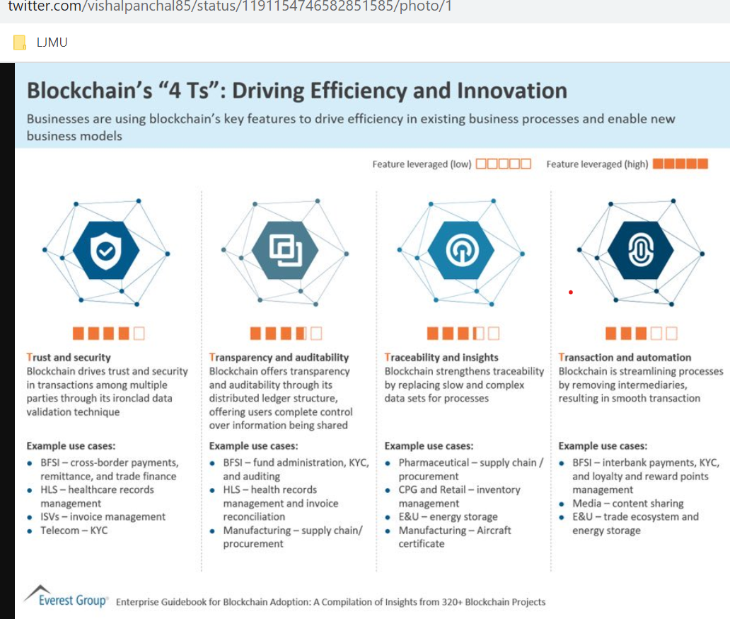

TweetID : 1176846124956733443

UserID : RushdiSiddiqui

Profession: Industry Expert

Tweet : Systems [#interoperability](https://twitter.com/hashtag/interoperability?src=hashtag_click) for [#foodsupply](https://twitter.com/hashtag/foodsupply?src=hashtag_click) (equally applicable to [#pharma](https://twitter.com/hashtag/pharma?src=hashtag_click)) should reduce friction & leakage..but, as impt, is authenticity (truth) at source ([#provenance](https://twitter.com/hashtag/provenance?src=hashtag_click)) before embedded in the [#immutability](https://twitter.com/hashtag/immutability?src=hashtag_click) of [#blockchain](https://twitter.com/hashtag/blockchain?src=hashtag_click) for trust.. established [#startups](https://twitter.com/hashtag/startups?src=hashtag_click) [@origin_trail](https://twitter.com/origin_trail) leadership

TweetID : 1247197544528203778

UserID : peteharrislp

Profession: Industry Expert

Tweet : There's certainly a lot going on in the supply chain track/trace space when it comes to [#blockchain](https://twitter.com/hashtag/blockchain?src=hashtag_click). More to come, especially for [#pharma](https://twitter.com/hashtag/pharma?src=hashtag_click) and especially for [#COVID19](https://twitter.com/hashtag/COVID19?src=hashtag_click) ...

TweetID : 1247186658237321216

UserID : DelRayMan

Profession: Industry Expert

Tweet : Interesting to see the number of blockchain applications in traceability has SURPASSED payments, according to data from the [@Forbes](https://twitter.com/Forbes) [#Blockchain50](https://twitter.com/hashtag/Blockchain50?src=hashtag_click), analyzed by [@blockdata_tech](https://twitter.com/blockdata_tech): [https://blog.blockdata.tech/2020/04/forbes-blockchain-50-products-data-deep-dive/…](https://t.co/2IWGjt22AW) h/t [@Nielslucker](https://twitter.com/Nielslucker)

TweetID : 1144254588146585602

UserID : cybermiles

Profession: Community

Tweet : CyberMiles will have peer to peer marketplaces for pharmaceutical needs. Please stay tuned! [#ecommerce](https://twitter.com/hashtag/ecommerce?src=hashtag_click) [#medicine](https://twitter.com/hashtag/medicine?src=hashtag_click) [#pharma](https://twitter.com/hashtag/pharma?src=hashtag_click) [#hiv](https://twitter.com/hashtag/hiv?src=hashtag_click) [#blockchain](https://twitter.com/hashtag/blockchain?src=hashtag_click) [#decentralization](https://twitter.com/hashtag/decentralization?src=hashtag_click) [#cryptocurrency](https://twitter.com/hashtag/cryptocurrency?src=hashtag_click) [#marketplace](https://twitter.com/hashtag/marketplace?src=hashtag_click) [#peer2peer](https://twitter.com/hashtag/peer2peer?src=hashtag_click) [#aids](https://twitter.com/hashtag/aids?src=hashtag_click) [#healthcare](https://twitter.com/hashtag/healthcare?src=hashtag_click)

TweetID : 1177156745342459904

UserID : OdysseyCreator

Profession: Community

Tweet : In [#odyssey2020](https://twitter.com/hashtag/odyssey2020?src=hashtag_click), [#buidl](https://twitter.com/hashtag/buidl?src=hashtag_click) with [@KLMCargo](https://twitter.com/KLMCargo) & its stakeholders the information infrastructure for secure transport of pharma goods to prevent shipment of fake drugs. Awesome challenge workshop prepping for Odyssey Hackathon 2020. [#pharma](https://twitter.com/hashtag/pharma?src=hashtag_click) [#blockchain](https://twitter.com/hashtag/blockchain?src=hashtag_click) [#AI](https://twitter.com/hashtag/AI?src=hashtag_click) [#cargo](https://twitter.com/hashtag/cargo?src=hashtag_click)

TweetID : 1605230114207416328

UserID : XRPHealthcare

Profession: Organization

Tweet : “The aim of bringing security, transparency, and value to the users of the network.” Read more on our latest blog: [https://medium.com/@XRPHealthcare/xrph-provides-protects-and-safeguards-d882950d43d5…](https://t.co/MWbpKC8RQS) [#xrpl](https://twitter.com/hashtag/xrpl?src=hashtag_click) [#xrp](https://twitter.com/hashtag/xrp?src=hashtag_click) [#xrph](https://twitter.com/hashtag/xrph?src=hashtag_click) [#XRPHealthcare](https://twitter.com/hashtag/XRPHealthcare?src=hashtag_click) [#blockchain](https://twitter.com/hashtag/blockchain?src=hashtag_click) [#crypto](https://twitter.com/hashtag/crypto?src=hashtag_click) [#pharma](https://twitter.com/hashtag/pharma?src=hashtag_click) [#web3](https://twitter.com/hashtag/web3?src=hashtag_click) [#decentralized](https://twitter.com/hashtag/decentralized?src=hashtag_click) [#marketplace](https://twitter.com/hashtag/marketplace?src=hashtag_click)

TweetID : 1366725308590788616

UserID : PharmaLedger

Profession: Community

Tweet : TODAY! We’re joining [#SCOPE2021](https://twitter.com/hashtag/SCOPE2021?src=hashtag_click) starting with an introduction of the PharmaLedger project followed by a fireside chat on [#BlockchainConsortium](https://twitter.com/hashtag/BlockchainConsortium?src=hashtag_click) bringing together 4 of our partners/use case co-leads!

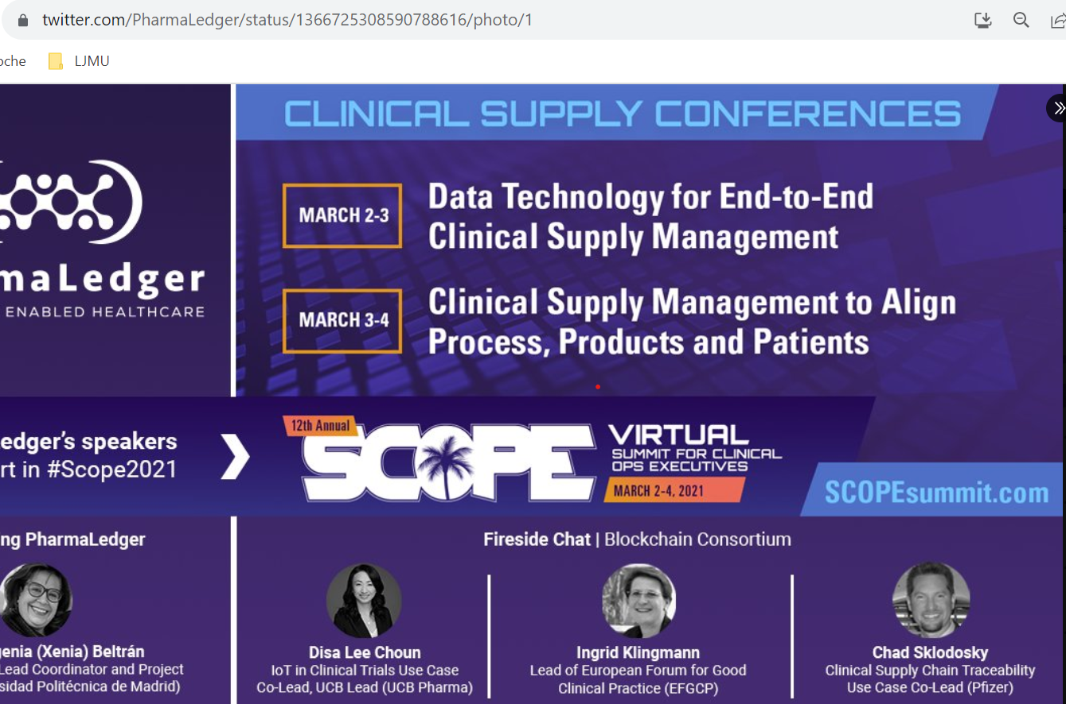

TweetID : 1162238997155831809

UserID : nikunjsanghvi

Profession: Industry Expert

Tweet : [#Blockchain](https://twitter.com/hashtag/Blockchain?src=hashtag_click) has extensive uses beyond [#Fintech](https://twitter.com/hashtag/Fintech?src=hashtag_click) / [#Bitcoin](https://twitter.com/hashtag/Bitcoin?src=hashtag_click) – such as the [#SmartContracts](https://twitter.com/hashtag/SmartContracts?src=hashtag_click) solution we [@Robosoft](https://twitter.com/Robosoft) built for a Top-10 [#Pharma](https://twitter.com/hashtag/Pharma?src=hashtag_click) co – as well as use cases in verticals such as [#Retail](https://twitter.com/hashtag/Retail?src=hashtag_click), [#Travel](https://twitter.com/hashtag/Travel?src=hashtag_click), [#Logistics](https://twitter.com/hashtag/Logistics?src=hashtag_click), [#Automobile](https://twitter.com/hashtag/Automobile?src=hashtag_click), and [#RealEstate](https://twitter.com/hashtag/RealEstate?src=hashtag_click):

TweetID : 1317095449359245312

UserID : CertiK

Profession: Community

Tweet : [@StatistaCharts](https://twitter.com/StatistaCharts) reveals life sciences industries, including but not limited to [#biotech](https://twitter.com/hashtag/biotech?src=hashtag_click), [#medical](https://twitter.com/hashtag/medical?src=hashtag_click) [#devices](https://twitter.com/hashtag/devices?src=hashtag_click), and [#pharma](https://twitter.com/hashtag/pharma?src=hashtag_click), take positions in DLT, with 23% of companies relevant to the sector already using [#blockchain](https://twitter.com/hashtag/blockchain?src=hashtag_click). [#techhealth](https://twitter.com/hashtag/techhealth?src=hashtag_click) [#iot](https://twitter.com/hashtag/iot?src=hashtag_click) [#blockchaintechnology](https://twitter.com/hashtag/blockchaintechnology?src=hashtag_click) [#adoption](https://twitter.com/hashtag/adoption?src=hashtag_click) [#certik](https://twitter.com/hashtag/certik?src=hashtag_click)

TweetID : 1620746443136040960

UserID : acoerco

Profession: Organization

Tweet : In this new podcast, our CEO [@jnasr](https://twitter.com/jnasr) talks about the use of [#DLT](https://twitter.com/hashtag/DLT?src=hashtag_click) and [#NFTs](https://twitter.com/hashtag/NFTs?src=hashtag_click) in [#healthcare](https://twitter.com/hashtag/healthcare?src=hashtag_click), and how blockchain-based solutions can add real value to the industry! Listen to the podcast on the link below or on any audio podcast platform:

TweetID : 1384439111940022282

UserID : Infosys

Profession: Organization

Tweet : [#Blockchain](https://twitter.com/hashtag/Blockchain?src=hashtag_click) is revolutionizing [#pharma](https://twitter.com/hashtag/pharma?src=hashtag_click) supply chain to ensure critical supply of vaccines. Introducing Infosys Blockchain Pharma Supply Chain solution that brings trust, transparency, and efficiency across the pharma value chain. Know more [https://infy.com/32rRQqH](https://t.co/fqIWtA8ZHw) [#Lifesciences](https://twitter.com/hashtag/Lifesciences?src=hashtag_click)

TweetID : 1165217203974750208

UserID : HLTHRun

Profession: Organization

Tweet : The global blockchain in pharmaceutical supply chain management market is expected to register an approximate CAGR of 22.5 per cent during the forecast period of 2019–2024. [https://buff.ly/2Z6j4E6](https://t.co/c7e0NK5tIy) [#blockchain](https://twitter.com/hashtag/blockchain?src=hashtag_click) [#pharma](https://twitter.com/hashtag/pharma?src=hashtag_click) [#research](https://twitter.com/hashtag/research?src=hashtag_click) [#shivom](https://twitter.com/hashtag/shivom?src=hashtag_click) [#healthcare](https://twitter.com/hashtag/healthcare?src=hashtag_click) [#chain](https://twitter.com/hashtag/chain?src=hashtag_click) [#IT](https://twitter.com/hashtag/IT?src=hashtag_click) [#industry](https://twitter.com/hashtag/industry?src=hashtag_click)

TweetID : 1602609423444238336

UserID : xrp334

Profession: Community

Tweet : [#XRPH](https://twitter.com/hashtag/XRPH?src=hashtag_click) will revolutionize the pharmaceutical industry “[#XRP](https://twitter.com/hashtag/XRP?src=hashtag_click) Healthcare’s developing decentralized marketplace is equipped and poised to become the fresh portal for big [#pharma](https://twitter.com/hashtag/pharma?src=hashtag_click) customers.” [#xrpl](https://twitter.com/hashtag/xrpl?src=hashtag_click) [#xrph](https://twitter.com/hashtag/xrph?src=hashtag_click) [#pharma](https://twitter.com/hashtag/pharma?src=hashtag_click) [#blockchain](https://twitter.com/hashtag/blockchain?src=hashtag_click) [#cryptocurrency](https://twitter.com/hashtag/cryptocurrency?src=hashtag_click) [#XRPL](https://twitter.com/hashtag/XRPL?src=hashtag_click) [#XRPHolders](https://twitter.com/hashtag/XRPHolders?src=hashtag_click)

TweetID : 1311067009040429063

UserID : GS1_US

Profession: Community

Tweet : What are the drivers of [#blockchain](https://twitter.com/hashtag/blockchain?src=hashtag_click) use in [#pharma](https://twitter.com/hashtag/pharma?src=hashtag_click)? Kraig Adams, VP at GS1 US, discusses the role of [#GS1Standards](https://twitter.com/hashtag/GS1Standards?src=hashtag_click). [http://ow.ly/LrVE50BBIPq](https://t.co/W8ijJ6YTiw) [#DSCSA](https://twitter.com/hashtag/DSCSA?src=hashtag_click)

TweetID : 1173540028871524353

UserID : IBMEurope

Profession: Organization

Tweet : Technology has upgraded procurement, and, as such, [#Blockchain](https://twitter.com/hashtag/Blockchain?src=hashtag_click) now gives you info about the safety of [#pharma](https://twitter.com/hashtag/pharma?src=hashtag_click) products: ingredients, suppliers and transportation. We can get into a deeper conversation at [#DPW2019](https://twitter.com/hashtag/DPW2019?src=hashtag_click). [https://ibm.co/31dSia5](https://t.co/wrSdWh02MI) @DPW2019

TweetID : 1602463369168310274

UserID : XRPHealthcare

Profession: Organization

Tweet : “XRP Healthcare’s developing decentralized marketplace is equipped and poised to become the fresh portal for big pharma customers.” [#xrpl](https://twitter.com/hashtag/xrpl?src=hashtag_click) [#xrph](https://twitter.com/hashtag/xrph?src=hashtag_click) [#pharma](https://twitter.com/hashtag/pharma?src=hashtag_click) [#blockchain](https://twitter.com/hashtag/blockchain?src=hashtag_click) [#cryptocurrency](https://twitter.com/hashtag/cryptocurrency?src=hashtag_click) [#cryptonews](https://twitter.com/hashtag/cryptonews?src=hashtag_click) Read more of our latest blog:

TweetID : 1547589769269370887

UserID : PharmaIQ

Profession: Community

Tweet : A new initiative backed by big [#pharma](https://twitter.com/hashtag/pharma?src=hashtag_click) uses [#blockchain](https://twitter.com/hashtag/blockchain?src=hashtag_click) technology to verify business credentials and exchange data securely. [@PharmaLedger](https://twitter.com/PharmaLedger) and [@GLEIF](https://twitter.com/GLEIF) are launching the new digital ID: [http://ow.ly/Oflv50JVSxk](https://t.co/vwk4xsgGzI) [#supplychain](https://twitter.com/hashtag/supplychain?src=hashtag_click) [#digitalID](https://twitter.com/hashtag/digitalID?src=hashtag_click)

TweetID : 1355080759707623425

UserID : KaoDataDC

Profession: Community

Tweet : From [#blockchain](https://twitter.com/hashtag/blockchain?src=hashtag_click) to big data + [#HPC](https://twitter.com/hashtag/HPC?src=hashtag_click) to [#IoT](https://twitter.com/hashtag/IoT?src=hashtag_click), technology is accelerating [#vaccine](https://twitter.com/hashtag/vaccine?src=hashtag_click) supply chains across the world. Great to see our sector supporting the enormous roll-out currently being undertaken globally. Read more on [@ZDNet](https://twitter.com/ZDNET): [https://zdnet.com/article/from-blockchain-to-big-data-and-iot-tech-is-trying-to-speed-up-vaccine-supply-chains/…](https://t.co/aThB7nEE0H) [#AI](https://twitter.com/hashtag/AI?src=hashtag_click) [#Pharma](https://twitter.com/hashtag/Pharma?src=hashtag_click) [#Bioinformatics](https://twitter.com/hashtag/Bioinformatics?src=hashtag_click)

TweetID : 950820547755159552

UserID : TizerWallet

Profession: Community

Tweet : 1. What if [#blockchain](https://twitter.com/hashtag/blockchain?src=hashtag_click) could be used to actually save people's lives? This is an idea discussed by the pharmaceutical heavyweights Pfizer, Amgen and Sanofi. [#medicine](https://twitter.com/hashtag/medicine?src=hashtag_click) [#pharma](https://twitter.com/hashtag/pharma?src=hashtag_click)

TweetID : 1480627084233957385

UserID : ZwijBerg

Profession: Community

Tweet : [$VET](https://twitter.com/search?q=%24VET&src=cashtag_click) [#VeChain](https://twitter.com/hashtag/VeChain?src=hashtag_click) to Develop Drug-Tracing Platform for Pharma Giant [@Bayer](https://twitter.com/Bayer). [#VeChain](https://twitter.com/hashtag/VeChain?src=hashtag_click) will help to help it track clinical trial drugs along the [#blockchain](https://twitter.com/hashtag/blockchain?src=hashtag_click). Known as "CSecure".

TweetID : 1630055121806663685

UserID : marginx_io

Profession: Community

Tweet : Pharma giant [#Pfizer](https://twitter.com/hashtag/Pfizer?src=hashtag_click) joins [#Decentralized](https://twitter.com/hashtag/Decentralized?src=hashtag_click) initiatives with [#VitaDAO](https://twitter.com/hashtag/VitaDAO?src=hashtag_click) [#India](https://twitter.com/hashtag/India?src=hashtag_click) to create a global regulatory framework for [#crypto](https://twitter.com/hashtag/crypto?src=hashtag_click) during [#G20](https://twitter.com/hashtag/G20?src=hashtag_click) Presidency [#Inflation](https://twitter.com/hashtag/Inflation?src=hashtag_click) worries drive down assets like [#Bitcoin](https://twitter.com/hashtag/Bitcoin?src=hashtag_click) & crypto-related [#stocks](https://twitter.com/hashtag/stocks?src=hashtag_click) [#blockchain](https://twitter.com/hashtag/blockchain?src=hashtag_click) [#fintech](https://twitter.com/hashtag/fintech?src=hashtag_click)

TweetID : 1713967730850721808

UserID : Real_PharmaDao

Profession: Community

Tweet : We spoke with [@Labiotech_eu](https://twitter.com/Labiotech_eu) about the potential of [#Blockchain](https://twitter.com/hashtag/Blockchain?src=hashtag_click) and [#DAOs](https://twitter.com/hashtag/DAOs?src=hashtag_click) to deliver funding for crucial biotech projects 

TweetID : 1367817193258377219

UserID : fatiebomba

Profession: Community

Tweet : 1/2 New month, new supplier! Another big pharma company is joining the party. Happy to see the progress [@Walmart](https://twitter.com/Walmart) is making on [#VeChain](https://twitter.com/hashtag/VeChain?src=hashtag_click), the only #1 Public [#blockchain](https://twitter.com/hashtag/blockchain?src=hashtag_click) for enterprise adoption.

TweetID : 1607761173620949010

UserID : XRPHealthcare

Profession: Organization

Tweet : We are working tirelessly behind the scenes to Bridge Blockchain to the Pharma and Healthcare industry via our Decentralized Marketplace. [#xrpl](https://twitter.com/hashtag/xrpl?src=hashtag_click) [#xrph](https://twitter.com/hashtag/xrph?src=hashtag_click) [#blockchain](https://twitter.com/hashtag/blockchain?src=hashtag_click)

TweetID : 1614813715135619072

UserID : XRPHealthcare

Profession: Organization

Tweet : Our partnerships will span a wide range of market segments in the Pharma and Healthcare industries. We believe that collaboration is the key to success - along with the security provided by XRPL blockchain technology. [#xrp](https://twitter.com/hashtag/xrp?src=hashtag_click) [#blockchain](https://twitter.com/hashtag/blockchain?src=hashtag_click) [#developers](https://twitter.com/hashtag/developers?src=hashtag_click) [#xrpl](https://twitter.com/hashtag/xrpl?src=hashtag_click) [#xrpledger](https://twitter.com/hashtag/xrpledger?src=hashtag_click) [#XRPHealthCare](https://twitter.com/hashtag/XRPHealthCare?src=hashtag_click)

TweetID : 1485678334356955149

UserID : Ilios369

Profession: Individual

Tweet : [@dHealth_Network](https://twitter.com/dHealth_Network) has competitive advantage over other [#blockchain](https://twitter.com/hashtag/blockchain?src=hashtag_click) [#projects](https://twitter.com/hashtag/projects?src=hashtag_click) with its powerful [#technology](https://twitter.com/hashtag/technology?src=hashtag_click) and strong partnerships with the leading pharma houses like [@Roche](https://twitter.com/Roche) ,[@LillyPad](https://twitter.com/LillyPad) and [@Novartis](https://twitter.com/Novartis). I smell a revolution coming 

TweetID : 1522050223962718208

UserID : stpiindia

Profession: Organization

Tweet : Procure+, an innovative startup incubated at [#STPIApiary](https://twitter.com/hashtag/STPIApiary?src=hashtag_click), provides [#Blockchain](https://twitter.com/hashtag/Blockchain?src=hashtag_click)-based solutions to address the challenges of pharma supply chain by ensuring traceability, authenticity, and transparency. Explore now: [https://apiary.stpi.in](https://t.co/IVwc47r0Ri). [#STPIINDIA](https://twitter.com/hashtag/STPIINDIA?src=hashtag_click) [#STPICoEs](https://twitter.com/hashtag/STPICoEs?src=hashtag_click) [#STPIStartups](https://twitter.com/hashtag/STPIStartups?src=hashtag_click)

TweetID : 1557372230992072714

UserID : CrxqtoWizard

Profession: Community

Tweet :

TweetID : 1396882567882813443

UserID : TraceLabsHQ

Profession: Organization Industry Expert Community

Tweet : [@MrBeast](https://twitter.com/MrBeast) Do you know that [@LillyFoundation](https://twitter.com/Lillyfoundation) and [@LillianFinance](https://twitter.com/LillianFinance) are saving the lives of children and vets? Through the power of [#Crypto](https://twitter.com/hashtag/Crypto?src=hashtag_click) and [#Blockchain](https://twitter.com/hashtag/Blockchain?src=hashtag_click) the [#healthcare](https://twitter.com/hashtag/healthcare?src=hashtag_click) [#market](https://twitter.com/hashtag/market?src=hashtag_click) is going to be revolutionized! Partnerships with hospitals, pharma, and many more yet to be announced [$Ly](https://twitter.com/search?q=%24Ly&src=cashtag_click)

TweetID : 1381918669060575236

UserID : EBlockchainCon

Profession: Community

Tweet : PharmaLedger panel, share their vision about how Blockchain can protect "Patient Data" setting a privacy law to conserve Identity privacy. "Trust is not something you can built overnight, but Blockchain has a lot of benefits in this field" [#blockchain](https://twitter.com/hashtag/blockchain?src=hashtag_click) [#healthcare](https://twitter.com/hashtag/healthcare?src=hashtag_click) [#pharma](https://twitter.com/hashtag/pharma?src=hashtag_click)

TweetID : 1617501563672735745

UserID : XRPHealthcare

Profession: Organization

Tweet : An essential component of the pharmaceutical industry is the guarantee of expeditious and secure transactions; XRPH’s marketplace aims to fulfill these essential preconditions. [#xrpl](https://twitter.com/hashtag/xrpl?src=hashtag_click) [#xrph](https://twitter.com/hashtag/xrph?src=hashtag_click) [#blockchain](https://twitter.com/hashtag/blockchain?src=hashtag_click) [#crypto](https://twitter.com/hashtag/crypto?src=hashtag_click) [#ripple](https://twitter.com/hashtag/ripple?src=hashtag_click) [#xrp](https://twitter.com/hashtag/xrp?src=hashtag_click) [#pharma](https://twitter.com/hashtag/pharma?src=hashtag_click) [#XRPHealthcare](https://twitter.com/hashtag/XRPHealthcare?src=hashtag_click)

Web3 is based on Decentralization which is web revolution.

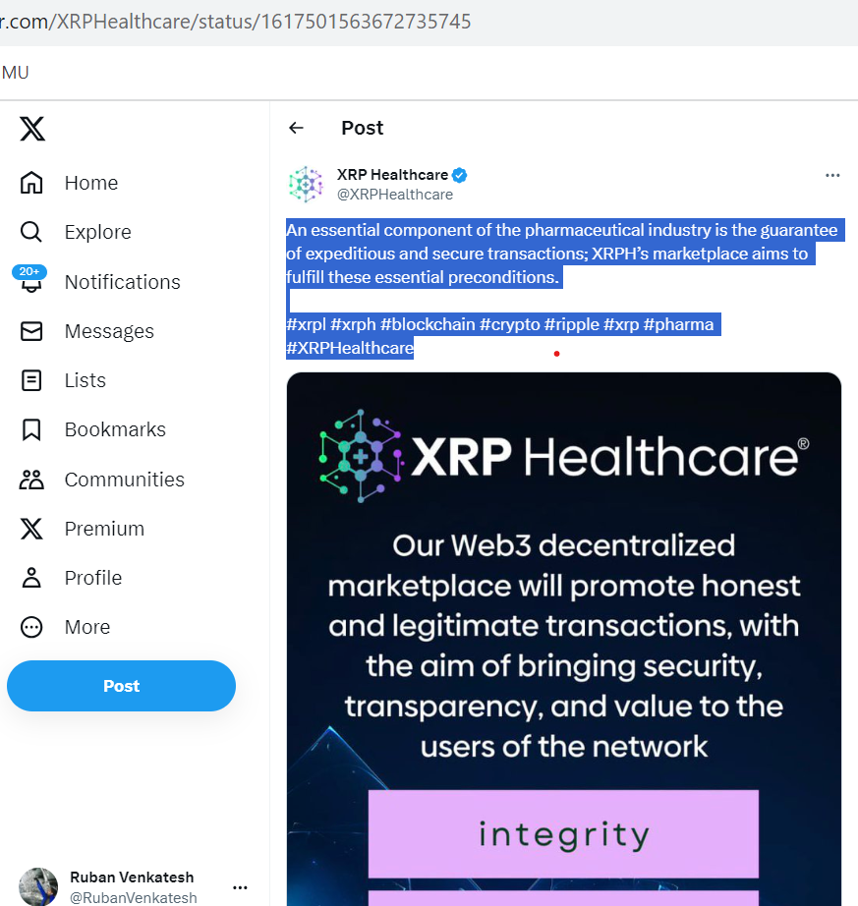

TweetID : 1292712116273651712

UserID : stpiindia

Profession: Organization

Tweet : “Temperature-controlled supply chain plays a key role for pharma industry and [#blockchain](https://twitter.com/hashtag/blockchain?src=hashtag_click) has the potential for seamless monitoring,” underlined Shri Adamya Sharma, Partner, [@FelixAdvisory](https://twitter.com/FelixAdvisory). [#STPIINDIA](https://twitter.com/hashtag/STPIINDIA?src=hashtag_click) [#STPICoEs](https://twitter.com/hashtag/STPICoEs?src=hashtag_click) [#STPIApiary](https://twitter.com/hashtag/STPIApiary?src=hashtag_click) [#STPIPulse](https://twitter.com/hashtag/STPIPulse?src=hashtag_click) Watch live: [https://bit.ly/stpipulse_apiary1](https://t.co/cpTMJoqnGx)

TweetID : 1605170647289643008

UserID : XRPHealthcare

Profession: Organization

Tweet : “The integrity and future of the developing XRPH ecosystem demands that it retains sovereignty over its own digital asset, and thus over its decentralized marketplace and the elements connected therein.” [#xrpl](https://twitter.com/hashtag/xrpl?src=hashtag_click) [#xrp](https://twitter.com/hashtag/xrp?src=hashtag_click) [#xrph](https://twitter.com/hashtag/xrph?src=hashtag_click) [#blockchain](https://twitter.com/hashtag/blockchain?src=hashtag_click) [#crypto](https://twitter.com/hashtag/crypto?src=hashtag_click) [#pharma](https://twitter.com/hashtag/pharma?src=hashtag_click) [#web3](https://twitter.com/hashtag/web3?src=hashtag_click)

TweetID : 1330831201939152897

UserID : HealthcareLdr

Profession: Community

Tweet : Using [#blockchain](https://twitter.com/hashtag/blockchain?src=hashtag_click) to monitor the COVID-19 vaccine  supply chain [http://bit.ly/36VESn4](https://t.co/hUkLTB0vUR) [@wef](https://twitter.com/wef) [#CovidVaccine](https://twitter.com/hashtag/CovidVaccine?src=hashtag_click) [#DigitalHealth](https://twitter.com/hashtag/DigitalHealth?src=hashtag_click) [#supplychain](https://twitter.com/hashtag/supplychain?src=hashtag_click) [#hospitals](https://twitter.com/hashtag/hospitals?src=hashtag_click) [#Pharmaceutical](https://twitter.com/hashtag/Pharmaceutical?src=hashtag_click) [#pharma](https://twitter.com/hashtag/pharma?src=hashtag_click)

TweetID : 1638085295496126465

UserID : AimedisGlobal

Profession: Organization

Tweet : We are currently developing experiences: 1) Dubai based institution 2) Pharma company meeting and business hub (US based) 3) Surgical training facility (UK based) [#InnovationForEveryone](https://twitter.com/hashtag/InnovationForEveryone?src=hashtag_click) [#medicine](https://twitter.com/hashtag/medicine?src=hashtag_click) [#MedTwitter](https://twitter.com/hashtag/MedTwitter?src=hashtag_click) [#AIMX](https://twitter.com/hashtag/AIMX?src=hashtag_click) [#Blockchain](https://twitter.com/hashtag/Blockchain?src=hashtag_click) [#ehealth](https://twitter.com/hashtag/ehealth?src=hashtag_click) [#AI](https://twitter.com/hashtag/AI?src=hashtag_click) [#Web3](https://twitter.com/hashtag/Web3?src=hashtag_click) [#Metaverse](https://twitter.com/hashtag/Metaverse?src=hashtag_click) [#Healthcare](https://twitter.com/hashtag/Healthcare?src=hashtag_click)

TweetID : 1527710204581797888

UserID : TraceLabsHQ

Profession: Individual

Tweet : Let’s get this right. Block chain talks with a top Pharma. Partnership talks with major credit card company. Major TIER 1 EXCHANGE INBOUND. CHILD SURGERIES. [#LFG](https://twitter.com/hashtag/LFG?src=hashtag_click) [@LillianFinance](https://twitter.com/LillianFinance) [#LillianFinance](https://twitter.com/hashtag/LillianFinance?src=hashtag_click) [#ETH](https://twitter.com/hashtag/ETH?src=hashtag_click) [#Trending](https://twitter.com/hashtag/Trending?src=hashtag_click) [#fintech](https://twitter.com/hashtag/fintech?src=hashtag_click) [#blockchain](https://twitter.com/hashtag/blockchain?src=hashtag_click) [#altcoinseason](https://twitter.com/hashtag/altcoinseason?src=hashtag_click) we are not a meme. [#LOVE](https://twitter.com/hashtag/LOVE?src=hashtag_click)

TweetID : 1363068323186024458

UserID : VechainLuxembo1

Profession: Industry Expert

Tweet : Pharma industry will also need [#blockchain](https://twitter.com/hashtag/blockchain?src=hashtag_click) to protect consumers. [#vechain](https://twitter.com/hashtag/vechain?src=hashtag_click) ecosystem will definitely help this industry to [#track](https://twitter.com/hashtag/track?src=hashtag_click) and [#trace](https://twitter.com/hashtag/trace?src=hashtag_click) drugs. Don’t miss the new revolution  [$VET](https://twitter.com/search?q=%24VET&src=cashtag_click)

TweetID : 1415415752987869186

UserID : CDWGWAGov

Profession: Community

Tweet : Digital is changing the pharma & healthcare industry [#technology](https://twitter.com/hashtag/technology?src=hashtag_click) [#business](https://twitter.com/hashtag/business?src=hashtag_click) [#infosec](https://twitter.com/hashtag/infosec?src=hashtag_click) [#everett](https://twitter.com/hashtag/everett?src=hashtag_click) [#google](https://twitter.com/hashtag/google?src=hashtag_click) [#blockchain](https://twitter.com/hashtag/blockchain?src=hashtag_click) [#amazon](https://twitter.com/hashtag/amazon?src=hashtag_click) [#bitcoin](https://twitter.com/hashtag/bitcoin?src=hashtag_click) [#youtube](https://twitter.com/hashtag/youtube?src=hashtag_click) [#live](https://twitter.com/hashtag/live?src=hashtag_click) [#100daysofcode](https://twitter.com/hashtag/100daysofcode?src=hashtag_click) [#nowplaying](https://twitter.com/hashtag/nowplaying?src=hashtag_click) [#security](https://twitter.com/hashtag/security?src=hashtag_click) [#cdwsocial](https://twitter.com/hashtag/cdwsocial?src=hashtag_click)

TweetID : 1337675426940944385

UserID : stpiindia

Profession: Organization

Tweet : Companies like [@ChronicledInc](https://twitter.com/ChronicledInc) are creating [#Blockchain](https://twitter.com/hashtag/Blockchain?src=hashtag_click)-based pharma supply chain solution by enabling drug companies to comply with regulations. Explore how [#STPIApiary](https://twitter.com/hashtag/STPIApiary?src=hashtag_click) is nurturing [#startups](https://twitter.com/hashtag/startups?src=hashtag_click) to build similar solutions:

TweetID : 1513467438796529671

UserID : EUBlockchain

Profession: Community

Tweet : How does the [#healthcare](https://twitter.com/hashtag/healthcare?src=hashtag_click) sector, the [#pharma](https://twitter.com/hashtag/pharma?src=hashtag_click) industries  & the [#COVID19](https://twitter.com/hashtag/COVID19?src=hashtag_click) management benefit form [#blockchain](https://twitter.com/hashtag/blockchain?src=hashtag_click) technology? [#EUBOF](https://twitter.com/hashtag/EUBOF?src=hashtag_click)’s latest Thematic Report on Blockchain Applications for Healthcare provides the answers. Read more  [https://bit.ly/3xiTEDi](https://t.co/80A9JCbUGe)

TweetID : 1546210346263789570

UserID : KirkDBorne

Profession: Industry Expert

Tweet : Explore the latest articles & resources in [#Analytics](https://twitter.com/hashtag/Analytics?src=hashtag_click) [#DataScience](https://twitter.com/hashtag/DataScience?src=hashtag_click) [#AI](https://twitter.com/hashtag/AI?src=hashtag_click) [#MachineLearning](https://twitter.com/hashtag/MachineLearning?src=hashtag_click) for [#DataScientists](https://twitter.com/hashtag/DataScientists?src=hashtag_click) at [@DataScienceCtrl](https://twitter.com/Datasciencectrl) [http://bit.ly/3P3zx1G](https://t.co/moG65BSBLn) by [@kurt_cagle](https://twitter.com/kurt_cagle) —— [#abdsc](https://twitter.com/hashtag/abdsc?src=hashtag_click) [#BigData](https://twitter.com/hashtag/BigData?src=hashtag_click) [#IoT](https://twitter.com/hashtag/IoT?src=hashtag_click) [#IIoT](https://twitter.com/hashtag/IIoT?src=hashtag_click) [#IoTPL](https://twitter.com/hashtag/IoTPL?src=hashtag_click) [#IoTCL](https://twitter.com/hashtag/IoTCL?src=hashtag_click) [#Pharma](https://twitter.com/hashtag/Pharma?src=hashtag_click) [#Chatbots](https://twitter.com/hashtag/Chatbots?src=hashtag_click) [#DataViz](https://twitter.com/hashtag/DataViz?src=hashtag_click) [#DataLabeling](https://twitter.com/hashtag/DataLabeling?src=hashtag_click) [#blockchain](https://twitter.com/hashtag/blockchain?src=hashtag_click) [#Web3](https://twitter.com/hashtag/Web3?src=hashtag_click) [#Metaverse](https://twitter.com/hashtag/Metaverse?src=hashtag_click)

TweetID : 1603770014355673097

UserID : dHealth_Network

Profession: Community

Tweet : The pharma industry loses much [#money](https://twitter.com/hashtag/money?src=hashtag_click) on fraud in [#supplychains](https://twitter.com/hashtag/supplychains?src=hashtag_click) due to thefts and counterfeit [#medicine](https://twitter.com/hashtag/medicine?src=hashtag_click). [#blockchain](https://twitter.com/hashtag/blockchain?src=hashtag_click) can solve this by improving the real-time [#tracking](https://twitter.com/hashtag/tracking?src=hashtag_click) of [#drugs](https://twitter.com/hashtag/drugs?src=hashtag_click) and verifying the drug’s country of origin and manufacturer. [#dHealth](https://twitter.com/hashtag/dHealth?src=hashtag_click)

TweetID : 1325886668252061698

UserID : realdomestique

Profession: Individual

Tweet : Startup which I work for recently got acquired by 300+Billion dollar pharma company who is currently looking to pilot [#blockchain](https://twitter.com/hashtag/blockchain?src=hashtag_click) technology to improve the quality of data and reduce the administrative costs. Now you know why I'm all in on [$DGB](https://twitter.com/search?q=%24DGB&src=cashtag_click) [#DGB](https://twitter.com/hashtag/DGB?src=hashtag_click) DYOR [#DigiByte](https://twitter.com/hashtag/DigiByte?src=hashtag_click)

TweetID : 1149313423538360320

UserID : DecentratechC

Profession: Community

Tweet : Lots happening in [#blockchain](https://twitter.com/hashtag/blockchain?src=hashtag_click) and [#supplychain](https://twitter.com/hashtag/supplychain?src=hashtag_click) - especially for food and pharma. It's getting increasingly real.

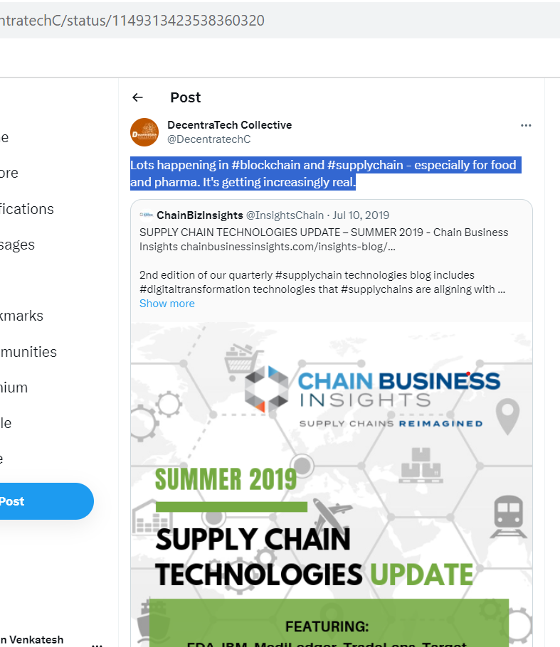

TweetID : 1406897650587291649

UserID : p14416575

Profession: Individual

Tweet : [#blockchain](https://twitter.com/hashtag/blockchain?src=hashtag_click) could be a game-changer for identity management and verification at key stages —during enrollment and at registration, all while maintaining strict patient privacy. Blockchain like [$TRAC](https://twitter.com/search?q=%24TRAC&src=cashtag_click) could be used in pharma and healthcare use cases.

TweetID : 1622743139818561537

UserID : acoerco

Profession: Organization

Tweet : In this week’s Acoer Bytes, we focus on our HashLoad, a secure file storage and sharing solution that ensures the trustworthiness of data. We also highlight an interesting article by [@HarvardBiz](https://twitter.com/HarvardBiz) on why big [#pharma](https://twitter.com/hashtag/pharma?src=hashtag_click) is betting on [#blockchain](https://twitter.com/hashtag/blockchain?src=hashtag_click). Read more here: [https://acoer.com/acoer-bytes](https://t.co/hqSG4XgpVx)

TweetID : 1230894213572612097

UserID : ChronicledInc

Profession: Organization

Tweet : We are proud to announce 24 pharma companies have collaborated to submit the MediLedger DSCSA Pilot Final Report to the FDA, proposing blockchain for an interoperable track & trace system for US drugs [#collaboration](https://twitter.com/hashtag/collaboration?src=hashtag_click) [#blockchain](https://twitter.com/hashtag/blockchain?src=hashtag_click) [https://prn.to/2HJaP60](https://t.co/NcAQWcMBwX)

TweetID : 1479406983409197056

UserID : drlennylomax

Profession: Individual

Tweet : Our Objective with the Symbiotic [#Blockchain](https://twitter.com/hashtag/Blockchain?src=hashtag_click): To hold big pharma accountable To make accurate [#medical](https://twitter.com/hashtag/medical?src=hashtag_click) data available To make clinical trials affordable To introduce a new line of plant-based [#medicine](https://twitter.com/hashtag/medicine?src=hashtag_click) To bring easy connection between doctors To give power back to [#patients](https://twitter.com/hashtag/patients?src=hashtag_click)

TweetID : 1251321266331672576

UserID : elleprovocateur

Profession: Individual

Tweet : Jan 31 2019: "Global Pharma Giant [#Merck](https://twitter.com/hashtag/Merck?src=hashtag_click) Wins US [#Blockchain](https://twitter.com/hashtag/Blockchain?src=hashtag_click), [#AI](https://twitter.com/hashtag/AI?src=hashtag_click) Patent for Product Authenticity" "Last week, U.S.-based health insurance giant Aetna partnered with tech mogul [#IBM](https://twitter.com/hashtag/IBM?src=hashtag_click) to build a blockchain network designed for the healthcare industry,..."

TweetID : 1379839369905893378

UserID : TomazOT

Profession: Individual

Tweet : A great recap of what [@WHO](https://twitter.com/WHO) describes to be the key [#pharma](https://twitter.com/hashtag/pharma?src=hashtag_click) industry data challenges by [@JureSkornik](https://twitter.com/JureSkornik). Check out the article and learn how [@origin_trail](https://twitter.com/origin_trail) is the best tool to address them! [#TraceOn](https://twitter.com/hashtag/TraceOn?src=hashtag_click) [#data](https://twitter.com/hashtag/data?src=hashtag_click) [#enterprise](https://twitter.com/hashtag/enterprise?src=hashtag_click) [#blockchain](https://twitter.com/hashtag/blockchain?src=hashtag_click) . Working with customers in the pharmaceutical industry, we see OriginTrail DKG as being uniquely suited to enable the important features of traceability and verification systems highlighted in @WHO's policy paper." More in General Manager's Point of View

TweetID : 1313137391398395904

UserID : akbcrypto2

Profession: Individual

Tweet : [#Blockchain](https://twitter.com/hashtag/Blockchain?src=hashtag_click) continues to attract interest in the pharma industry Through drug distribution history management service, it is possible to innovate business by implementing product-specific history management, real-time distribution history tracking [@WHO](https://twitter.com/WHO) [@SamsungIndia](https://twitter.com/SamsungIndia) [$TRX](https://twitter.com/search?q=%24TRX&src=cashtag_click) [#AKB](https://twitter.com/hashtag/AKB?src=hashtag_click)

TweetID : 1652599022337634304

UserID : AuthenaAG

Profession: Community

Tweet : Advanced tech like [#blockchain](https://twitter.com/hashtag/blockchain?src=hashtag_click) & [#IoT](https://twitter.com/hashtag/IoT?src=hashtag_click) can secure the global pharma supply chain and protect patients from counterfeit drugs. Don't miss Authena CEO [@MatPanzavolta](https://twitter.com/MatPanzavolta)'s article on page 32 of the [@PMPSmag](https://twitter.com/PMPSmag) May 2023 © Samedan! [#pharmaceuticals](https://twitter.com/hashtag/pharmaceuticals?src=hashtag_click) 

TweetID : 1308310939243081729

UserID : adrianafreitas

Profession: Individual

Tweet : Tech speaks for itself Can it make bread? NO Is about [#usecases](https://twitter.com/hashtag/usecases?src=hashtag_click) [@PharmaLedger](https://twitter.com/PharmaLedger) Adoption is beyond platform creation "How [#Blockchain](https://twitter.com/hashtag/Blockchain?src=hashtag_click) is Changing Pharma Jorge A. Ferrer Roig Clarisse Dias da Mota [@Novartis](https://twitter.com/Novartis) Ken Thursby [@MSDInvents](https://twitter.com/MSDInvents) Wafaa Ahmed [@NBS_NTU](https://twitter.com/NBS_NTU) [@EBlockchainCon](https://twitter.com/EBlockchainCon) [#EBCvirtual](https://twitter.com/hashtag/EBCvirtual?src=hashtag_click)

TweetID : 1522010625588830209

UserID : ChronicledInc

Profession: Organization

Tweet : We're thrilled to be innovating w/ the exceptional team [@cardinalhealth](https://twitter.com/cardinalhealth). Together, we're leveraging the [#blockchain](https://twitter.com/hashtag/blockchain?src=hashtag_click) to solve complex problems in the [#healthcare](https://twitter.com/hashtag/healthcare?src=hashtag_click) industry Check out this post by Ray Bajaj, SVP, Chief Technology Officer @ Cardinal Health

TweetID : 1519315437456035841

UserID : ChronicledInc

Profession: Organization

Tweet : We are very excited to announce the addition of [@Healthcare_ABC](https://twitter.com/Healthcare_ABC) to the [#MediLedger](https://twitter.com/hashtag/MediLedger?src=hashtag_click) Network! [#AmersiourceBergen](https://twitter.com/hashtag/AmersiourceBergen?src=hashtag_click) has been an amazing innovation partner in working towards fixing the inefficiencies across [#LifeSciences](https://twitter.com/hashtag/LifeSciences?src=hashtag_click) & [#Healthcare](https://twitter.com/hashtag/Healthcare?src=hashtag_click) 

TweetID : 1512171620802215948

UserID : ChronicledInc

Profession: Organization Industry Expert Community

Tweet : Yes, there's more to [#NFTs](https://twitter.com/hashtag/NFTs?src=hashtag_click) than pixels and apes. CTO [@iogreco](https://twitter.com/iogreco) discusses new paradigms emerging in [#blockchaintechnology](https://twitter.com/hashtag/blockchaintechnology?src=hashtag_click), where NFTs can become collateral to optimize the [#healthcareindustry](https://twitter.com/hashtag/healthcareindustry?src=hashtag_click). [#blockchaininhealthcare](https://twitter.com/hashtag/blockchaininhealthcare?src=hashtag_click) [#blockchainadoption](https://twitter.com/hashtag/blockchainadoption?src=hashtag_click) [#blockchaintech](https://twitter.com/hashtag/blockchaintech?src=hashtag_click)

TweetID : 1493678459012272129

UserID : ChronicledInc

Profession: Organization

Tweet : Big milestone at Chronicled today: a successful demo of ZK-p tech to record proofs of contract updates from a manufacturer to a wholesaler on the MediLedger Blockchain. Could be the 1st successful application of ZK-p to solve a real world business problem outside of crypto!

TweetID : 1422598142961270785

UserID : cardinalhealth

Profession: Organization

Tweet : We’re leveraging new [#blockchain](https://twitter.com/hashtag/blockchain?src=hashtag_click) technology on the MediLedger network to create a compelling customer experience. Learn how we're partnering with [@ChronicledInc](https://twitter.com/ChronicledInc) to make it possible:

TweetID : 1317047879069028354

UserID : Victoria_AGago

Profession: Industry Expert

Tweet : I’m very honoured and happy about our recent strategic partnership between [@PharmaLedger](https://twitter.com/PharmaLedger), the leading pharma [#blockchain](https://twitter.com/hashtag/blockchain?src=hashtag_click) consortium, and the [@EBlockchainCon](https://twitter.com/EBlockchainCon).

TweetID : 1494356041756196869

UserID : LedgerInsights

Profession: Community

Tweet : .[@ChronicledInc](https://twitter.com/ChronicledInc) the company that developed the [@mediledger](https://twitter.com/mediledger) pharma network has raised $8.3m from [@TrueGlobalVCs](https://twitter.com/TrueGlobalVCs)

TweetID : 1270762976086298625

UserID : techreview

Profession: Community

Tweet : [CONTENT FROM [@DeloitteOnTech](https://twitter.com/DeloitteOnTech)] [#Blockchain](https://twitter.com/hashtag/Blockchain?src=hashtag_click) is being applied in highly regulated industries like financial services, life sciences, and pharma. Establishing regulations on privacy, economic sanctions, and tax reporting will be hard—but it’s critical.

TweetID : 1202897932648943616

UserID : LedgerInsights

Profession: Community

Tweet : .@RBI_Presse and [@sparkasse](https://twitter.com/sparkasse) Bielefeld executed a pilot on @network_polo [#blockchain](https://twitter.com/hashtag/blockchain?src=hashtag_click) trade finance network Transaction for pharmaceuticals sold by [@DrWolffGroup](https://twitter.com/DrWolffGroup) to Austrian wholesaler sam Pharma Integration from SServicePartner [@Cordablockchain](https://twitter.com/Cordablockchain)

TweetID : 1433418520008826880

UserID : globalyouthigf

Profession: Community

Tweet : The [#UK](https://twitter.com/hashtag/UK?src=hashtag_click) will create a new digital supply chain for the pharma industry that will use [#blockchain](https://twitter.com/hashtag/blockchain?src=hashtag_click). People will be able to monitor it. Will the fact that a supply chain is based on blockchain allow a safer purchase of meds online?[#YouthIGFActs](https://twitter.com/hashtag/YouthIGFActs?src=hashtag_click) [@HealthcareDig](https://twitter.com/HealthcareDig)

TweetID : 1410284998859669513

UserID : TraceLabsHQ

Profession: Industry Expert

Tweet : Many people’s knowledge of [#blockchain](https://twitter.com/hashtag/blockchain?src=hashtag_click) has come almost exclusively from what they’ve read about cryptocurrency. I've shared some thoughts with [@ForbesTechCncl](https://twitter.com/ForbesTechCncl) on how it can be leveraged in the pharma industry:

TweetID : 1022771973741584385

UserID : Marcus_Crouc

Profession: Individual

Tweet : AI and Blockchain Transforming Pharma Supply Chain [http://bit.ly/2Ol0XBu](https://t.co/XaxmwTou8r) [#AI](https://twitter.com/hashtag/AI?src=hashtag_click) [#ArtificialIntelligence](https://twitter.com/hashtag/ArtificialIntelligence?src=hashtag_click) [#Blockchain](https://twitter.com/hashtag/Blockchain?src=hashtag_click) [#blockchaindevelopment](https://twitter.com/hashtag/blockchaindevelopment?src=hashtag_click) [#blockchaintechnology](https://twitter.com/hashtag/blockchaintechnology?src=hashtag_click) [#supplychain](https://twitter.com/hashtag/supplychain?src=hashtag_click) [#Pharmaceutical](https://twitter.com/hashtag/Pharmaceutical?src=hashtag_click) [#pharma18](https://twitter.com/hashtag/pharma18?src=hashtag_click) [#transformation](https://twitter.com/hashtag/transformation?src=hashtag_click)

TweetID : 1140505199817236480

UserID : JMunozCasillas

Profession: Individual

Tweet : The FDA Partners with Walmart, IBM, Merck to Improve Pharma Supply Chain via Blockchain [https://buff.ly/2KUxAGX](https://t.co/L9YgtFW8PQ) [#SupplyChain](https://twitter.com/hashtag/SupplyChain?src=hashtag_click) [#blockchain](https://twitter.com/hashtag/blockchain?src=hashtag_click) [#Pharmaceutical](https://twitter.com/hashtag/Pharmaceutical?src=hashtag_click)

TweetID : 1114542870910791681

UserID : Vikezmedia

Profession: Individual

Tweet : IBM Developing Blockchain Solution to Combat Fake Medicine in Africa [#Africa](https://twitter.com/hashtag/Africa?src=hashtag_click) [#IBM](https://twitter.com/hashtag/IBM?src=hashtag_click) [#Blockchain](https://twitter.com/hashtag/Blockchain?src=hashtag_click) [#fakedrugs](https://twitter.com/hashtag/fakedrugs?src=hashtag_click) [#innovation](https://twitter.com/hashtag/innovation?src=hashtag_click) [#tech](https://twitter.com/hashtag/tech?src=hashtag_click) [#supplychain](https://twitter.com/hashtag/supplychain?src=hashtag_click) [#tech](https://twitter.com/hashtag/tech?src=hashtag_click) [#VIKEZ](https://twitter.com/hashtag/VIKEZ?src=hashtag_click) [#healthcare](https://twitter.com/hashtag/healthcare?src=hashtag_click) [#consumers](https://twitter.com/hashtag/consumers?src=hashtag_click) [#business](https://twitter.com/hashtag/business?src=hashtag_click) [#Pharma](https://twitter.com/hashtag/Pharma?src=hashtag_click) [https://bitsonline.com/ibm-blockchain-combat-fake-drugs-africa/](https://t.co/ZYgx2HzYtp)

TweetID : 1396882567882813443

UserID : ScottWLuton

Profession: Industry Expert

Tweet : “Why Big Pharma Is Betting on Blockchain” [https://buff.ly/2XDtwPO](https://t.co/A8OqRHY6al) [#supplychain](https://twitter.com/hashtag/supplychain?src=hashtag_click) [#blockchain](https://twitter.com/hashtag/blockchain?src=hashtag_click) [#pharma](https://twitter.com/hashtag/pharma?src=hashtag_click) [#tech](https://twitter.com/hashtag/tech?src=hashtag_click) [#covid19](https://twitter.com/hashtag/covid19?src=hashtag_click)

TweetID : 1027208562181922822

UserID : Esprezzoapp

Profession: Community

Tweet : Great to see out partner [@vechainofficial](https://twitter.com/vechainofficial) leveraging [#blockchain](https://twitter.com/hashtag/blockchain?src=hashtag_click) to reduce counterfeit vaccines in China! [#supplychain](https://twitter.com/hashtag/supplychain?src=hashtag_click) [#crypto](https://twitter.com/hashtag/crypto?src=hashtag_click) [#pharma](https://twitter.com/hashtag/pharma?src=hashtag_click)

TweetID : 1115181946420768768

UserID : jwoods_57

Profession: Industry Expert

Tweet : Enjoyed speaking on 2 [#blockchain](https://twitter.com/hashtag/blockchain?src=hashtag_click) in [#healthcare](https://twitter.com/hashtag/healthcare?src=hashtag_click) panels at [@ELEV8con](https://twitter.com/ELEV8con) this past week in [#losangeles](https://twitter.com/hashtag/losangeles?src=hashtag_click). The 1st panel was on [#smartcontract](https://twitter.com/hashtag/smartcontract?src=hashtag_click) [#automation](https://twitter.com/hashtag/automation?src=hashtag_click) in healthcare. The 2nd on [#blockchain](https://twitter.com/hashtag/blockchain?src=hashtag_click) for [#pharma](https://twitter.com/hashtag/pharma?src=hashtag_click) [#supplychain](https://twitter.com/hashtag/supplychain?src=hashtag_click). Enlightening discussions and great people! [#enterprise](https://twitter.com/hashtag/enterprise?src=hashtag_click)

TweetID : 1142455209878327296

UserID : jaimecampos787

Profession: Organization Industry Expert Community Individual

Tweet : [#IoT](https://twitter.com/hashtag/IoT?src=hashtag_click) [#Blockchain](https://twitter.com/hashtag/Blockchain?src=hashtag_click) & [#AI](https://twitter.com/hashtag/AI?src=hashtag_click) will revolutionize [#business](https://twitter.com/hashtag/business?src=hashtag_click). [@dragonchaingang](https://twitter.com/dragonchaingang) Interchain [#BaaS](https://twitter.com/hashtag/BaaS?src=hashtag_click) Platform Check*[https://dragonchain.com/blockchain-platform…](https://t.co/2ZhjtJukzW) [#4IR](https://twitter.com/hashtag/4IR?src=hashtag_click) [#5G](https://twitter.com/hashtag/5G?src=hashtag_click) [#SmartCities](https://twitter.com/hashtag/SmartCities?src=hashtag_click) [#ML](https://twitter.com/hashtag/ML?src=hashtag_click) [#DL](https://twitter.com/hashtag/DL?src=hashtag_click) [#logistics](https://twitter.com/hashtag/logistics?src=hashtag_click) [#AR](https://twitter.com/hashtag/AR?src=hashtag_click) [#VR](https://twitter.com/hashtag/VR?src=hashtag_click) [#SupplyChain](https://twitter.com/hashtag/SupplyChain?src=hashtag_click) [#Health](https://twitter.com/hashtag/Health?src=hashtag_click) [#Finance](https://twitter.com/hashtag/Finance?src=hashtag_click) [#Retail](https://twitter.com/hashtag/Retail?src=hashtag_click) [#transport](https://twitter.com/hashtag/transport?src=hashtag_click) [#pharma](https://twitter.com/hashtag/pharma?src=hashtag_click) [#biotech](https://twitter.com/hashtag/biotech?src=hashtag_click) [#energy](https://twitter.com/hashtag/energy?src=hashtag_click) [#DLT](https://twitter.com/hashtag/DLT?src=hashtag_click) [#aerospace](https://twitter.com/hashtag/aerospace?src=hashtag_click) [#RealEstate](https://twitter.com/hashtag/RealEstate?src=hashtag_click)

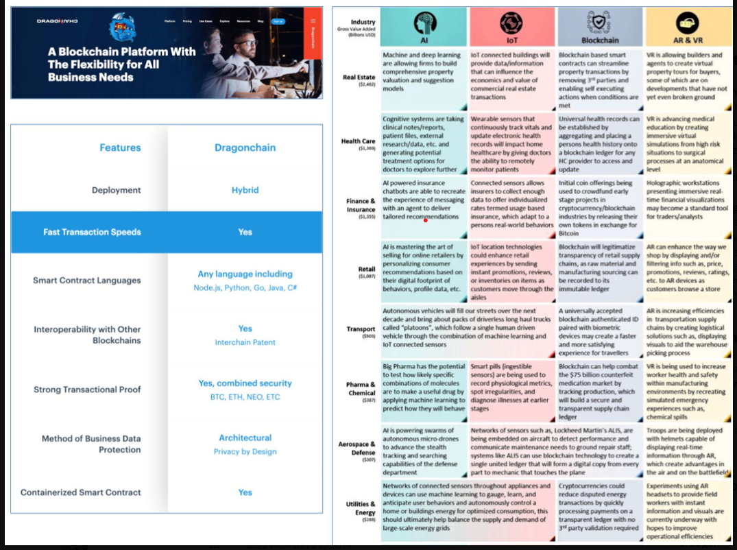

TweetID : 1024837208249958416

UserID : CargoXio

Profession: Community

Tweet : China pharma scandal sparks call for [#blockchain](https://twitter.com/hashtag/blockchain?src=hashtag_click) in drug supply chain | [#SupplyChain](https://twitter.com/hashtag/SupplyChain?src=hashtag_click) [#business](https://twitter.com/hashtag/business?src=hashtag_click) [#news](https://twitter.com/hashtag/news?src=hashtag_click) | [https://blockchaintechnology-news.com/2018/07/26/china-pharma-scandal-sparks-call-for-blockchain-in-drug-supply-chain/](https://t.co/88FCmUTsz1)

TweetID : 1039754135871152129

UserID : anylsite

Profession: Community

Tweet : Thanks to [http://jsb-solutions.com](https://t.co/1QGeZe8RO8) for meeting with us and discussing [#blockchain](https://twitter.com/hashtag/blockchain?src=hashtag_click) opportunities within the pharma [#SupplyChain](https://twitter.com/hashtag/SupplyChain?src=hashtag_click), among others!

TweetID : 1062703532439166976

UserID : DynaSys

Profession: Organization

Tweet : Blockchain in the Pharmaceutical Value Chain Through | DynaSys Blog [http://ow.ly/6LGP30mC9yZ](https://t.co/zU3a2GpYvG) [#SupplyChain](https://twitter.com/hashtag/SupplyChain?src=hashtag_click) [#Blockchain](https://twitter.com/hashtag/Blockchain?src=hashtag_click) [#Pharma](https://twitter.com/hashtag/Pharma?src=hashtag_click) [#LifeSciences](https://twitter.com/hashtag/LifeSciences?src=hashtag_click) [#SmartContracts](https://twitter.com/hashtag/SmartContracts?src=hashtag_click)

TweetID : 1149313423538360320

UserID : DecentratechC

Profession: Organization

Tweet : Lots happening in [#blockchain](https://twitter.com/hashtag/blockchain?src=hashtag_click) and [#supplychain](https://twitter.com/hashtag/supplychain?src=hashtag_click) - especially for food and pharma. It's getting increasingly real.

TweetID : 981867243553349632

UserID : Adentsinfo

Profession: Organization

Tweet : [#Blockchain](https://twitter.com/hashtag/Blockchain?src=hashtag_click) as a 'trust machine'. Marc Gardette from [@Microsoft](https://twitter.com/Microsoft) explains how Blockchain technology can help establishing a more transparent [#SupplyChain](https://twitter.com/hashtag/SupplyChain?src=hashtag_click) in [#pharma](https://twitter.com/hashtag/pharma?src=hashtag_click) [#SerializationSummit](https://twitter.com/hashtag/SerializationSummit?src=hashtag_click)

TweetID : 1059411095406895105

UserID : VeriDocGlobal

Profession: Organization

Tweet : VeriDoc Global is the solution towards an honest, transparent future. [http://veridocglobal.com](https://t.co/He0V0U8A94) [#PublicSafety](https://twitter.com/hashtag/PublicSafety?src=hashtag_click) [#AntiFraud](https://twitter.com/hashtag/AntiFraud?src=hashtag_click) [#blockchain](https://twitter.com/hashtag/blockchain?src=hashtag_click) [#fintech](https://twitter.com/hashtag/fintech?src=hashtag_click) [#tech](https://twitter.com/hashtag/tech?src=hashtag_click) [#massadoption](https://twitter.com/hashtag/massadoption?src=hashtag_click) [#erc20](https://twitter.com/hashtag/erc20?src=hashtag_click) [#supplychain](https://twitter.com/hashtag/supplychain?src=hashtag_click) [#counterfeit](https://twitter.com/hashtag/counterfeit?src=hashtag_click) [#identity](https://twitter.com/hashtag/identity?src=hashtag_click) [#passport](https://twitter.com/hashtag/passport?src=hashtag_click) [#foodsafety](https://twitter.com/hashtag/foodsafety?src=hashtag_click) [#pharma](https://twitter.com/hashtag/pharma?src=hashtag_click) [#medicine](https://twitter.com/hashtag/medicine?src=hashtag_click) [#document](https://twitter.com/hashtag/document?src=hashtag_click) [#security](https://twitter.com/hashtag/security?src=hashtag_click) [#landtitle](https://twitter.com/hashtag/landtitle?src=hashtag_click)

TweetID : 1156687996684513280

UserID : OmniversalisDAO

Profession: Community

Tweet : Offering a full array of [#SupplyChain](https://twitter.com/hashtag/SupplyChain?src=hashtag_click) Management solutions to [#Pharma](https://twitter.com/hashtag/Pharma?src=hashtag_click) [#Hiotech](https://twitter.com/hashtag/Hiotech?src=hashtag_click) & [#Healthcare](https://twitter.com/hashtag/Healthcare?src=hashtag_click) companies using [#Blockchain](https://twitter.com/hashtag/Blockchain?src=hashtag_click) [#IoT](https://twitter.com/hashtag/IoT?src=hashtag_click) & our next-gen [#AI](https://twitter.com/hashtag/AI?src=hashtag_click)  [http://tradepharma.network](https://t.co/hp5K5OBvxw) [#Medicines](https://twitter.com/hashtag/Medicines?src=hashtag_click) [#B2B](https://twitter.com/hashtag/B2B?src=hashtag_click) [#Counterfeiting](https://twitter.com/hashtag/Counterfeiting?src=hashtag_click) [#MachineLearning](https://twitter.com/hashtag/MachineLearning?src=hashtag_click) [#BayesianModeling](https://twitter.com/hashtag/BayesianModeling?src=hashtag_click) [#Algorithms](https://twitter.com/hashtag/Algorithms?src=hashtag_click) [#DataScience](https://twitter.com/hashtag/DataScience?src=hashtag_click) [#PharmaShiftAI](https://twitter.com/hashtag/PharmaShiftAI?src=hashtag_click)

TweetID : 1305461334662950913

UserID : BchainLadies

Profession: Community

Tweet : Dear Ladies, say welcome to: Cristina BaldiWide experience as manager of [#corporatefinance](https://twitter.com/hashtag/corporatefinance?src=hashtag_click), credit & [#riskmanagement](https://twitter.com/hashtag/riskmanagement?src=hashtag_click).Specialized in [#Blockchain](https://twitter.com/hashtag/Blockchain?src=hashtag_click) Technology Management, [#fintech](https://twitter.com/hashtag/fintech?src=hashtag_click) solution & pharma [#supplychain](https://twitter.com/hashtag/supplychain?src=hashtag_click) [#traceability](https://twitter.com/hashtag/traceability?src=hashtag_click) are both the focus of her activities.

TweetID : 1503308495122227205

UserID : smponline

Profession: Organization Industry Expert Community Individual

Tweet : Pharma Supply Chain and Security World (15-16 March) [https://bit.ly/35jajdN](https://t.co/GaWZGifmPW). Tap into the latest [#IoT](https://twitter.com/hashtag/IoT?src=hashtag_click), [#AI](https://twitter.com/hashtag/AI?src=hashtag_click) and [#ML](https://twitter.com/hashtag/ML?src=hashtag_click) & [#Blockchain](https://twitter.com/hashtag/Blockchain?src=hashtag_click) pharma innovations at the [@corvusglobal](https://twitter.com/corvusglobal) event [#ad](https://twitter.com/hashtag/ad?src=hashtag_click) [#PSW](https://twitter.com/hashtag/PSW?src=hashtag_click) [#PharmaSecurityWorld](https://twitter.com/hashtag/PharmaSecurityWorld?src=hashtag_click) [#pharma](https://twitter.com/hashtag/pharma?src=hashtag_click) [#pharmaconference](https://twitter.com/hashtag/pharmaconference?src=hashtag_click) [#SCM](https://twitter.com/hashtag/SCM?src=hashtag_click) [#supplychain](https://twitter.com/hashtag/supplychain?src=hashtag_click)

TweetID : 1060827408666947584

UserID : mvollmer1

Profession: Industry Expert

Tweet : SAP leads Pharma [#SupplyChain](https://twitter.com/hashtag/SupplyChain?src=hashtag_click) [#Blockchain](https://twitter.com/hashtag/Blockchain?src=hashtag_click).. [http://ari.ba/e11081812](https://t.co/XKX7SG5eWP) via [@sapindustries](https://twitter.com/SAPIndustries) [#LifeSciences](https://twitter.com/hashtag/LifeSciences?src=hashtag_click)

TweetID : 1103789000404492288

UserID : 23_consulting

Profession: Organization Industry Expert Community Individual

Tweet : We are proud to contribute to the French [#blockchain](https://twitter.com/hashtag/blockchain?src=hashtag_click) and [#healthcare](https://twitter.com/hashtag/healthcare?src=hashtag_click) community and share our work with an incredibly exciting and dynamic ecosystem. Thank you [@pikciochainpkc](https://twitter.com/pikciochainpkc) and [@KryptoSphere_](https://twitter.com/KRYPTOSPHERE_) for hosting this meetup tonight at [#WAIParis](https://twitter.com/hashtag/WAIParis?src=hashtag_click) [#pharma](https://twitter.com/hashtag/pharma?src=hashtag_click) [#supplychain](https://twitter.com/hashtag/supplychain?src=hashtag_click) [#data](https://twitter.com/hashtag/data?src=hashtag_click)

TweetID : 1041990304314941440

UserID : MuellerSabine13

Profession: Industry Expert

Tweet : Blockchain has the potential to bring enormous change to the supply chain industry. Nowhere is this more pronounced than in the pharmaceuticals. [http://buff.ly/2D8SKin](https://t.co/MLkKeMkZYG) [#blockchain](https://twitter.com/hashtag/blockchain?src=hashtag_click) [#pharma](https://twitter.com/hashtag/pharma?src=hashtag_click) [#supplychain](https://twitter.com/hashtag/supplychain?src=hashtag_click)

TweetID : 1055069164312936448

UserID : R_Healthcare

Profession: Organization

Tweet : Blockchain applications in the pharmaceutical supply chain and the impact on M&A - Read Caron Dhillon's latest blog [#blockchain](https://twitter.com/hashtag/blockchain?src=hashtag_click) [#pharma](https://twitter.com/hashtag/pharma?src=hashtag_click) [#supplychain](https://twitter.com/hashtag/supplychain?src=hashtag_click) [#manda](https://twitter.com/hashtag/manda?src=hashtag_click) -<https://bit.ly/2CF0Tcv>

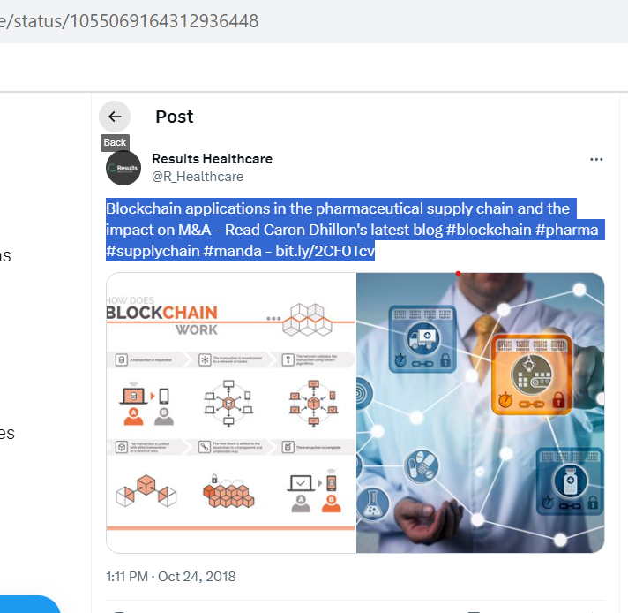

TweetID : 1230722655126347777

UserID : RIyengar13

Profession: Industry Expert

Tweet : Thanks [@IBMBlockchain](https://twitter.com/IBMBlockchain) team for including my post with [@jwoods_57](https://twitter.com/jwoods_57) on [#productauthenticity](https://twitter.com/hashtag/productauthenticity?src=hashtag_click) in [#SupplyChain](https://twitter.com/hashtag/SupplyChain?src=hashtag_click) solving issues in [#food](https://twitter.com/hashtag/food?src=hashtag_click), in [#pharma](https://twitter.com/hashtag/pharma?src=hashtag_click) [#counterfeitdrugs](https://twitter.com/hashtag/counterfeitdrugs?src=hashtag_click), in [#conflictminerals](https://twitter.com/hashtag/conflictminerals?src=hashtag_click) adapted with an excerpt of our book [#Enterprise](https://twitter.com/hashtag/Enterprise?src=hashtag_click) [#Blockchain](https://twitter.com/hashtag/Blockchain?src=hashtag_click) Has Arrived

TweetID : 1230115217419403265

UserID : IBMBlockchain

Profession: Organization

Tweet : "This technological breakthrough has now made it possible to quickly verify the [#authenticity](https://twitter.com/hashtag/authenticity?src=hashtag_click) of products such as premium olive oil or [#fair](https://twitter.com/hashtag/fair?src=hashtag_click) trade coffee, as well as the origin and processing of “conflict-free” minerals" [#blockchain](https://twitter.com/hashtag/blockchain?src=hashtag_click) [#technology](https://twitter.com/hashtag/technology?src=hashtag_click)

TweetID : 1191154746582851585

UserID : vishalpanchal85

Profession: Industry

Tweet : BUSINESSES are using [#blockchain](https://twitter.com/hashtag/blockchain?src=hashtag_click)’s  key features to drive efficiency in existing business processes & enable new business models. [http://buff.ly/2pgKVka](https://t.co/iEAxsE9oyz) [@EverestGroup](https://twitter.com/EverestGroup) via [@antgrasso](https://twitter.com/antgrasso) [#SmartContracts](https://twitter.com/hashtag/SmartContracts?src=hashtag_click) [#DigitalTransformation](https://twitter.com/hashtag/DigitalTransformation?src=hashtag_click) [#HealthTech](https://twitter.com/hashtag/HealthTech?src=hashtag_click) [#pharma](https://twitter.com/hashtag/pharma?src=hashtag_click) [#supplychain](https://twitter.com/hashtag/supplychain?src=hashtag_click) [#IIoT](https://twitter.com/hashtag/IIoT?src=hashtag_click)

TweetID : 1397213661396099075

UserID : p14416575

Profession: Individual

Tweet : I can see only one project which could be one of the [#blockchain](https://twitter.com/hashtag/blockchain?src=hashtag_click) winners in next 4 year according to [@ChainCouncil](https://twitter.com/ChainCouncil) trends. [$TRAC](https://twitter.com/search?q=%24TRAC&src=cashtag_click) has already working product in [#pharma](https://twitter.com/hashtag/pharma?src=hashtag_click) [#supplychain](https://twitter.com/hashtag/supplychain?src=hashtag_click) [#crossbording](https://twitter.com/hashtag/crossbording?src=hashtag_click) trades.... more about it:<https://origintrailexplained.info>

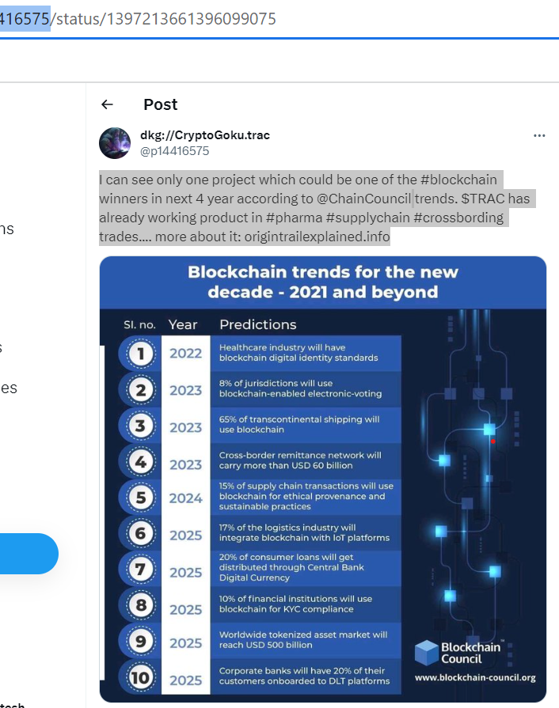

TweetID : 1123250571794763778

UserID : alvie_barr

Profession: Community

Tweet : Multi-state pilot, approved by [@US_FDA](https://twitter.com/US_FDA), will use [#blockchain](https://twitter.com/hashtag/blockchain?src=hashtag_click) to better track specialty prescription drugs Link: [https://fiercehealthcare.com/tech/university-health-system-wakemed-testing-blockchain-to-track-specialty-prescriptions…](https://t.co/0MpW5ngiO2) [@HeatherLandi](https://twitter.com/HeatherLandi) [@FierceHealth](https://twitter.com/FierceHealth) [@IU_Health](https://twitter.com/IU_Health) [#healthcare](https://twitter.com/hashtag/healthcare?src=hashtag_click) [#IoT](https://twitter.com/hashtag/IoT?src=hashtag_click) [#IoMT](https://twitter.com/hashtag/IoMT?src=hashtag_click) [#HealthIT](https://twitter.com/hashtag/HealthIT?src=hashtag_click) [#interoperability](https://twitter.com/hashtag/interoperability?src=hashtag_click) [#pharma](https://twitter.com/hashtag/pharma?src=hashtag_click) [#PatientOutcomes](https://twitter.com/hashtag/PatientOutcomes?src=hashtag_click) [#PatientSafety](https://twitter.com/hashtag/PatientSafety?src=hashtag_click) [#SupplyChain](https://twitter.com/hashtag/SupplyChain?src=hashtag_click)

TweetID : 1115282828785332224

UserID : 23_consulting

Profession: Community

Tweet : The Center for Supply Chain Studies published a very comprehensive white paper on The Drug Supply Chain Security Act [#DSCSA](https://twitter.com/hashtag/DSCSA?src=hashtag_click) and [#Blockchain](https://twitter.com/hashtag/Blockchain?src=hashtag_click) for stakeholders in the [#Pharmaceutical](https://twitter.com/hashtag/Pharmaceutical?src=hashtag_click) supply chain Download it here: [https://c4scs.org/request-white-paper-blockchain-study-1…](https://t.co/LDBwAKXfs5) [#Pharma](https://twitter.com/hashtag/Pharma?src=hashtag_click) [#SupplyChain](https://twitter.com/hashtag/SupplyChain?src=hashtag_click) [#DLT](https://twitter.com/hashtag/DLT?src=hashtag_click)

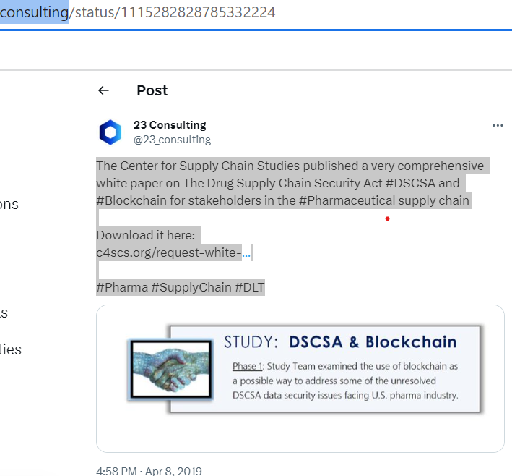

TweetID : 1226800527046062081

UserID : ACGWorld

Profession: Organization

Tweet : ACG [#Inspection](https://twitter.com/hashtag/Inspection?src=hashtag_click) launches a new [#blockchain](https://twitter.com/hashtag/blockchain?src=hashtag_click)-based solution that also features [#ArtificialIntelligence](https://twitter.com/hashtag/ArtificialIntelligence?src=hashtag_click) ([#AI](https://twitter.com/hashtag/AI?src=hashtag_click)) and [#Internet](https://twitter.com/hashtag/Internet?src=hashtag_click) of Things ([#IoT](https://twitter.com/hashtag/IoT?src=hashtag_click)), which would help pharma companies ensure tight monitoring of their packaged products through the entire [#supplychain](https://twitter.com/hashtag/supplychain?src=hashtag_click). [https://buff.ly/31Eyspv](https://t.co/k3z5IImPsn)

TweetID : 1255036020141277184

UserID : OpenLedgerDC

Profession: Community

Tweet : Introducing a [#blockchain](https://twitter.com/hashtag/blockchain?src=hashtag_click) -based 'smart' warehouse: a new way to improve the distribution of pharmaceuticals.

TweetID : 1040209240642740225

UserID : 1Paulrichardson

Profession: Individual

Tweet : Blockchain has the potential to bring enormous change to the supply chain industry. Nowhere is this more pronounced than in the pharmaceuticals. [http://bit.ly/2QrLDnE](https://t.co/GQ7MKwWDb6) [#blockchain](https://twitter.com/hashtag/blockchain?src=hashtag_click) [#pharma](https://twitter.com/hashtag/pharma?src=hashtag_click) [#supplychain](https://twitter.com/hashtag/supplychain?src=hashtag_click)

TweetID : 1049272257644642306

UserID : Atmosphere05com

Profession: Community

Tweet : Artificial intelligence and blockchain are powerful individually, but combining the two may be the key to truly impactful big data analytics [#AI](https://twitter.com/hashtag/AI?src=hashtag_click) [#ArtificialIntelligence](https://twitter.com/hashtag/ArtificialIntelligence?src=hashtag_click) [#Blockchain](https://twitter.com/hashtag/Blockchain?src=hashtag_click) [#Data](https://twitter.com/hashtag/Data?src=hashtag_click) [#ML](https://twitter.com/hashtag/ML?src=hashtag_click) [#machinelearning](https://twitter.com/hashtag/machinelearning?src=hashtag_click) [#SupplyChain](https://twitter.com/hashtag/SupplyChain?src=hashtag_click) [#pharma](https://twitter.com/hashtag/pharma?src=hashtag_click) [#health](https://twitter.com/hashtag/health?src=hashtag_click) [#healthcare](https://twitter.com/hashtag/healthcare?src=hashtag_click) [#EHR](https://twitter.com/hashtag/EHR?src=hashtag_click)

TweetID : 1222083166887804928

UserID : MediConnectUK

Profession: Community

Tweet : [#MediConnect](https://twitter.com/hashtag/MediConnect?src=hashtag_click) is the only [#blockchain](https://twitter.com/hashtag/blockchain?src=hashtag_click) solution intended to revolutionise the use of medication in the UK. It will provide traceability of drugs all the way through the [#supplychain](https://twitter.com/hashtag/supplychain?src=hashtag_click) enabling the removal of false medicines within the Pharma system.

TweetID : 1375122777825546243

UserID : com/Infosys

Profession: Organization

Tweet : Introducing the new Infosys [#Blockchain](https://twitter.com/hashtag/Blockchain?src=hashtag_click) Pharma [#SupplyChain](https://twitter.com/hashtag/SupplyChain?src=hashtag_click) Solution that brings trust, transparency, and efficiency across the [#valuechain](https://twitter.com/hashtag/valuechain?src=hashtag_click). Know more. [https://infy.com/3tUa3co](https://t.co/o6QKrdHu8g)

TweetID : 1010179855135019009

UserID : IoTslam

Profession: Community

Tweet : There is a lot going on with [#Blockchain](https://twitter.com/hashtag/Blockchain?src=hashtag_click) in the Pharma [#SupplyChain](https://twitter.com/hashtag/SupplyChain?src=hashtag_click) space, yet little attention is being placed on hospitals – hence starting with [#IoT](https://twitter.com/hashtag/IoT?src=hashtag_click) [@jimsabogal](https://twitter.com/jimsabogal) [#IoTSlam](https://twitter.com/hashtag/IoTSlam?src=hashtag_click) [#IoTCommunity](https://twitter.com/hashtag/IoTCommunity?src=hashtag_click) [#strategy](https://twitter.com/hashtag/strategy?src=hashtag_click) [#Pharma](https://twitter.com/hashtag/Pharma?src=hashtag_click) [#MedicalDevice](https://twitter.com/hashtag/MedicalDevice?src=hashtag_click) [#HealthIT](https://twitter.com/hashtag/HealthIT?src=hashtag_click) [#cloudcomputing](https://twitter.com/hashtag/cloudcomputing?src=hashtag_click) [#IoT](https://twitter.com/hashtag/IoT?src=hashtag_click) [#Blockchain](https://twitter.com/hashtag/Blockchain?src=hashtag_click)

TweetID : 1149310437936308225

UserID : peteharrislp

Profession: Industry Expert

Tweet : I just wrote this blog about [#blockchain](https://twitter.com/hashtag/blockchain?src=hashtag_click) for [#supplychain](https://twitter.com/hashtag/supplychain?src=hashtag_click). The TL;DR is - it's real, especially in food, agriculture and pharma. Oh, and there's even a mention of [#QuantumComputing](https://twitter.com/hashtag/QuantumComputing?src=hashtag_click) in this one.

TweetID : 1123182904820023297

UserID : RushdiSiddiqui

Profession: Industry Expert

Tweet : The inefficiency n lack of transparency in [#Supplychain](https://twitter.com/hashtag/Supplychain?src=hashtag_click), for [#food](https://twitter.com/hashtag/food?src=hashtag_click) or precious minerals or [#pharma](https://twitter.com/hashtag/pharma?src=hashtag_click)/[#drugs](https://twitter.com/hashtag/drugs?src=hashtag_click) and so on, not only increases costs to end customer but also raises health risks, hence, [#blockchain](https://twitter.com/hashtag/blockchain?src=hashtag_click) presents one solution, but behavior modification as required, tech helps

TweetID : 1120995122055979009

UserID : shepwedd

Profession: Organization

Tweet : Head of pharma and life sciences Joanna Boag-Thomson details how [#blockchain](https://twitter.com/hashtag/blockchain?src=hashtag_click) technology could improve collaboration and [#supplychain](https://twitter.com/hashtag/supplychain?src=hashtag_click) management in the [#healthcare](https://twitter.com/hashtag/healthcare?src=hashtag_click) and [#lifesciences](https://twitter.com/hashtag/lifesciences?src=hashtag_click) industry.

TweetID : 1266430715924627456

UserID : unblockedfuture

Profession: Industry Expert

Tweet : Covid19 brought visibility to long-festering problems in the medical supply chain—yet [#blockchain](https://twitter.com/hashtag/blockchain?src=hashtag_click) gives hope. Check out my article in [@HarvardBiz](https://twitter.com/HarvardBiz) to see how [#pharma](https://twitter.com/hashtag/pharma?src=hashtag_click) is making inroads for truth in the [#SupplyChain](https://twitter.com/hashtag/SupplyChain?src=hashtag_click).

TweetID : 1105459590471266309

UserID : LedgerInsights

Profession: Community

Tweet : Yesterday [@TraceLink](https://twitter.com/TraceLink) announced a [#blockchain](https://twitter.com/hashtag/blockchain?src=hashtag_click) pharma pilot. Last month the [@US_FDA](https://twitter.com/US_FDA) announced a pilot program for the [#pharma](https://twitter.com/hashtag/pharma?src=hashtag_click) industry to help to trace [#drugs](https://twitter.com/hashtag/drugs?src=hashtag_click). Everyone in the pharma [#SupplyChain](https://twitter.com/hashtag/SupplyChain?src=hashtag_click) needs to comply with the DCSCA legislation by 2023

TweetID : 1109817148518682624

UserID : StephTweetChat

Profession: Industry Expert

Tweet : Many experts think that [#PatientSafety](https://twitter.com/hashtag/PatientSafety?src=hashtag_click), enhanced drug surveillance, & the integrity of drug [#SupplyChain](https://twitter.com/hashtag/SupplyChain?src=hashtag_click) will be secured by [#blockchain](https://twitter.com/hashtag/blockchain?src=hashtag_click). [#HealthTech](https://twitter.com/hashtag/HealthTech?src=hashtag_click) [#Data](https://twitter.com/hashtag/Data?src=hashtag_click) [#Pharma](https://twitter.com/hashtag/Pharma?src=hashtag_click) [#EmergingTech](https://twitter.com/hashtag/EmergingTech?src=hashtag_click) [#Interoperability](https://twitter.com/hashtag/Interoperability?src=hashtag_click) [#Technology](https://twitter.com/hashtag/Technology?src=hashtag_click) [#Tech](https://twitter.com/hashtag/Tech?src=hashtag_click) [#Innovation](https://twitter.com/hashtag/Innovation?src=hashtag_click)<https://lnkd.in/eJQVe6d>

TweetID : 1324799282902372362

UserID : BakerHostetler

Profession: Organization

Tweet : Robert A. Musiala Jr., Esq., CFCS will present "Blockchain for Enterprise: Legal and Business Issues," which focuses on the food, cobalt and pharma supply chains at the virtual Trufflecon Blockchain Developer Conference. [#blockchain](https://twitter.com/hashtag/blockchain?src=hashtag_click) [#supplychain](https://twitter.com/hashtag/supplychain?src=hashtag_click)

TweetID : 1134678478232739840

UserID : StephTweetChat

Profession: Community

Tweet : Pfizer Inc., has joined with MediLedger Project Contracting and Chargebacks working group to find a blockchain-based solution to the inefficiencies found within the industry’s supply chain pricing and eligibility contracts.

TweetID : 1716384846245707796

UserID : AppikrLabs

Profession: Organization

Tweet : Ready to explore the benefits of blockchain app development? Our ultimate blog on Blockchain’s Impact on Healthcare with the knowledge of blockchain to thrive in the healthcare industry. [#healthcare](https://twitter.com/hashtag/healthcare?src=hashtag_click) [#healthMobileApps](https://twitter.com/hashtag/healthMobileApps?src=hashtag_click) [#blockchain](https://twitter.com/hashtag/blockchain?src=hashtag_click) Read more: [https://appikr.com/blog/blockchain-impact-on-healthcare-comprehensive-guide/](https://t.co/9azpU5e9mB)

TweetID : 1716425237288423926

UserID : SingingInDCloud

Profession: Community

Tweet : Those who claim blockchain is only suitable for the financial sector have a limited view. Its immutability, transparency, and traceability are essential for many sectors, among which healthcare stands out. Rt [@antgrasso](https://twitter.com/antgrasso) [#blockchain](https://twitter.com/hashtag/blockchain?src=hashtag_click) [#healthcare](https://twitter.com/hashtag/healthcare?src=hashtag_click)

TweetID : 1715216334873653342

UserID : hati_intl

Profession: Community

Tweet : Blockchain addresses five major healthcare pain points.

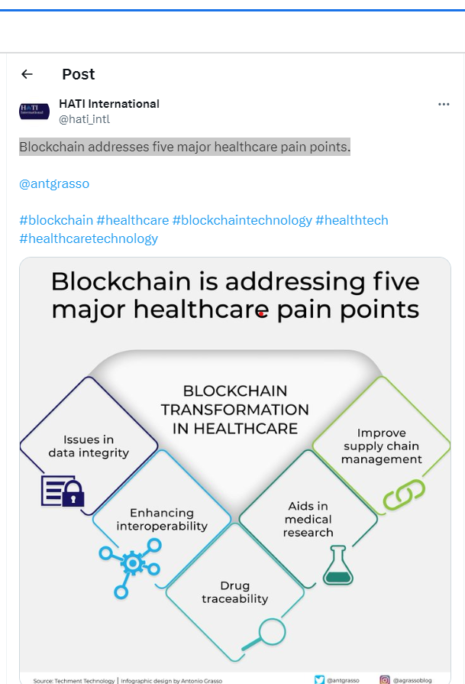

TweetID : 1716811063826760112

UserID : dInnovaTrain

Profession: Community

Tweet : Blockchain technology can transform healthcare by placing patients at the center of the healthcare ecosystem and improving healthcare data security, privacy, and interoperability. Source [@techmenttech](https://twitter.com/techmenttech) Link [http://bit.ly/3fH4h9l](https://t.co/Uj0DfYOyOb) rt [@antgrasso](https://twitter.com/antgrasso) [#HealthTech](https://twitter.com/hashtag/HealthTech?src=hashtag_click) [#blockchain](https://twitter.com/hashtag/blockchain?src=hashtag_click) [#Healthcare](https://twitter.com/hashtag/Healthcare?src=hashtag_click)

TweetID : 1714097395749757434

UserID : IRIS_CHAIN

Profession: Organization

Tweet : We aim to develop an [#application](https://twitter.com/hashtag/application?src=hashtag_click)-based smart [#healthcare](https://twitter.com/hashtag/healthcare?src=hashtag_click) [#blockchain](https://twitter.com/hashtag/blockchain?src=hashtag_click) service that enhances user convenience based on [#bio](https://twitter.com/hashtag/bio?src=hashtag_click) [#data](https://twitter.com/hashtag/data?src=hashtag_click).

TweetID : 1715204930792051106

UserID : simplyfitech

Profession: Organization

Tweet : Decentralization eliminates the possibility of a single point of failure by preventing any one entity from controlling the whole network. [#decentralization](https://twitter.com/hashtag/decentralization?src=hashtag_click) [#blockchain](https://twitter.com/hashtag/blockchain?src=hashtag_click) [#wealth](https://twitter.com/hashtag/wealth?src=hashtag_click) [#healthcare](https://twitter.com/hashtag/healthcare?src=hashtag_click)

TweetID : 1714768814175338649

UserID : YakuzaKokae

Profession: Individual

Tweet : Immutability, transparency, and traceability are essential for many sectors, among which healthcare stands out. Those who claim blockchain is only suitable for the financial sector have a limited view. [#Blockchain](https://twitter.com/hashtag/Blockchain?src=hashtag_click) [#Healthcare](https://twitter.com/hashtag/Healthcare?src=hashtag_click) [#Transparency](https://twitter.com/hashtag/Transparency?src=hashtag_click)

TweetID : 1716847105892098253

UserID : BluewheelM

Profession: Community

Tweet : Bitcoin, More than Money: While Bitcoin is a digital currency, its underlying [#blockchain](https://twitter.com/hashtag/blockchain?src=hashtag_click) technology has far-reaching implications across industries. Let's dive into how it's revolutionizing sectors like [#healthcare](https://twitter.com/hashtag/healthcare?src=hashtag_click), supply chain management, and beyond. 

TweetID : 1039754135871152129

UserID : anylsite

Profession: Community

Tweet : Thanks to [http://jsb-solutions.com](https://t.co/1QGeZe8RO8) for meeting with us and discussing [#blockchain](https://twitter.com/hashtag/blockchain?src=hashtag_click) opportunities within the pharma [#SupplyChain](https://twitter.com/hashtag/SupplyChain?src=hashtag_click), among others!

TweetID : 1603326440245977088

UserID : krypctalk

Profession: Community

Tweet : Check out the article: How blockchain technology is here to revolutionise the Pharmaceutical industry. [https://medium.com/@krypcblockchain/evolving-pharmaceutical-industry-with-blockchain-technology-f0fe0a2d147…](https://t.co/72Gwjp1n9L) [#pharma](https://twitter.com/hashtag/pharma?src=hashtag_click) [#supplychain](https://twitter.com/hashtag/supplychain?src=hashtag_click) [#blockchaintechnology](https://twitter.com/hashtag/blockchaintechnology?src=hashtag_click) [#blockchain](https://twitter.com/hashtag/blockchain?src=hashtag_click) [#healthcare](https://twitter.com/hashtag/healthcare?src=hashtag_click) [#digitalhealth](https://twitter.com/hashtag/digitalhealth?src=hashtag_click) [#medtech](https://twitter.com/hashtag/medtech?src=hashtag_click) [#technology](https://twitter.com/hashtag/technology?src=hashtag_click) [#web3solutions](https://twitter.com/hashtag/web3solutions?src=hashtag_click) [#web3](https://twitter.com/hashtag/web3?src=hashtag_click)

TweetID : 1523950124791382017

UserID : pharma_outlook

Profession: Community

Tweet : How [#Technology](https://twitter.com/hashtag/Technology?src=hashtag_click) is transforming the Pharma [#SupplyChain](https://twitter.com/hashtag/SupplyChain?src=hashtag_click) [#Pharma](https://twitter.com/hashtag/Pharma?src=hashtag_click) supply chain has always been recalled as the most complicated and strained network amongst all By [@AbhrasnataDas](https://twitter.com/AbhrasnataDas), Correspondent, [#IndiaPharmaOutlook](https://twitter.com/hashtag/IndiaPharmaOutlook?src=hashtag_click) Read More: [https://cutt.ly/UHwsl6h](https://t.co/jHqDcVAwfo) [#Blockchain](https://twitter.com/hashtag/Blockchain?src=hashtag_click) [#Datascience](https://twitter.com/hashtag/Datascience?src=hashtag_click)

TweetID : 1055069164312936448

UserID : R_Healthcare

Profession: Community

Tweet : Blockchain applications in the pharmaceutical supply chain and the impact on M&A - Read Caron Dhillon's latest blog [#blockchain](https://twitter.com/hashtag/blockchain?src=hashtag_click) [#pharma](https://twitter.com/hashtag/pharma?src=hashtag_click) [#supplychain](https://twitter.com/hashtag/supplychain?src=hashtag_click) [#manda](https://twitter.com/hashtag/manda?src=hashtag_click)

TweetID : 1010179855135019009

UserID : IoTslam

Profession: Community

Tweet : There is a lot going on with [#Blockchain](https://twitter.com/hashtag/Blockchain?src=hashtag_click) in the Pharma [#SupplyChain](https://twitter.com/hashtag/SupplyChain?src=hashtag_click) space, yet little attention is being placed on hospitals – hence starting with [#IoT](https://twitter.com/hashtag/IoT?src=hashtag_click) [@jimsabogal](https://twitter.com/jimsabogal) [#IoTSlam](https://twitter.com/hashtag/IoTSlam?src=hashtag_click) [#IoTCommunity](https://twitter.com/hashtag/IoTCommunity?src=hashtag_click) [#strategy](https://twitter.com/hashtag/strategy?src=hashtag_click) [#Pharma](https://twitter.com/hashtag/Pharma?src=hashtag_click) [#MedicalDevice](https://twitter.com/hashtag/MedicalDevice?src=hashtag_click) [#HealthIT](https://twitter.com/hashtag/HealthIT?src=hashtag_click) [#cloudcomputing](https://twitter.com/hashtag/cloudcomputing?src=hashtag_click) [#IoT](https://twitter.com/hashtag/IoT?src=hashtag_click) [#Blockchain](https://twitter.com/hashtag/Blockchain?src=hashtag_click)

TweetID : 989209978509590528

UserID : OliverWightEAME

Profession: Community

Tweet : [#Pharma](https://twitter.com/hashtag/Pharma?src=hashtag_click) [#supplychain](https://twitter.com/hashtag/supplychain?src=hashtag_click) leaders: how well managed is your [#data](https://twitter.com/hashtag/data?src=hashtag_click)? Are you ready for the '[#Blockchain](https://twitter.com/hashtag/Blockchain?src=hashtag_click) Revolution'? We take a look at the facts in our latest blog: [http://ow.ly/gw5g30jzwiu](https://t.co/kJQLgqVUnB)

TweetID : 1120296519435988992

UserID : Sofrigam

Profession: Community

Tweet : A [#Blockchain](https://twitter.com/hashtag/Blockchain?src=hashtag_click) protocol discovered by a researcher at Portland University could prevent [#counterfeit](https://twitter.com/hashtag/counterfeit?src=hashtag_click) [#pharmaceutical](https://twitter.com/hashtag/pharmaceutical?src=hashtag_click) sales : [https://sciencedaily.com/releases/2019/04/190415154651.htm…](https://t.co/IDRXVfx4qk) [@ScienceDaily](https://twitter.com/ScienceDaily) [#pharma](https://twitter.com/hashtag/pharma?src=hashtag_click) [#supplychain](https://twitter.com/hashtag/supplychain?src=hashtag_click)

TweetID : 1285578625039790081

UserID : GoSpaceX

Profession: Community

Tweet :  [$AMB](https://twitter.com/search?q=%24AMB&src=cashtag_click) Ambrosus on the right track Top 10 Logistics Industry Trends & Innovations: 2020 & Beyond Belizean [#startup](https://twitter.com/hashtag/startup?src=hashtag_click) Ambrosus builds a [#Blockchain](https://twitter.com/hashtag/Blockchain?src=hashtag_click)-based end-to-end [#IoT](https://twitter.com/hashtag/IoT?src=hashtag_click) network for the food and pharma [#supplychain](https://twitter.com/hashtag/supplychain?src=hashtag_click) sectors. [#cryptocurrency](https://twitter.com/hashtag/cryptocurrency?src=hashtag_click) [#Crypto](https://twitter.com/hashtag/Crypto?src=hashtag_click) [#altcoin](https://twitter.com/hashtag/altcoin?src=hashtag_click)

TweetID : 1641338220729303040

UserID : alisonldoughty

Profession: Industry Expert

Tweet : MyHealthVerse will accumulate [#biomarkers](https://twitter.com/hashtag/biomarkers?src=hashtag_click) and synthetic data and analyze using [#AI](https://twitter.com/hashtag/AI?src=hashtag_click) before they get converted to [#NFTs](https://twitter.com/hashtag/NFTs?src=hashtag_click) and made available to [#pharma](https://twitter.com/hashtag/pharma?src=hashtag_click) and [#biotech](https://twitter.com/hashtag/biotech?src=hashtag_click) companies.  [#blockchain](https://twitter.com/hashtag/blockchain?src=hashtag_click) [#blockchainhealth](https://twitter.com/hashtag/blockchainhealth?src=hashtag_click)

TweetID : 1640337878113824768

UserID : Gyan_Consulting

Profession: Organization

Tweet : Blockchain technology allows healthcare providers to securely store and share patient data, including medical records and test results [#blockchain](https://twitter.com/hashtag/blockchain?src=hashtag_click) [#digitalhealth](https://twitter.com/hashtag/digitalhealth?src=hashtag_click) [#pharma](https://twitter.com/hashtag/pharma?src=hashtag_click) [#enterpriseblockchain](https://twitter.com/hashtag/enterpriseblockchain?src=hashtag_click) [#gyanconsulting](https://twitter.com/hashtag/gyanconsulting?src=hashtag_click)

TweetID : 1636624237640163331

UserID : EricGail

Profession: Industry

Tweet : Jane Lyons, Country Manager of PharmaLex Ireland, shares her insights on the top trends that will shape the sector this year, from the adoption of [#AI](https://twitter.com/hashtag/AI?src=hashtag_click) to [#blockchain](https://twitter.com/hashtag/blockchain?src=hashtag_click) technology and advancements in [#DigitalHealth](https://twitter.com/hashtag/DigitalHealth?src=hashtag_click). Very worth reading. [#Pharma](https://twitter.com/hashtag/Pharma?src=hashtag_click)

TweetID : 1635658831198842887

UserID : BrackenData

Profession: Community

Tweet : We’ve all come to recognize the rise and fall pattern of major trends that take hold in our world, as well as those that stick around. In this blog post, we delve into the Web3 and blockchain-related tech that will last in the space: [https://hubs.la/Q01DFDCR0](https://t.co/MRQbPXche8) [#Blockchain](https://twitter.com/hashtag/Blockchain?src=hashtag_click) [#Pharma](https://twitter.com/hashtag/Pharma?src=hashtag_click)

TweetID : 1635583416459468800

UserID : pharmatrace

Profession: Community

Tweet : In this article we tell how PharmaTrace smart contracts will change the pharma business. Please contact us to know the details of our solutions. [#blockchain](https://twitter.com/hashtag/blockchain?src=hashtag_click) [#pharmatrace](https://twitter.com/hashtag/pharmatrace?src=hashtag_click) [#supplychain](https://twitter.com/hashtag/supplychain?src=hashtag_click) [#smartcontracts](https://twitter.com/hashtag/smartcontracts?src=hashtag_click) [#pharma](https://twitter.com/hashtag/pharma?src=hashtag_click) [#pharmaceuticalindustry](https://twitter.com/hashtag/pharmaceuticalindustry?src=hashtag_click)

TweetID : 1628360063734927361

UserID : DataDynamicsInc

Profession: Organization

Tweet : [#Data](https://twitter.com/hashtag/Data?src=hashtag_click) integrity issues have plagued the [#pharma](https://twitter.com/hashtag/pharma?src=hashtag_click) industry since its inception. [#Blockchain](https://twitter.com/hashtag/Blockchain?src=hashtag_click), with its potential to assist in processes from product serialization to data flow tracking, could be the best solution yet. [https://medtechintelligence.com/column/blockchain-can-solve-pharmas-costly-data-integrity-problem/…](https://t.co/TTLqXvX5ag) [#BigData](https://twitter.com/hashtag/BigData?src=hashtag_click) [#Analytics](https://twitter.com/hashtag/Analytics?src=hashtag_click) [#TechnologyNews](https://twitter.com/hashtag/TechnologyNews?src=hashtag_click)

TweetID : 1624567393358954499

UserID : BHTYJournal

Profession: Community

Tweet : "[@PharmaLedger](https://twitter.com/PharmaLedger): Blockchain-Enabled Healthcare- Privacy-Enhancement [https://youtu.be/XwIB03uEgQE](https://t.co/CJedconjmJ) via [@YouTube](https://twitter.com/YouTube) [#blockchain](https://twitter.com/hashtag/blockchain?src=hashtag_click) [#privacy](https://twitter.com/hashtag/privacy?src=hashtag_click) [#identity](https://twitter.com/hashtag/identity?src=hashtag_click) [#pharma](https://twitter.com/hashtag/pharma?src=hashtag_click) [#ConV2X](https://twitter.com/hashtag/ConV2X?src=hashtag_click) [#BHTY](https://twitter.com/hashtag/BHTY?src=hashtag_click) [#blockchainevnt](https://twitter.com/hashtag/blockchainevnt?src=hashtag_click) [#sympsoium](https://twitter.com/hashtag/sympsoium?src=hashtag_click)

TweetID : 1624000240528289792

UserID : DrDavidFBeach

Profession: Industry Expert

Tweet : [#Blockchain](https://twitter.com/hashtag/Blockchain?src=hashtag_click) and other Web 3.0 technologies promise to create new therapeutic experiences while honoring the privacy of patient data. But, shared industry standards are necessary for reaching this potential. [#Pharma](https://twitter.com/hashtag/Pharma?src=hashtag_click) [https://tiny-link.io/6ki0AmzcOTayrhEzdGMu](https://t.co/owbNchm8xn)

TweetID : 1622457107097190402

UserID : FCE_GROUP_AG

Profession: Organization

Tweet : [#Blockchain](https://twitter.com/hashtag/Blockchain?src=hashtag_click) could rid [#pharma](https://twitter.com/hashtag/pharma?src=hashtag_click) [#supplychains](https://twitter.com/hashtag/supplychains?src=hashtag_click) of counterfeit, improperly stored, and expired drugs. And it could also seriously improve overall contemporary [#healthcare](https://twitter.com/hashtag/healthcare?src=hashtag_click), and some companies are already moving towards it. [https://fcegroup.ch/n/bt](https://t.co/JpyObENGwW)

TweetID : 1621630054332596225

UserID : DPtechtrueup

Profession: Individual

Tweet : The Influence of Blockchain Technologies in the Healthcare Industry [http://ow.ly/Ehvp50MJ1vM](https://t.co/Brj5GftOmv) [#Pharma](https://twitter.com/hashtag/Pharma?src=hashtag_click) [#Blockchain](https://twitter.com/hashtag/Blockchain?src=hashtag_click) [#Technology](https://twitter.com/hashtag/Technology?src=hashtag_click) [#Healthcare](https://twitter.com/hashtag/Healthcare?src=hashtag_click)

TweetID : 1618900938680401920

UserID : EricGail

Profession: Organization Industry Expert Community Individual

Tweet : [#Blockchain](https://twitter.com/hashtag/Blockchain?src=hashtag_click) offers a powerful solution to the global counterfeit drug problem, providing transparency and security to [#Pharma](https://twitter.com/hashtag/Pharma?src=hashtag_click) companies' [#SupplyChains](https://twitter.com/hashtag/SupplyChains?src=hashtag_click) and helping to reduce drug abuse. It has the potential to revolutionize the industry.<https://tiny-link.io/M3oV9AvbkNSSz03ngXBo>

TweetID : 1616718129098522625

UserID : Be_CREDIBLE

Profession: Community

Tweet : Our Co-founder & CEO, Mr. Jitesh Shetty will address an audience at the 72nd Indian Pharmaceutical Congress (IPC), Nagpur about Blockchain Technology in Pharmaceutical Sciences & Drug Discovery Process. [#IndianPharmaceuticalCongress](https://twitter.com/hashtag/IndianPharmaceuticalCongress?src=hashtag_click) [#IPC](https://twitter.com/hashtag/IPC?src=hashtag_click) [#pharmaceutical](https://twitter.com/hashtag/pharmaceutical?src=hashtag_click) [#Pharma](https://twitter.com/hashtag/Pharma?src=hashtag_click) [#blockchain](https://twitter.com/hashtag/blockchain?src=hashtag_click)

TweetID : 1616373622653829120

UserID : 2amtech

Profession: Community

Tweet :Blockchain has been around in the [#banking](https://twitter.com/hashtag/banking?src=hashtag_click), [#finance](https://twitter.com/hashtag/finance?src=hashtag_click) and [#pharma](https://twitter.com/hashtag/pharma?src=hashtag_click) industries for some time now. However, for [#healthcare](https://twitter.com/hashtag/healthcare?src=hashtag_click), it holds the potential to solve long-standing challenges of the complex workflows within organizations.

TweetID : 1616318368075718656

UserID : Sven_Loeffler

Profession: Industry Expert

Tweet :[#Pharma](https://twitter.com/hashtag/Pharma?src=hashtag_click) is a $2T industry with a lot at stake in managing the [#SupplyChain](https://twitter.com/hashtag/SupplyChain?src=hashtag_click). [#Blockchain](https://twitter.com/hashtag/Blockchain?src=hashtag_click) can provide transparency, enhanced traceability, and improved quality control to ensure drugs remain safe and effective.

TweetID : 1616034985659490307

UserID : HLLifeSciences

Profession: Community

Tweet : [#ATMPs](https://twitter.com/hashtag/ATMPs?src=hashtag_click) and [#blockchain](https://twitter.com/hashtag/blockchain?src=hashtag_click) technology represent two of the most promising current developments in the [#pharma](https://twitter.com/hashtag/pharma?src=hashtag_click) and [#technology](https://twitter.com/hashtag/technology?src=hashtag_click) sectors. The article by our lawyers considers the potential benefits blockchain technology may have in the ATMP supply chain. [https://bit.ly/3QXwl9W](https://t.co/gUhACRhaZZ)

TweetID : 1615631623025790976

UserID : PharmTechTrends

Profession: Community

Tweet :Modern pharma supply chain systems are complicated. Learn more about how a blockchain-based framework can be utilized to enhance transparency and safety. [#pharma](https://twitter.com/hashtag/pharma?src=hashtag_click) [#manufacturing](https://twitter.com/hashtag/manufacturing?src=hashtag_click) [#supplychain](https://twitter.com/hashtag/supplychain?src=hashtag_click) [#blockchain](https://twitter.com/hashtag/blockchain?src=hashtag_click) [#smartcontracts](https://twitter.com/hashtag/smartcontracts?src=hashtag_click) [https://bit.ly/3wcUtf4](https://t.co/sGPg717Bid)

TweetID : 1614883856213065728

UserID : CSiepler

Profession: Industry Expert

Tweet : [#Pharma](https://twitter.com/hashtag/Pharma?src=hashtag_click) is a $2T industry with a lot at stake in managing the [#SupplyChain](https://twitter.com/hashtag/SupplyChain?src=hashtag_click). [#Blockchain](https://twitter.com/hashtag/Blockchain?src=hashtag_click) can provide transparency, enhanced traceability, and improved quality control to ensure drugs remain safe and effective. [https://link-shortener.io/Mp1bXBcDmHCqItVUC8HT](https://t.co/37NjWrvaR9)

TweetID : 1613167877237923840

UserID : Gyan_Consulting

Profession: Organization

Tweet : Many Pharma companies have already started on their digital transformation journeys with cybersecurity initiatives and adopting new technologies such as additive manufacturing, robotics, analytics, and mobility. [#pharma](https://twitter.com/hashtag/pharma?src=hashtag_click) [#digitaltransformation](https://twitter.com/hashtag/digitaltransformation?src=hashtag_click) [#ai](https://twitter.com/hashtag/ai?src=hashtag_click) [#blockchain](https://twitter.com/hashtag/blockchain?src=hashtag_click) [#digitalhealth](https://twitter.com/hashtag/digitalhealth?src=hashtag_click)

TweetID : 1612724139818733571

UserID : stratesys

Profession: Community

Tweet : [#StratesysPapers](https://twitter.com/hashtag/StratesysPapers?src=hashtag_click) [#Trends](https://twitter.com/hashtag/Trends?src=hashtag_click) #2023 [#Pharma](https://twitter.com/hashtag/Pharma?src=hashtag_click) [@CincoDiascom](https://twitter.com/CincoDiascom) publica las principales conclusiones del estudio recientemente elaborado por el equipo de expertos de [@stratesys](https://twitter.com/stratesys) en la industria [#LifeScences](https://twitter.com/hashtag/LifeScences?src=hashtag_click)  [https://lnkd.in/dY7aqdCv](https://t.co/AusWwLSHLh) - [#ArtificialIntelligence](https://twitter.com/hashtag/ArtificialIntelligence?src=hashtag_click) [#MachineLearning](https://twitter.com/hashtag/MachineLearning?src=hashtag_click) [#Blockchain](https://twitter.com/hashtag/Blockchain?src=hashtag_click)

TweetID : 1607773356895473667

UserID : PharmaCommerce

Profession: Community

Tweet :How [#privacy](https://twitter.com/hashtag/privacy?src=hashtag_click) and [#technology](https://twitter.com/hashtag/technology?src=hashtag_click) literacy can coexist behind a [#blockchain](https://twitter.com/hashtag/blockchain?src=hashtag_click)-based approach to patient [#dataanalytics](https://twitter.com/hashtag/dataanalytics?src=hashtag_click) and controlVishal Singal and Siddhartha Tomar of [@Axtria](https://twitter.com/Axtria)

TweetID : 1606008927145103369

UserID : PharmaProWorld

Profession: Community

Tweet :In recent years, interest in [#Blockchain](https://twitter.com/hashtag/Blockchain?src=hashtag_click) distributed ledger technology has crescendoed & crashed. Boosters of the technology proclaimed that it could revolutionize everything from the [#Pharma](https://twitter.com/hashtag/Pharma?src=hashtag_click)/[#Biotech](https://twitter.com/hashtag/Biotech?src=hashtag_click) [#SupplyChain](https://twitter.com/hashtag/SupplyChain?src=hashtag_click) to business contracts.

TweetID : 1605911220564811776

UserID : HCTriangle

Profession: Organization

Tweet : [#blockchain](https://twitter.com/hashtag/blockchain?src=hashtag_click) accelerates drug development and streamlines the [#clinicaltrial](https://twitter.com/hashtag/clinicaltrial?src=hashtag_click) processes due to its potential to improve interoperability and enhance data sharing. Learn More: [https://bit.ly/3VbIQPC](https://t.co/FdAUfttrS7)

TweetID : 1605507177447399426

UserID : PharmaCommerce

Profession: Community

Tweet : How [#privacy](https://twitter.com/hashtag/privacy?src=hashtag_click) and [#technology](https://twitter.com/hashtag/technology?src=hashtag_click) literacy can coexist behind a [#blockchain](https://twitter.com/hashtag/blockchain?src=hashtag_click)-based approach to patient [#dataanalytics](https://twitter.com/hashtag/dataanalytics?src=hashtag_click) and controlVishal Singal and Siddhartha Tomar of [@Axtria](https://twitter.com/Axtria) [http://ow.ly/puA650M2wxi](https://t.co/8TATyYdLKf) [#pharma](https://twitter.com/hashtag/pharma?src=hashtag_click) [#pharmaceutical](https://twitter.com/hashtag/pharmaceutical?src=hashtag_click) [#patientdata](https://twitter.com/hashtag/patientdata?src=hashtag_click)

TweetID : 1605159671081361409

UserID : Gyan_Consulting

Profession: Organization

Tweet :As the biologics industry continues to grow, biopharmaceutical companies are evaluating continuous processing as a means of improving efficiency. Below are some factors to consider. [#biopharma](https://twitter.com/hashtag/biopharma?src=hashtag_click) [#blockchain](https://twitter.com/hashtag/blockchain?src=hashtag_click) [#biopharmaceutical](https://twitter.com/hashtag/biopharmaceutical?src=hashtag_click) [#pharma](https://twitter.com/hashtag/pharma?src=hashtag_click) [#lifesciences](https://twitter.com/hashtag/lifesciences?src=hashtag_click) [#disruption](https://twitter.com/hashtag/disruption?src=hashtag_click) [#pharmaceutical](https://twitter.com/hashtag/pharmaceutical?src=hashtag_click)

TweetID : 1603423413535756288

UserID : realBillSager

Profession: Industry Expert

Tweet : Innovative [#blockchain](https://twitter.com/hashtag/blockchain?src=hashtag_click) based systems can help [#pharma](https://twitter.com/hashtag/pharma?src=hashtag_click) companies track drugs in transit and ensure they're stored correctly, addressing [#SupplyChain](https://twitter.com/hashtag/SupplyChain?src=hashtag_click) vulnerabilities. Do you think such a solution is coming any time soon? [#iworkforComcast](https://twitter.com/hashtag/iworkforComcast?src=hashtag_click) [http://short-url.us/gABEiklrL9nEnObeCFot](https://t.co/FYn6i1lBv0)

TweetID : 1603326440245977088

UserID : krypctalk

Profession: Community

Tweet : Check out the article: How blockchain technology is here to revolutionise the Pharmaceutical industry. [https://medium.com/@krypcblockchain/evolving-pharmaceutical-industry-with-blockchain-technology-f0fe0a2d147…](https://t.co/72Gwjp1n9L) [#pharma](https://twitter.com/hashtag/pharma?src=hashtag_click) [#supplychain](https://twitter.com/hashtag/supplychain?src=hashtag_click) [#blockchaintechnology](https://twitter.com/hashtag/blockchaintechnology?src=hashtag_click) [#blockchain](https://twitter.com/hashtag/blockchain?src=hashtag_click) [#healthcare](https://twitter.com/hashtag/healthcare?src=hashtag_click) [#digitalhealth](https://twitter.com/hashtag/digitalhealth?src=hashtag_click) [#medtech](https://twitter.com/hashtag/medtech?src=hashtag_click) [#technology](https://twitter.com/hashtag/technology?src=hashtag_click) [#web3solutions](https://twitter.com/hashtag/web3solutions?src=hashtag_click) [#web3](https://twitter.com/hashtag/web3?src=hashtag_click)

TweetID : 1602717521152458752

UserID : paul_savas

Profession: Industry Expert

Tweet : Innovative [#blockchain](https://twitter.com/hashtag/blockchain?src=hashtag_click) based systems can help [#pharma](https://twitter.com/hashtag/pharma?src=hashtag_click) companies track drugs in transit and ensure they're stored correctly, addressing [#SupplyChain](https://twitter.com/hashtag/SupplyChain?src=hashtag_click) vulnerabilities. Do you think such a solution is coming any time soon?

TweetID : 1602645768053161987

UserID : Gyan_Consulting

Profession: Organization

Tweet : AI and digital healthcare are prime examples of growth trends setting up life sciences for long-term sustainability. Here are the best lifesciences trends to consider. [#digitalhealthcare](https://twitter.com/hashtag/digitalhealthcare?src=hashtag_click) [#telehealth](https://twitter.com/hashtag/telehealth?src=hashtag_click) [#LifeSciences](https://twitter.com/hashtag/LifeSciences?src=hashtag_click) [#lifescienceindustry](https://twitter.com/hashtag/lifescienceindustry?src=hashtag_click) [#clinicaltrials](https://twitter.com/hashtag/clinicaltrials?src=hashtag_click) [#pharma](https://twitter.com/hashtag/pharma?src=hashtag_click) [#tech](https://twitter.com/hashtag/tech?src=hashtag_click) [#blockchain](https://twitter.com/hashtag/blockchain?src=hashtag_click)

TweetID : 1600475388068634625

UserID : Gyan_Consulting

Profession: Organization

Tweet : Here are five ways for the Life Sciences industry helping to streamline the entire process from research to approval and delivery of the therapies that patients so desperately need. [#blockchain](https://twitter.com/hashtag/blockchain?src=hashtag_click) [#lifesciences](https://twitter.com/hashtag/lifesciences?src=hashtag_click) [#lifescience](https://twitter.com/hashtag/lifescience?src=hashtag_click) [#healthcare](https://twitter.com/hashtag/healthcare?src=hashtag_click) [#biotechnology](https://twitter.com/hashtag/biotechnology?src=hashtag_click) [#biology](https://twitter.com/hashtag/biology?src=hashtag_click) [#pharma](https://twitter.com/hashtag/pharma?src=hashtag_click) [#biopharma](https://twitter.com/hashtag/biopharma?src=hashtag_click)

TweetID : 1602224418264158208

UserID : PharmTechTrends

Profession: Community

Tweet : These top technologies make healthcare more effective and efficient, improving patient and provider experiences. [#pharma](https://twitter.com/hashtag/pharma?src=hashtag_click) [#AI](https://twitter.com/hashtag/AI?src=hashtag_click) [#machinelearning](https://twitter.com/hashtag/machinelearning?src=hashtag_click) [#blockchain](https://twitter.com/hashtag/blockchain?src=hashtag_click) [#emergingtechnologies](https://twitter.com/hashtag/emergingtechnologies?src=hashtag_click) [#biotechnology](https://twitter.com/hashtag/biotechnology?src=hashtag_click) [#geneediting](https://twitter.com/hashtag/geneediting?src=hashtag_click)

TweetID : 1598648640834265088

UserID : serv_block

Profession: Community

Tweet : Are blockchain solutions currently offering value in the pharmaceutical space? Let us know in the comments [http://bit.ly/3ToK0WY](https://t.co/TUyl0Tg68O) [#blockchain](https://twitter.com/hashtag/blockchain?src=hashtag_click) [#pharmaindustry](https://twitter.com/hashtag/pharmaindustry?src=hashtag_click) [#biotech](https://twitter.com/hashtag/biotech?src=hashtag_click) [#industry40](https://twitter.com/hashtag/industry40?src=hashtag_click) [#pharmaceutical](https://twitter.com/hashtag/pharmaceutical?src=hashtag_click) [#pharma](https://twitter.com/hashtag/pharma?src=hashtag_click) [#gxp](https://twitter.com/hashtag/gxp?src=hashtag_click)

TweetID : 1598286205271310337

UserID : digitrendsinc

Profession: Community

Tweet : Talk about the biggest disruption in the world of technology; Blockchain and NFT-what potential they hold for the Pharma industry; how DigiTrends is gearing decentralization of the Pharma Industry. Read here: [https://bit.ly/3B0YmXi](https://t.co/KG2yL9TMcu) [#nft](https://twitter.com/hashtag/nft?src=hashtag_click) [#blockchain](https://twitter.com/hashtag/blockchain?src=hashtag_click) [#pharma](https://twitter.com/hashtag/pharma?src=hashtag_click) [#technology](https://twitter.com/hashtag/technology?src=hashtag_click)

TweetID : 1597938810209402882

UserID : _thebamboo_io

Profession: Community

Tweet : [#Blockchain](https://twitter.com/hashtag/Blockchain?src=hashtag_click) can transform [#pharma](https://twitter.com/hashtag/pharma?src=hashtag_click) by helping find the right people for a medical trial faster. Blockchain can help bring some of the data integrity, accessibility, security, privacy, and interoperability needed by pharma. Read more: [http://ow.ly/PJsl50LOxIP](https://t.co/6nXfN04EAy)

TweetID : 1597168750159360001

UserID : serv_block

Profession: Community

Tweet : Interested in learning more about blockchain within Manufacturing? Read our latest article on the intersection of manufacturing and blockchain [http://bit.ly/3NR6U8t](https://t.co/LxGFd18vSo) [#blockchain](https://twitter.com/hashtag/blockchain?src=hashtag_click) [#pharmaindustry](https://twitter.com/hashtag/pharmaindustry?src=hashtag_click) [#biotech](https://twitter.com/hashtag/biotech?src=hashtag_click) [#industry40](https://twitter.com/hashtag/industry40?src=hashtag_click) [#pharmaceutical](https://twitter.com/hashtag/pharmaceutical?src=hashtag_click) [#pharma](https://twitter.com/hashtag/pharma?src=hashtag_click) [#gxp](https://twitter.com/hashtag/gxp?src=hashtag_click)

TweetID : 1597128954770751488

UserID : stratesys

Profession: Community

Tweet : [#Pharma](https://twitter.com/hashtag/Pharma?src=hashtag_click) [#AI](https://twitter.com/hashtag/AI?src=hashtag_click) [#MachineLearning](https://twitter.com/hashtag/MachineLearning?src=hashtag_click) [#Blockchain](https://twitter.com/hashtag/Blockchain?src=hashtag_click) - Nuestros expertos de 'LifeSciences & Chemical' comparten esta semana un interesante 'paper' en el que radiografían algunas tecnologías con mayor impacto en la transformación digital del sector farmacéutico

TweetID : 1595371611187687430

UserID : CSiepler

Profession: Industry Expert

Tweet : Traceability and security are essential elements of the [#pharma](https://twitter.com/hashtag/pharma?src=hashtag_click) [#SupplyChain](https://twitter.com/hashtag/SupplyChain?src=hashtag_click). [#Blockchain](https://twitter.com/hashtag/Blockchain?src=hashtag_click) offers both, but it's not the only solution. Has your enterprise invested in blockchain as a solution for ongoing fulfillment woes? [https://tinyurl.com/2h9sxo5j](https://t.co/DosTsQtxEW)

TweetID : 1594733265876828162

UserID : serv_block

Profession: Community

Tweet : 6 out of 10 Pharma Companies are preparing for Blockchain Adoption. Is your company on the list? [http://bit.ly/3G3UQ1z](https://t.co/HxwhpGAwtf) [#blockchain](https://twitter.com/hashtag/blockchain?src=hashtag_click) [#pharmaindustry](https://twitter.com/hashtag/pharmaindustry?src=hashtag_click) [#biotech](https://twitter.com/hashtag/biotech?src=hashtag_click) [#industry40](https://twitter.com/hashtag/industry40?src=hashtag_click) [#pharmaceutical](https://twitter.com/hashtag/pharmaceutical?src=hashtag_click) [#pharma](https://twitter.com/hashtag/pharma?src=hashtag_click) [#gxp](https://twitter.com/hashtag/gxp?src=hashtag_click)

TweetID : 1592865344464494594

UserID : _thebamboo_io

Profession: Community

Tweet : [#Blockchain](https://twitter.com/hashtag/Blockchain?src=hashtag_click) can transform [#pharma](https://twitter.com/hashtag/pharma?src=hashtag_click) by helping to manage & access drug trial data for research purposes. Blockchain in healthcare helps pharma create auditable, unalterable, and distributed databases for storing and accessing drug trial data.

TweetID : 1592778245094526976

UserID : pharmaphorum

Profession: Community

Tweet : A closer look at why [#blockchain](https://twitter.com/hashtag/blockchain?src=hashtag_click) is the next [#pharma](https://twitter.com/hashtag/pharma?src=hashtag_click) focus, an [#innovation](https://twitter.com/hashtag/innovation?src=hashtag_click) that addresses [#supplychain](https://twitter.com/hashtag/supplychain?src=hashtag_click) vulnerabilities with a collaborative blockchain-based system that keeps track of [#drugs](https://twitter.com/hashtag/drugs?src=hashtag_click) in transit and ensures correct storage.

TweetID : 1591053684787535872

UserID : _thebamboo_io

Profession: Community

Tweet : [#Blockchain](https://twitter.com/hashtag/Blockchain?src=hashtag_click) can transform [#pharma](https://twitter.com/hashtag/pharma?src=hashtag_click) by imporving the drug supply chain. By enabling complete visibility & transparency throughout the drug supply chain, blockchain allows tracking of drugs to their point of origin & eliminates falsified medication.

TweetID : 1588459110168674305

UserID : pharmaphorum

Profession: Community

Tweet : Exploring why [#blockchain](https://twitter.com/hashtag/blockchain?src=hashtag_click) is the next big focus for big [#pharma](https://twitter.com/hashtag/pharma?src=hashtag_click), addressing [#supplychain](https://twitter.com/hashtag/supplychain?src=hashtag_click) vulnerabilities with an innovative, collaborative blockchain-based system that keeps track of [#drugs](https://twitter.com/hashtag/drugs?src=hashtag_click) in transit and ensures they're correctly stored.

TweetID : 1588576896287182851

UserID : pharmaphorum

Profession: Community

Tweet : A closer look at why [#blockchain](https://twitter.com/hashtag/blockchain?src=hashtag_click) is the next [#pharma](https://twitter.com/hashtag/pharma?src=hashtag_click) focus, an [#innovation](https://twitter.com/hashtag/innovation?src=hashtag_click) that addresses [#supplychain](https://twitter.com/hashtag/supplychain?src=hashtag_click) vulnerabilities with a collaborative blockchain-based system that keeps track of [#drugs](https://twitter.com/hashtag/drugs?src=hashtag_click) in transit and ensures correct storage.

TweetID : 1709954097330184655

UserID : PharmaOutSourc

Profession: Community

Tweet : Want to minimize your [#supplychain](https://twitter.com/hashtag/supplychain?src=hashtag_click) risks and ensure patient safety? Take a quick tour with [@Oracle](https://twitter.com/Oracle) to see how [#pharma](https://twitter.com/hashtag/pharma?src=hashtag_click) companies can gain multi-tier visibility across their supply chains to quickly detect and resolve issues. [https://hubs.ly/Q024t3Fj0](https://t.co/FLhBNcWKcg) [#USPharma23](https://twitter.com/hashtag/USPharma23?src=hashtag_click) [#blockchain](https://twitter.com/hashtag/blockchain?src=hashtag_click)

TweetID : 1701860765492466176

UserID : QodeNext

Profession: Community

Tweet : Blockchain technology is revolutionizing the pharmaceutical supply chain, ensuring transparency, traceability, and accountability. Discover how it's transforming the industry. [https://bit.ly/3XKMhQb](https://t.co/syOHc4DEfu) [#Blockchain](https://twitter.com/hashtag/Blockchain?src=hashtag_click) [#Pharma](https://twitter.com/hashtag/Pharma?src=hashtag_click) [#SupplyChain](https://twitter.com/hashtag/SupplyChain?src=hashtag_click) [#Technology](https://twitter.com/hashtag/Technology?src=hashtag_click) [#Industry40](https://twitter.com/hashtag/Industry40?src=hashtag_click) [#TrackAndTrace](https://twitter.com/hashtag/TrackAndTrace?src=hashtag_click)

TweetID : 1666749014837014540

UserID : serv_block

Profession: Community

Tweet : Exciting news! [#ServBlock](https://twitter.com/hashtag/ServBlock?src=hashtag_click)'s CEO, John Ward, shares insights on revolutionizing the Pharma Supply Chain with [#Blockchain](https://twitter.com/hashtag/Blockchain?src=hashtag_click), Digitalization, & Collaboration in an interview with Pharma Focus Asia. Must-read for [#pharma](https://twitter.com/hashtag/pharma?src=hashtag_click) managers Link Below [#HealthTech](https://twitter.com/hashtag/HealthTech?src=hashtag_click) [#SupplyChainInnovation](https://twitter.com/hashtag/SupplyChainInnovation?src=hashtag_click)

TweetID : 1666393862678478849

UserID : BlockchainsNow

Profession: Community

Tweet : "Hey everyone! Guess what? [#Blockchain](https://twitter.com/hashtag/Blockchain?src=hashtag_click) is here to the rescue! Is it possible that this technology can also solve pharmas supply management woes? Let's find out together and share your thoughts using the hashtag! [#supplymanagement](https://twitter.com/hashtag/supplymanagement?src=hashtag_click) [#pharma](https://twitter.com/hashtag/pharma?src=hashtag_click) [#innovation](https://twitter.com/hashtag/innovation?src=hashtag_click) [#likeandretweet](https://twitter.com/hashtag/likeandretweet?src=hashtag_click)"

TweetID : 1655654047800782848

UserID : News_on_block

Profession: Community

Tweet : The use of blockchain in the pharmaceutical industry ensures that the supply chain is more secure and transparent. [#Pharma](https://twitter.com/hashtag/Pharma?src=hashtag_click) [#Blockchain](https://twitter.com/hashtag/Blockchain?src=hashtag_click)

TweetID : 1658802501141901313

UserID : pharmatrace

Profession: Community

Tweet : How PharmaTrace helps pharma companies to avoid drug shortages and address key barriers that may impede patient access to medical treatment. [#pharma](https://twitter.com/hashtag/pharma?src=hashtag_click) [#pharmatrace](https://twitter.com/hashtag/pharmatrace?src=hashtag_click) [#blockchain](https://twitter.com/hashtag/blockchain?src=hashtag_click) [#healthtech](https://twitter.com/hashtag/healthtech?src=hashtag_click) [#drugshortages](https://twitter.com/hashtag/drugshortages?src=hashtag_click) [#smartcontracts](https://twitter.com/hashtag/smartcontracts?src=hashtag_click) [#patientsafety](https://twitter.com/hashtag/patientsafety?src=hashtag_click)

TweetID : 1646788338005729280

UserID : qliktag

Profession: Community

Tweet : Today we look at personalization of medicine / treatment doses & safety with NFC authentication chips, blockchain custody with NFT and value adding digital features - [https://qliktag.com/hybrid-product-ideas-with-qliktag-personalized-medicine-with-nfc-blockchain-authentication/…](https://t.co/xa6nIXGLjA) [#healthcare](https://twitter.com/hashtag/healthcare?src=hashtag_click) [#pharma](https://twitter.com/hashtag/pharma?src=hashtag_click) [#medicine](https://twitter.com/hashtag/medicine?src=hashtag_click) [#web3](https://twitter.com/hashtag/web3?src=hashtag_click) [#blockchain](https://twitter.com/hashtag/blockchain?src=hashtag_click) [#nft](https://twitter.com/hashtag/nft?src=hashtag_click) [#personalizedmedicine](https://twitter.com/hashtag/personalizedmedicine?src=hashtag_click) [#nfc](https://twitter.com/hashtag/nfc?src=hashtag_click)

TweetID : 1646476258413277184

UserID : PharmTechTrends

Profession: Community

Tweet : Blockchain technology can transform the entire lifecylce of drugs ranging from early stage discovery to their disposal. [#pharma](https://twitter.com/hashtag/pharma?src=hashtag_click) [#blockchain](https://twitter.com/hashtag/blockchain?src=hashtag_click) [#drugdiscovery](https://twitter.com/hashtag/drugdiscovery?src=hashtag_click) [#drugdevelopmentdrug](https://twitter.com/hashtag/drugdevelopmentdrug?src=hashtag_click) [#manufacturing](https://twitter.com/hashtag/manufacturing?src=hashtag_click) [#distribution](https://twitter.com/hashtag/distribution?src=hashtag_click)<https://bit.ly/4063sLq>

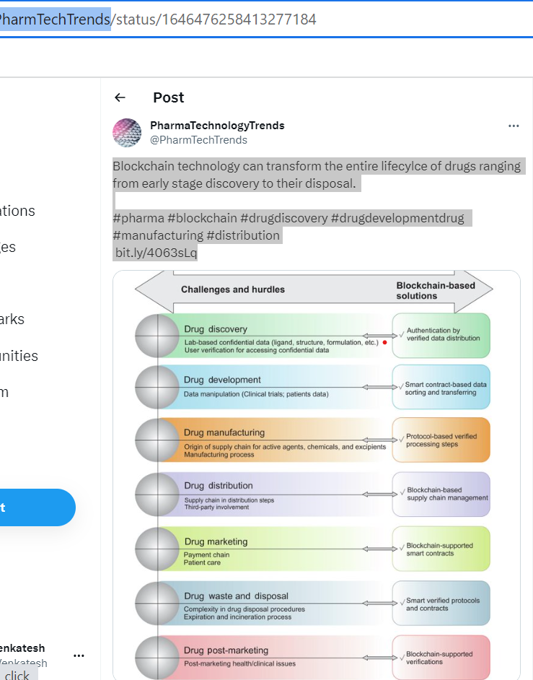

TweetID : 1645687822316359681

UserID : QodeNext

Profession: Community

Tweet : 6. Blockchain This technology provides a unified, secure, transparent, and efficient supply chain management system for pharmaceutical companies to govern their complex supply chain across the globe. [#BlockChain](https://twitter.com/hashtag/BlockChain?src=hashtag_click) [#Pharma](https://twitter.com/hashtag/Pharma?src=hashtag_click) [#SupplyChain](https://twitter.com/hashtag/SupplyChain?src=hashtag_click) [#Security](https://twitter.com/hashtag/Security?src=hashtag_click)

TweetID : 1713917322631549267

UserID : IBMBlockchain

Profession: Organization

Tweet : Libby's ([@nestle](https://twitter.com/Nestle)) adoption of [#blockchain](https://twitter.com/hashtag/blockchain?src=hashtag_click) exemplifies a decades-long partnership with their farmers - one based on trust and transparency. [@IBM](https://twitter.com/IBM) Food Trust enables the source tracking of ingredients, affording transparency into [#foodsafety](https://twitter.com/hashtag/foodsafety?src=hashtag_click) and sustainable production.

TweetID : 1709597610657354207

UserID : IBMBlockchain

Profession: Organization

Tweet : In partnership with [@compassgroupusa](https://twitter.com/compassgroupusa) and [@NestleUSA](https://twitter.com/NestleUSA), [@IBM](https://twitter.com/IBM) Global Real Estate is leveraging IBM Food Trust™ [#blockchain](https://twitter.com/hashtag/blockchain?src=hashtag_click) technology to bring a “pumpkin-inspired” food transparency pilot initiative to IBM employees this U.S. holiday season: [https://ibm.biz/BdM5Cj](https://t.co/asCX3YzMb6)

TweetID : 1705225911048487389

UserID : IBMBlockchain

Profession: Organization

Tweet : Food safety experts [@FrankYiannasFDA](https://twitter.com/FrankYiannasFDA) and Andy Kennedy to discuss the immediate need for food companies to securely capture and process food [#traceability](https://twitter.com/hashtag/traceability?src=hashtag_click) data required by the [@FDA](https://twitter.com/FDA) – [#FSMA204](https://twitter.com/hashtag/FSMA204?src=hashtag_click). Learn from the experts. Stay Compliant. Register here: [https://ibm.co/46mKLXG](https://t.co/4jqT74S22d)

TweetID : 1704888333074092259

UserID : IBMBlockchain

Profession: Organization

Tweet : Supply chain technologist Wiggs Civitillo outlines how the recently announced offering between [@IBM](https://twitter.com/IBM) and [@iFoodDS](https://twitter.com/iFoodDS) – FoodDS Trace Exchange with IBM Food Trust – can be applied to reduce food waste and improve [#foodsafety](https://twitter.com/hashtag/foodsafety?src=hashtag_click) through traceability data: [https://ibm.biz/BdMLTN](https://t.co/svjl5zArM7)

TweetID : 1629101383273046017

UserID : MikeS_NH

Profession: Industry Expert

Tweet :[#Supplychain](https://twitter.com/hashtag/Supplychain?src=hashtag_click) control towers, [#blockchain](https://twitter.com/hashtag/blockchain?src=hashtag_click), and order management [#virtualassistants](https://twitter.com/hashtag/virtualassistants?src=hashtag_click) are key to supply chain operations transformation in [#pharma](https://twitter.com/hashtag/pharma?src=hashtag_click), as are supply chain planning platforms and [#sourcing](https://twitter.com/hashtag/sourcing?src=hashtag_click) [#analytics](https://twitter.com/hashtag/analytics?src=hashtag_click)...

TweetID : 1623695011832561665

UserID : HCTriangle

Profession: Industry Expert

Tweet : Enhanced Drug Supply Chain Visibility - The effective use of [#blockchain](https://twitter.com/hashtag/blockchain?src=hashtag_click) in the drug [#supplychain](https://twitter.com/hashtag/supplychain?src=hashtag_click) ensures an auditable trail to safeguard drug provenance. Learn More: [https://bit.ly/3Xkguno](https://t.co/l3ZwgYoRNO) [#pharma](https://twitter.com/hashtag/pharma?src=hashtag_click) [#lifesciences](https://twitter.com/hashtag/lifesciences?src=hashtag_click) [#drugsafety](https://twitter.com/hashtag/drugsafety?src=hashtag_click)

TweetID : 1623349293376749569

UserID : virtue_insight

Profession: Industry Expert

Tweet : Our key speaker Alexandru POPA, Associate Director, [#Blockchain](https://twitter.com/hashtag/Blockchain?src=hashtag_click) for [#Pharma](https://twitter.com/hashtag/Pharma?src=hashtag_click) [#SupplyChain](https://twitter.com/hashtag/SupplyChain?src=hashtag_click), [#MSD](https://twitter.com/hashtag/MSD?src=hashtag_click) virtually presenting about How MSD is fighting the fakes with [#blockchain](https://twitter.com/hashtag/blockchain?src=hashtag_click) [#technology](https://twitter.com/hashtag/technology?src=hashtag_click) in 11th [#Pharma](https://twitter.com/hashtag/Pharma?src=hashtag_click) [#AntiCounterfeiting](https://twitter.com/hashtag/AntiCounterfeiting?src=hashtag_click) & [#Serialisation](https://twitter.com/hashtag/Serialisation?src=hashtag_click) 2023 [https://bit.ly/3T3EuZU](https://t.co/KGt2oQYfn5)

TweetID : 1465693347314475016

UserID : HCTriangle

Profession: Industry Expert

Tweet : [#Blockchain](https://twitter.com/hashtag/Blockchain?src=hashtag_click)'s key features, including immutability, distributed nature, and transparency provide the [#pharma](https://twitter.com/hashtag/pharma?src=hashtag_click) companies a more reliable way to add governance within the supply chain and ensure patient safety and compliance. [https://bit.ly/3CxrSBM](https://t.co/F9p6zQW5Rw) [#lifesciences](https://twitter.com/hashtag/lifesciences?src=hashtag_click) [#supplychain](https://twitter.com/hashtag/supplychain?src=hashtag_click) [#HCTI](https://twitter.com/hashtag/HCTI?src=hashtag_click)

TweetID : 1463864447215095812

UserID : HCTriangle

Profession: Industry Expert

Tweet : Enhanced Drug Supply Chain Visibility - The effective use of blockchain in the drug supply chain ensures an auditable trail to safeguard drug provenance. Learn More: [https://bit.ly/3CxrSBM](https://t.co/F9p6zQW5Rw) [#blockchain](https://twitter.com/hashtag/blockchain?src=hashtag_click) [#pharma](https://twitter.com/hashtag/pharma?src=hashtag_click) [#lifesciences](https://twitter.com/hashtag/lifesciences?src=hashtag_click) [#supplychain](https://twitter.com/hashtag/supplychain?src=hashtag_click) [#drugsafety](https://twitter.com/hashtag/drugsafety?src=hashtag_click) [#HCTI](https://twitter.com/hashtag/HCTI?src=hashtag_click)

TweetID : 1452285009805647876

UserID : GS1_US

Profession: Community

Tweet : What is the biggest benefit of using [#blockchain](https://twitter.com/hashtag/blockchain?src=hashtag_click) in the [#pharma](https://twitter.com/hashtag/pharma?src=hashtag_click) industry? Jeffery Denton, VP of Global Secure [#SupplyChain](https://twitter.com/hashtag/SupplyChain?src=hashtag_click) at AmerisourceBergen, provides insight in our industry Q&A. [http://ow.ly/80UP30rWOX1](https://t.co/q5Sj4LXD4L) [@Healthcare_ABC](https://twitter.com/Healthcare_ABC)

TweetID : 1448559091928940546

UserID : HealthcareLdr

Profession: Community

Tweet : How [#ArtificialIntelligence](https://twitter.com/hashtag/ArtificialIntelligence?src=hashtag_click) and [#Blockchain](https://twitter.com/hashtag/Blockchain?src=hashtag_click) Can Execute Vaccine Allocations for Countries in Need by [@joshinav](https://twitter.com/joshinav) [@BBNTimes_en](https://twitter.com/BBNTimes_en) via [@Ronald_vanLoon](https://twitter.com/Ronald_vanLoon) Read more: [http://buff.ly/3DyYSLX](https://t.co/9hZddUAHOK) [#ML](https://twitter.com/hashtag/ML?src=hashtag_click) [#AI](https://twitter.com/hashtag/AI?src=hashtag_click) [#COVID19](https://twitter.com/hashtag/COVID19?src=hashtag_click) [#HealthTech](https://twitter.com/hashtag/HealthTech?src=hashtag_click) [#DL](https://twitter.com/hashtag/DL?src=hashtag_click) [#healthtech](https://twitter.com/hashtag/healthtech?src=hashtag_click) [#digitalhealth](https://twitter.com/hashtag/digitalhealth?src=hashtag_click) [#supplychain](https://twitter.com/hashtag/supplychain?src=hashtag_click) [#Pharmaceutical](https://twitter.com/hashtag/Pharmaceutical?src=hashtag_click) [#pharma](https://twitter.com/hashtag/pharma?src=hashtag_click)

TweetID : 1433036310546194438

UserID : HealthcareDig

Profession: Community

Tweet : The UK is set to create its first digital supply chain for the pharmaceutical sector, backed by the government, [@UKRI_News](https://twitter.com/UKRI_News) & key industry players including [@FarmaTrust](https://twitter.com/FarmaTrust) [@Siemens](https://twitter.com/Siemens) [@GSK](https://twitter.com/GSK) & [@AstraZeneca](https://twitter.com/AstraZeneca) [http://ow.ly/y6pF50G2dHz](https://t.co/1Q7EsVkC42) [#supplychain](https://twitter.com/hashtag/supplychain?src=hashtag_click) [#pharma](https://twitter.com/hashtag/pharma?src=hashtag_click) [#healthcare](https://twitter.com/hashtag/healthcare?src=hashtag_click) [#blockchain](https://twitter.com/hashtag/blockchain?src=hashtag_click)

TweetID : 1426002110164791304

UserID : AlexaBlockchain

Profession: Community

Tweet : Healthcare Triangle launches a new plug-and-play Blockchain solution – Blockedge. It helps pharma companies bring drugs to market faster, at lower cost, and more [@HCTriangle](https://twitter.com/HCTriangle) [#Blockchain](https://twitter.com/hashtag/Blockchain?src=hashtag_click) [#Healthcare](https://twitter.com/hashtag/Healthcare?src=hashtag_click) [#Pharma](https://twitter.com/hashtag/Pharma?src=hashtag_click) [#SupplyChain](https://twitter.com/hashtag/SupplyChain?src=hashtag_click)

TweetID : 1415974610378575876

UserID : koolexindia

Profession: Community

Tweet : The pharma blockchain holds the potential to enhance security, integrity, data provenance, and the functionality of the supply chains with its transparent, immutable and auditable nature. [#koolex](https://twitter.com/hashtag/koolex?src=hashtag_click) [#blockchain](https://twitter.com/hashtag/blockchain?src=hashtag_click) [#transparent](https://twitter.com/hashtag/transparent?src=hashtag_click) [#supplychain](https://twitter.com/hashtag/supplychain?src=hashtag_click) [#pharma](https://twitter.com/hashtag/pharma?src=hashtag_click) [#pharmadistribution](https://twitter.com/hashtag/pharmadistribution?src=hashtag_click) [#servicetonation](https://twitter.com/hashtag/servicetonation?src=hashtag_click)

TweetID : 1387311488977752065

UserID : UJakimaviciute

Profession: Industry Expert

Tweet : [#Pharma](https://twitter.com/hashtag/Pharma?src=hashtag_click) industry investments in [#blockchain](https://twitter.com/hashtag/blockchain?src=hashtag_click) decreased in 2020 as organizations shifted priorities during [#COVID19](https://twitter.com/hashtag/COVID19?src=hashtag_click) pandemic: [https://globaldata.com/pharma-industry-investments-blockchain-decreased-2020-organizations-shifted-priorities-covid-19-pandemic-says-globaldata/…](https://t.co/ZWygOnIvl9) [#DigitalTransformation](https://twitter.com/hashtag/DigitalTransformation?src=hashtag_click) [#SupplyChain](https://twitter.com/hashtag/SupplyChain?src=hashtag_click) [#emergingtechnologies](https://twitter.com/hashtag/emergingtechnologies?src=hashtag_click) [#technology](https://twitter.com/hashtag/technology?src=hashtag_click) [#TechInvestment](https://twitter.com/hashtag/TechInvestment?src=hashtag_click)

TweetID : 1381721161709461504

UserID : tinalll

Profession: Industry Expert

Tweet : Technologies like artificial intelligence, automation, collaboration tools and blockchain can help build trust and ensure safety throughout the supply chain. [#supplychain](https://twitter.com/hashtag/supplychain?src=hashtag_click) [#pharma](https://twitter.com/hashtag/pharma?src=hashtag_click) [#COVID19](https://twitter.com/hashtag/COVID19?src=hashtag_click) [#blockchain](https://twitter.com/hashtag/blockchain?src=hashtag_click)

TweetID : 1377282196248072196

UserID : FitchSolutions

Profession: Organization

Tweet : [#Blockchain](https://twitter.com/hashtag/Blockchain?src=hashtag_click) -Based Systems To Combat Fake Covid-19 Vaccines [http://ow.ly/DjHh50EcrUp](https://t.co/8KgaAPFC2N) [#healthcare](https://twitter.com/hashtag/healthcare?src=hashtag_click) [#supplychain](https://twitter.com/hashtag/supplychain?src=hashtag_click) [#pharma](https://twitter.com/hashtag/pharma?src=hashtag_click)

TweetID : 1362461078949609477

UserID : sallyeaves

Profession: Industry Expert

Tweet : I second that Nick! And I think the pandemic experience has accelerated this - have had a surge of interest & questions around [#blockchain](https://twitter.com/hashtag/blockchain?src=hashtag_click) across a wider range of use cases, especially [#pharma](https://twitter.com/hashtag/pharma?src=hashtag_click) & [#supplychain](https://twitter.com/hashtag/supplychain?src=hashtag_click) [#CloudTweetChat](https://twitter.com/hashtag/CloudTweetChat?src=hashtag_click) [#CloudComputing](https://twitter.com/hashtag/CloudComputing?src=hashtag_click)

TweetID : 1357399960933826561

UserID : corvusglobal

Profession: Community

Tweet : Officials warn of fake covid-19 [#vaccines](https://twitter.com/hashtag/vaccines?src=hashtag_click) The only way is to make the [#supplychain](https://twitter.com/hashtag/supplychain?src=hashtag_click) airtight to eliminate [#counterfeitdrugs](https://twitter.com/hashtag/counterfeitdrugs?src=hashtag_click) penetration into global legitimate medicine supply chains Join us Virtually [https://lnkd.in/g49FXph](https://t.co/ZI6lC9b1mB) [#PSW](https://twitter.com/hashtag/PSW?src=hashtag_click) [#Pharma](https://twitter.com/hashtag/Pharma?src=hashtag_click) [#serialization](https://twitter.com/hashtag/serialization?src=hashtag_click) [#traceability](https://twitter.com/hashtag/traceability?src=hashtag_click) [#IP](https://twitter.com/hashtag/IP?src=hashtag_click) [#Blockchain](https://twitter.com/hashtag/Blockchain?src=hashtag_click)

TweetID : 1335951671214555140

UserID : MattHansen0

Profession: Industry Expert

Tweet : This whole thread is so incredibly disheartening. I think there is a real use case here for [#blockchain](https://twitter.com/hashtag/blockchain?src=hashtag_click) ledger tech for the [#pharma](https://twitter.com/hashtag/pharma?src=hashtag_click) [#supplychain](https://twitter.com/hashtag/supplychain?src=hashtag_click) to give some visibility and responsibility to all parties involved. [#MicrosoftBlockchain](https://twitter.com/hashtag/MicrosoftBlockchain?src=hashtag_click) [#MSFTBlockchain](https://twitter.com/hashtag/MSFTBlockchain?src=hashtag_click)

TweetID : 1291028255198388227

UserID : vaQtec

Profession: Community

Tweet : Everyone is talking about, we are already using it: [#BlockChain](https://twitter.com/hashtag/BlockChain?src=hashtag_click) technology secures quality relevant data of [#GDPcompliant](https://twitter.com/hashtag/GDPcompliant?src=hashtag_click) TempChains. [https://bit.ly/2Dzi6q3](https://t.co/5kA5jpuU0s) [#BlockchainTechnology](https://twitter.com/hashtag/BlockchainTechnology?src=hashtag_click) [#logistics](https://twitter.com/hashtag/logistics?src=hashtag_click) [#supplychain](https://twitter.com/hashtag/supplychain?src=hashtag_click) [#lifescience](https://twitter.com/hashtag/lifescience?src=hashtag_click) [#pharma](https://twitter.com/hashtag/pharma?src=hashtag_click) [#datasecurity](https://twitter.com/hashtag/datasecurity?src=hashtag_click)

TweetID : 1277839290962247680

UserID : frankzanotto

Profession: Individual

Tweet : Isn't it time to reimagine how you run your business - how an open / trusted /collaborative commercial platform powered by [#Blockchain](https://twitter.com/hashtag/Blockchain?src=hashtag_click) can provide more value to your customers? Think new & improved - think [#DLT](https://twitter.com/hashtag/DLT?src=hashtag_click) [http://bit.ly/2Az6cLa](https://t.co/zhTD0fu9k0) [#innovation](https://twitter.com/hashtag/innovation?src=hashtag_click) [#disruption](https://twitter.com/hashtag/disruption?src=hashtag_click) [#SupplyChain](https://twitter.com/hashtag/SupplyChain?src=hashtag_click) [#Pharma](https://twitter.com/hashtag/Pharma?src=hashtag_click)

TweetID : 1258758595933605890

UserID : antgrasso

Profession: Industry Expert

Tweet : Within the next years, approximately 30 % of life sciences companies plan to utilize blockchain, opening new business opportunities, and addressing challenges of the past. Link >> [https://bit.ly/2z9LLUs](https://t.co/qn4BYCHzQE) [@worldpharma2day](https://twitter.com/worldpharma2day) [@AccentureLifSci](https://twitter.com/AccentureLifSci) via [@antgrasso](https://twitter.com/antgrasso) [#blockchain](https://twitter.com/hashtag/blockchain?src=hashtag_click)

TweetID : 1247494528954773504

UserID : AetsoftC

Profession: Organization

Tweet : Automate clinical trials, R&D processes, payments, and product verification throughout the [#supplychain](https://twitter.com/hashtag/supplychain?src=hashtag_click). Create decentralized, networks and incentivize record activities on immutable, auditable blockchains with [#pharma](https://twitter.com/hashtag/pharma?src=hashtag_click) [#blockchain](https://twitter.com/hashtag/blockchain?src=hashtag_click) solutions from Aetsoft.

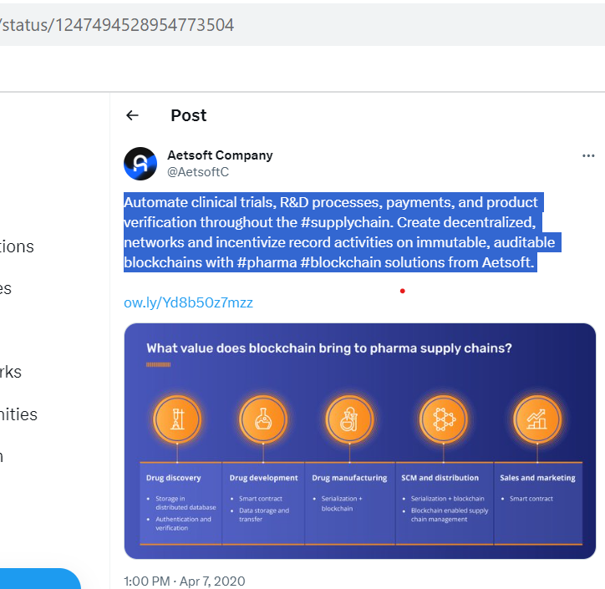

TweetID : 1229446414285115394

UserID : CarrymedGmbH

Profession: Organization

Tweet : Everybody, talks about [#blockchain](https://twitter.com/hashtag/blockchain?src=hashtag_click) for the supply chain but can you explain what it is and how it really works? We gave it a try in our latest blog series about the practical applications of blockchain in the [#pharma](https://twitter.com/hashtag/pharma?src=hashtag_click) [#supplychain](https://twitter.com/hashtag/supplychain?src=hashtag_click).

TweetID : 1225106125344911365

UserID : OYB_Blockchain

Profession: Community

Tweet : [#Supplychain](https://twitter.com/hashtag/Supplychain?src=hashtag_click) for [#pharmaceuticals](https://twitter.com/hashtag/pharmaceuticals?src=hashtag_click) is only one of many possibilities in [#pharma](https://twitter.com/hashtag/pharma?src=hashtag_click) [#industry](https://twitter.com/hashtag/industry?src=hashtag_click). Novartis knows how [#blockchain](https://twitter.com/hashtag/blockchain?src=hashtag_click) can help its [#business](https://twitter.com/hashtag/business?src=hashtag_click) [https://cnnmoney.ch/shows/blockcha](https://t.co/67Jqd5I55A)in

TweetID : 1218123309684051968

UserID : Sofrigam

Profession: Community

Tweet : Dubai's [#Health](https://twitter.com/hashtag/Health?src=hashtag_click) Authorities introduce a new [#TrackandTrace](https://twitter.com/hashtag/TrackandTrace?src=hashtag_click) system to oversee the entire [#pharmaceutical](https://twitter.com/hashtag/pharmaceutical?src=hashtag_click) [#supplychain](https://twitter.com/hashtag/supplychain?src=hashtag_click) & detect any issue to improve [#drug](https://twitter.com/hashtag/drug?src=hashtag_click) quality and [#patient](https://twitter.com/hashtag/patient?src=hashtag_click) safety. [https://europeanpharmaceuticalreview.com/article/109849/establishing-a-new-pharmaceutical-track-and-trace-system-in-dubai/…](https://t.co/HUEMeoWzOQ) [#serialization](https://twitter.com/hashtag/serialization?src=hashtag_click) [#blockchain](https://twitter.com/hashtag/blockchain?src=hashtag_click) [#traceability](https://twitter.com/hashtag/traceability?src=hashtag_click) [#pharma](https://twitter.com/hashtag/pharma?src=hashtag_click) [#pharmasupplychain](https://twitter.com/hashtag/pharmasupplychain?src=hashtag_click)

TweetID : 1214180273635516418

UserID : corvusglobal

Profession: Community

Tweet : We are happy to announce our Newest Exhibitor PharmaTrace @ Pharma Supply-Chain & Security World 2020 [#conference](https://twitter.com/hashtag/conference?src=hashtag_click) & expo [#PSW](https://twitter.com/hashtag/PSW?src=hashtag_click) [#corvusglobal](https://twitter.com/hashtag/corvusglobal?src=hashtag_click) [#Anticounterfeiting](https://twitter.com/hashtag/Anticounterfeiting?src=hashtag_click) [#blockchain](https://twitter.com/hashtag/blockchain?src=hashtag_click) [#Pharmablockchain](https://twitter.com/hashtag/Pharmablockchain?src=hashtag_click) [#BrandProtection](https://twitter.com/hashtag/BrandProtection?src=hashtag_click) [#serialisation](https://twitter.com/hashtag/serialisation?src=hashtag_click) [#lifscience](https://twitter.com/hashtag/lifscience?src=hashtag_click) [#pharma](https://twitter.com/hashtag/pharma?src=hashtag_click) [#traceability](https://twitter.com/hashtag/traceability?src=hashtag_click) [#tracking](https://twitter.com/hashtag/tracking?src=hashtag_click) [#supplychain](https://twitter.com/hashtag/supplychain?src=hashtag_click)

TweetID : 1202588838012563456

UserID : OpenLedgerDC

Profession: Community

Tweet : Blockchain to disrupt flows in pharmaceutical supply chains with immutable audit trails, real-time monitoring, and decentralization: study the breakdown in our latest article at [http://ow.ly/VMfa50xrrmc](https://t.co/bsvjngHa8N) [#blockchain](https://twitter.com/hashtag/blockchain?src=hashtag_click) [#pharma](https://twitter.com/hashtag/pharma?src=hashtag_click) [#dlt](https://twitter.com/hashtag/dlt?src=hashtag_click) [#supplychain](https://twitter.com/hashtag/supplychain?src=hashtag_click) [#logistics](https://twitter.com/hashtag/logistics?src=hashtag_click) [#healthcare](https://twitter.com/hashtag/healthcare?src=hashtag_click)

TweetID : 1178661730831888385

UserID : KSoftSystemsInc

Profession: Organization

Tweet : Can blockchain tackle the problem of counterfeit medicine? [#blockchain](https://twitter.com/hashtag/blockchain?src=hashtag_click) [#blockchainsolutions](https://twitter.com/hashtag/blockchainsolutions?src=hashtag_click) [#blockchaintech](https://twitter.com/hashtag/blockchaintech?src=hashtag_click) [#counterfeit](https://twitter.com/hashtag/counterfeit?src=hashtag_click) [#medicine](https://twitter.com/hashtag/medicine?src=hashtag_click) [#who](https://twitter.com/hashtag/who?src=hashtag_click) [#worldhealthorganization](https://twitter.com/hashtag/worldhealthorganization?src=hashtag_click) [#pharma](https://twitter.com/hashtag/pharma?src=hashtag_click) [#supplychain](https://twitter.com/hashtag/supplychain?src=hashtag_click)

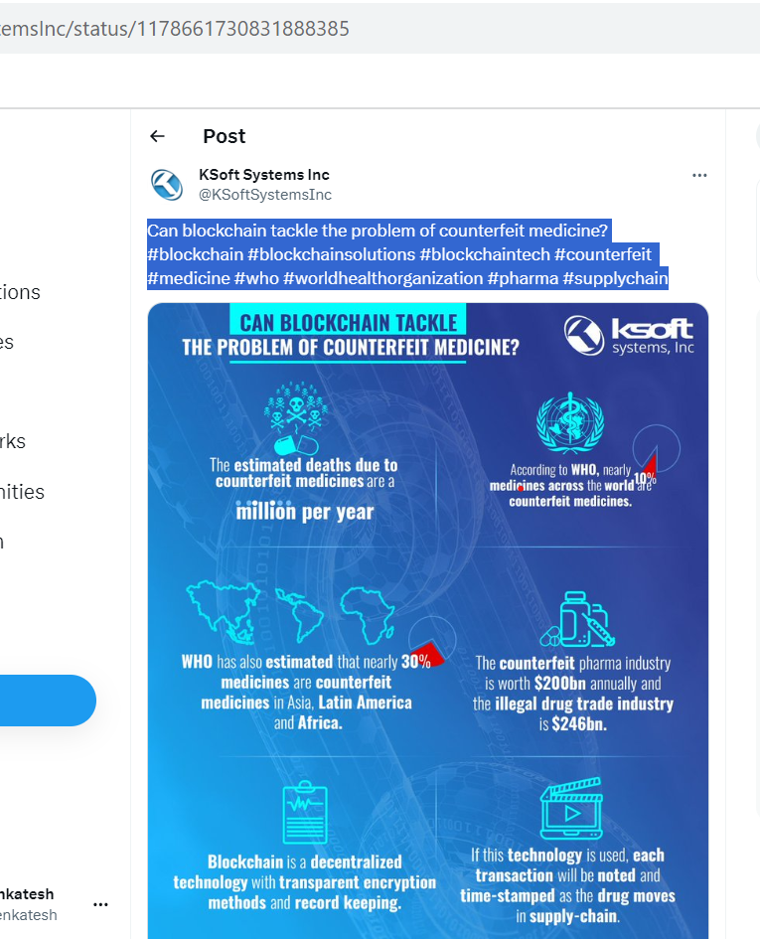

TweetID : 1120296519435988992

UserID : Sofrigam

Profession: Organization

Tweet : A [#Blockchain](https://twitter.com/hashtag/Blockchain?src=hashtag_click) protocol discovered by a researcher at Portland University could prevent [#counterfeit](https://twitter.com/hashtag/counterfeit?src=hashtag_click) [#pharmaceutical](https://twitter.com/hashtag/pharmaceutical?src=hashtag_click) sales : [https://sciencedaily.com/releases/2019/04/190415154651.htm…](https://t.co/IDRXVfx4qk) [@ScienceDaily](https://twitter.com/ScienceDaily) [#pharma](https://twitter.com/hashtag/pharma?src=hashtag_click) [#supplychain](https://twitter.com/hashtag/supplychain?src=hashtag_click)

TweetID : 1107654595860414464

UserID : TechWorldOracle

Profession: Community

Tweet : [@TechWorldOracle](https://twitter.com/TechWorldOracle) is very proud to support [@theEPOCHgroup](https://twitter.com/theEPOCHgroup) with their [#webinar](https://twitter.com/hashtag/webinar?src=hashtag_click) on [#SupplyChain](https://twitter.com/hashtag/SupplyChain?src=hashtag_click) Challenges in [#Pharma](https://twitter.com/hashtag/Pharma?src=hashtag_click) & [#Blockchain](https://twitter.com/hashtag/Blockchain?src=hashtag_click) opportunities. The broadcast takes place on Wednesday 20th March 2019 at 13:00 GMT. For further information, please visit: [https://epoch-group.org/webinar-with-catena-consulting/](https://t.co/nxVRXfoWl2)

TweetID : 1105459590471266309

UserID : LedgerInsights

Profession: Community

Tweet : Yesterday [@TraceLink](https://twitter.com/TraceLink) announced a [#blockchain](https://twitter.com/hashtag/blockchain?src=hashtag_click) pharma pilot. Last month the [@US_FDA](https://twitter.com/US_FDA) announced a pilot program for the [#pharma](https://twitter.com/hashtag/pharma?src=hashtag_click) industry to help to trace [#drugs](https://twitter.com/hashtag/drugs?src=hashtag_click). Everyone in the pharma [#SupplyChain](https://twitter.com/hashtag/SupplyChain?src=hashtag_click) needs to comply with the DCSCA legislation by 2023

TweetID : 1104137933211291648

UserID : OksanaPyzikUCL

Profession: Industry Expert

Tweet : What does [#healthcare](https://twitter.com/hashtag/healthcare?src=hashtag_click) look like in 2028? Joined [#MobileWorldCongress](https://twitter.com/hashtag/MobileWorldCongress?src=hashtag_click) panel to predict the future of [#mHealth](https://twitter.com/hashtag/mHealth?src=hashtag_click) w/ over 100,000 conf delegates. My [#MWC19](https://twitter.com/hashtag/MWC19?src=hashtag_click) bet lies on [#blockchain](https://twitter.com/hashtag/blockchain?src=hashtag_click) & [#AI](https://twitter.com/hashtag/AI?src=hashtag_click) to transform the [#pharma](https://twitter.com/hashtag/pharma?src=hashtag_click) supplychain. What do you think? [@ronanwisdom](https://twitter.com/ronanwisdom) [@peterohnemus](https://twitter.com/peterohnemus) [@rajasharif](https://twitter.com/rajasharif) 

TweetID : 1100758197818650626

UserID : zoreum

Profession: Organization

Tweet : Aslimedicine rewards vigilant public for reporting fake medicines with Asli tokens. Consumers can be benifited by redeeming by the tokens in zoreum exchange. Click here: [https://bit.ly/2SeTqVm](https://t.co/6CgRqKva8b) [#Aslimedicine](https://twitter.com/hashtag/Aslimedicine?src=hashtag_click) [#pharma](https://twitter.com/hashtag/pharma?src=hashtag_click) [#drugs](https://twitter.com/hashtag/drugs?src=hashtag_click) [#dApp](https://twitter.com/hashtag/dApp?src=hashtag_click) [#blockchain](https://twitter.com/hashtag/blockchain?src=hashtag_click) [#zoreum](https://twitter.com/hashtag/zoreum?src=hashtag_click) [#Ethereum](https://twitter.com/hashtag/Ethereum?src=hashtag_click) [#supplychain](https://twitter.com/hashtag/supplychain?src=hashtag_click)

TweetID : 1098151555918897152

UserID : chemanager

Profession: Community

Tweet : Wird die [#Blockchain](https://twitter.com/hashtag/Blockchain?src=hashtag_click)-Technologie die [#Pharmalogistik](https://twitter.com/hashtag/Pharmalogistik?src=hashtag_click) revolutionieren? Ist es sinnvoll wenn Pharmaunternehmen ihre [#Produktionslogistik](https://twitter.com/hashtag/Produktionslogistik?src=hashtag_click) outsourcen? Diese Fragen stand Mittelpunkt des [#Pharma](https://twitter.com/hashtag/Pharma?src=hashtag_click) [#SupplyChain](https://twitter.com/hashtag/SupplyChain?src=hashtag_click) Trends Symposiums. Lesen Sie die Ergebnisse hier: [http://bit.ly/2X5SS88](https://t.co/P06vdHDRYo)

TweetID : 1105459590471266309

UserID : LedgerInsights

Profession: Organization Industry Expert Community

Tweet :

TweetID : 1095085118991982593

UserID : MdxBlocks

Profession: Community

Tweet : [#Blockchain](https://twitter.com/hashtag/Blockchain?src=hashtag_click) is quickly increasing in interest and has received praise for its far-reaching applications. [http://mdxblocks.com](https://t.co/fAP7LyXmAM) [#MDxBLOCKS](https://twitter.com/hashtag/MDxBLOCKS?src=hashtag_click) [#blockchain](https://twitter.com/hashtag/blockchain?src=hashtag_click) [#pharma](https://twitter.com/hashtag/pharma?src=hashtag_click) [#clinicaltrials](https://twitter.com/hashtag/clinicaltrials?src=hashtag_click) [#biotech](https://twitter.com/hashtag/biotech?src=hashtag_click) [#chemicalindustry](https://twitter.com/hashtag/chemicalindustry?src=hashtag_click) [#supplychain](https://twitter.com/hashtag/supplychain?src=hashtag_click) [#medical](https://twitter.com/hashtag/medical?src=hashtag_click) [#financialservices](https://twitter.com/hashtag/financialservices?src=hashtag_click) [#industrialization](https://twitter.com/hashtag/industrialization?src=hashtag_click) [#suppliers](https://twitter.com/hashtag/suppliers?src=hashtag_click)

TweetID : 1094950938400509953

UserID : jimsabogal

Profession: Industry Expert

Tweet : FDA to run pharma blockchain pilots [https://buff.ly/2Bw418T](https://t.co/6Ztow8A8nM) [#blockchain](https://twitter.com/hashtag/blockchain?src=hashtag_click) [#supplychain](https://twitter.com/hashtag/supplychain?src=hashtag_click) [#pharma](https://twitter.com/hashtag/pharma?src=hashtag_click)

TweetID : 1094885044013985792

UserID : TheActiveledger

Profession: Community

Tweet : The system comprehensively documents each step that a pharmaceutical product takes on its way to the store shelf and eventually the consumer. via DHL Research [@Accenture](https://twitter.com/Accenture) [#blockchain](https://twitter.com/hashtag/blockchain?src=hashtag_click) [#usecase](https://twitter.com/hashtag/usecase?src=hashtag_click) [#supplychain](https://twitter.com/hashtag/supplychain?src=hashtag_click) [#pharma](https://twitter.com/hashtag/pharma?src=hashtag_click) [#drugs](https://twitter.com/hashtag/drugs?src=hashtag_click) [#infographic](https://twitter.com/hashtag/infographic?src=hashtag_click) CC [@MikeQuindazzi](https://twitter.com/MikeQuindazzi) [@dinisguarda](https://twitter.com/dinisguarda) [@walkermartyn](https://twitter.com/walkermartyn)

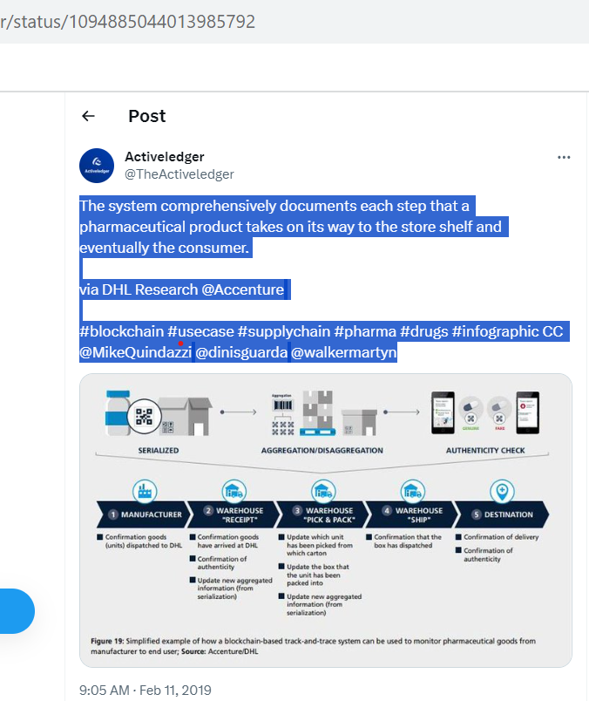

TweetID : 1085325760133562369

UserID : StephTweetChat

Profession: Individual

Tweet : [#Blockchain](https://twitter.com/hashtag/Blockchain?src=hashtag_click)’s capacity to provide clarity/accountability, & to minimize the influence/costs of middlemen, should put it on the agenda of every board. [#Digital](https://twitter.com/hashtag/Digital?src=hashtag_click) [#Tech](https://twitter.com/hashtag/Tech?src=hashtag_click) [#SupplyChain](https://twitter.com/hashtag/SupplyChain?src=hashtag_click) [#HealthTech](https://twitter.com/hashtag/HealthTech?src=hashtag_click) [#Pharma](https://twitter.com/hashtag/Pharma?src=hashtag_click) [#DigitalID](https://twitter.com/hashtag/DigitalID?src=hashtag_click) [#Innovation](https://twitter.com/hashtag/Innovation?src=hashtag_click) [https://lnkd.in/eEF37wK](https://t.co/OAASK0uuLy)

TweetID : 1085165631404687362

UserID : BME_Sponsoring

Profession: Community

Tweet : [#Global](https://twitter.com/hashtag/Global?src=hashtag_click) [#Pharma](https://twitter.com/hashtag/Pharma?src=hashtag_click) [#SupplyChain](https://twitter.com/hashtag/SupplyChain?src=hashtag_click) [#Congress](https://twitter.com/hashtag/Congress?src=hashtag_click) | February 12-14 2019 | Frankfurt, Germany | Visit: [https://bme.de/pscc](https://t.co/B34iSfRJX6) [#data](https://twitter.com/hashtag/data?src=hashtag_click) [#environment](https://twitter.com/hashtag/environment?src=hashtag_click) [#BigData](https://twitter.com/hashtag/BigData?src=hashtag_click) [#process](https://twitter.com/hashtag/process?src=hashtag_click) [#Mining](https://twitter.com/hashtag/Mining?src=hashtag_click) [#Transformation](https://twitter.com/hashtag/Transformation?src=hashtag_click) [#EmergingMarkets](https://twitter.com/hashtag/EmergingMarkets?src=hashtag_click) [#Pharmaceuticals](https://twitter.com/hashtag/Pharmaceuticals?src=hashtag_click) [#blockchain](https://twitter.com/hashtag/blockchain?src=hashtag_click) [#pharmaindustry](https://twitter.com/hashtag/pharmaindustry?src=hashtag_click) [#MedTech](https://twitter.com/hashtag/MedTech?src=hashtag_click) [#healthcare](https://twitter.com/hashtag/healthcare?src=hashtag_click) [@BMEeV](https://twitter.com/BMEeV)

TweetID : 1084257744872398849

UserID : MeSanjayvyas

Profession: Industry Expert

Tweet : Great Q&A with [#tech](https://twitter.com/hashtag/tech?src=hashtag_click) expert and co-founder of GlobalBlock, discussing the future of [#blockchain](https://twitter.com/hashtag/blockchain?src=hashtag_click) technology in the [#pharma](https://twitter.com/hashtag/pharma?src=hashtag_click) industry and it’s impact on related [#supplychain](https://twitter.com/hashtag/supplychain?src=hashtag_click)

TweetID : 1073216082280898560

UserID : sweetbridgeemea

Profession: Individual

Tweet : With the use of [#blockchain](https://twitter.com/hashtag/blockchain?src=hashtag_click), it will become much easier for the [#pharma](https://twitter.com/hashtag/pharma?src=hashtag_click) [#supplychain](https://twitter.com/hashtag/supplychain?src=hashtag_click) to be able to trace their goods. [https://buff.ly/2QtKiAu](https://t.co/5H65iqdAHL)

TweetID : 1073205665525571584

UserID : peter_monien

Profession: Individual

Tweet : Why the pharma supply chain needs to be ready for traceability - industry players must consolidate their medicine traceability practices to fight a rise in medicine counterfeiting [https://epmmagazine.com/opinion/why-the-pharma-supply-chain-needs-to-be-ready-for-traceabili/#.XBJbrn2PYH4.twitter…](https://t.co/xpc7TP8ocX) [#supplychain](https://twitter.com/hashtag/supplychain?src=hashtag_click) [#blockchain](https://twitter.com/hashtag/blockchain?src=hashtag_click) [#trackandtrace](https://twitter.com/hashtag/trackandtrace?src=hashtag_click) [#anticounterfeit](https://twitter.com/hashtag/anticounterfeit?src=hashtag_click) [#pharma](https://twitter.com/hashtag/pharma?src=hashtag_click)

TweetID : 1064681195668234240

UserID : jimsabogal

Profession: Industry Expert

Tweet : Also include [#Pharma](https://twitter.com/hashtag/Pharma?src=hashtag_click) and [#supplychain](https://twitter.com/hashtag/supplychain?src=hashtag_click). Securing our US Drug Supply Chain would use [#Blockchain](https://twitter.com/hashtag/Blockchain?src=hashtag_click) [@tsystemscom](https://twitter.com/tsystemscom)

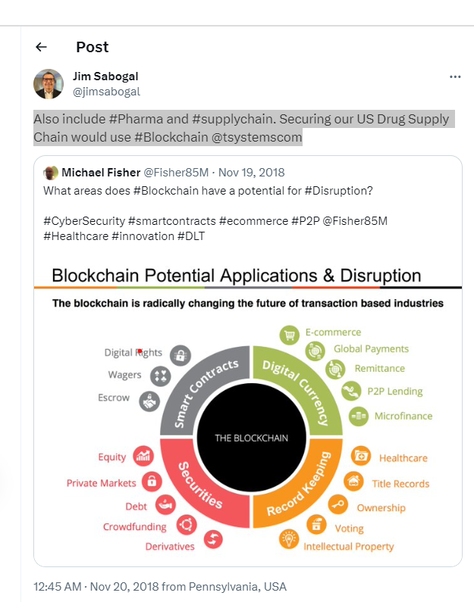

TweetID : 1064537814270992384

UserID : SettleMintCom

Profession: Community

Tweet : Time to speak about [#blockchain](https://twitter.com/hashtag/blockchain?src=hashtag_click) and how we can leverage blockchain technology for [#SupplyChain](https://twitter.com/hashtag/SupplyChain?src=hashtag_click) operations and [#management](https://twitter.com/hashtag/management?src=hashtag_click) in the [#pharma](https://twitter.com/hashtag/pharma?src=hashtag_click) [#sector](https://twitter.com/hashtag/sector?src=hashtag_click). Thanks to [@GIRPBrussels](https://twitter.com/GIRPBrussels) for the invitation! [@matt_vn](https://twitter.com/matt_vn) [#SettleMint](https://twitter.com/hashtag/SettleMint?src=hashtag_click) [#MINT](https://twitter.com/hashtag/MINT?src=hashtag_click)

TweetID : 1062703532439166976

UserID : DynaSys

Profession: Community

Tweet : Blockchain in the Pharmaceutical Value Chain Through | DynaSys Blog [http://ow.ly/6LGP30mC9yZ](https://t.co/zU3a2GpYvG) [#SupplyChain](https://twitter.com/hashtag/SupplyChain?src=hashtag_click) [#Blockchain](https://twitter.com/hashtag/Blockchain?src=hashtag_click) [#Pharma](https://twitter.com/hashtag/Pharma?src=hashtag_click) [#LifeSciences](https://twitter.com/hashtag/LifeSciences?src=hashtag_click) [#SmartContracts](https://twitter.com/hashtag/SmartContracts?src=hashtag_click)

TweetID : 1022433852223119360

UserID : TheBlockNews

Profession: Community

Tweet : China [#pharma](https://twitter.com/hashtag/pharma?src=hashtag_click) scandal sparks call for [#blockchain](https://twitter.com/hashtag/blockchain?src=hashtag_click) in drug [#SupplyChain](https://twitter.com/hashtag/SupplyChain?src=hashtag_click) : [http://bit.ly/2v1Kt8q](https://t.co/u7Q1oJbT9L)

TweetID : 1017701886248587265

UserID : 23_consulting

Profession: Community

Tweet : [@SAP](https://twitter.com/SAP) leads [#Pharma](https://twitter.com/hashtag/Pharma?src=hashtag_click) [#SupplyChain](https://twitter.com/hashtag/SupplyChain?src=hashtag_click) [#blockchain](https://twitter.com/hashtag/blockchain?src=hashtag_click) initiative in partnership with [#pharma](https://twitter.com/hashtag/pharma?src=hashtag_click) companies.

TweetID : 1014501856565977088

UserID : james_hextall

Profession: Industry Expert

Tweet : Blockchain has the potential to bring enormous change to the supply chain industry. Nowhere is this more pronounced than in the pharmaceuticals. [http://bit.ly/2u4iPY5](https://t.co/ljaStunP6s) [#blockchain](https://twitter.com/hashtag/blockchain?src=hashtag_click) [#pharma](https://twitter.com/hashtag/pharma?src=hashtag_click) [#supplychain](https://twitter.com/hashtag/supplychain?src=hashtag_click)

TweetID : 1013935376669511681

UserID : nisumtech

Profession: Organization

Tweet : [#Pharma](https://twitter.com/hashtag/Pharma?src=hashtag_click) Giant [#Merck](https://twitter.com/hashtag/Merck?src=hashtag_click) Eyes [#Blockchain](https://twitter.com/hashtag/Blockchain?src=hashtag_click) for Fighting [#CounterfeitMeds](https://twitter.com/hashtag/CounterfeitMeds?src=hashtag_click). [http://bit.ly/2IAbPqU](https://t.co/8LwK1NB22H) [#SupplyChain](https://twitter.com/hashtag/SupplyChain?src=hashtag_click) [#EnterpriseEthereumAlliance](https://twitter.com/hashtag/EnterpriseEthereumAlliance?src=hashtag_click) [#DistributedStorage](https://twitter.com/hashtag/DistributedStorage?src=hashtag_click)

TweetID : 1012732823202037761

UserID : kinapseglobal

Profession: Organization

Tweet : [#Blockchain](https://twitter.com/hashtag/Blockchain?src=hashtag_click) could revolutionise the pharma supply chain, solving big issues in logistics, counterfeiting, and patient usage. Follow the link to find out how. [https://buff.ly/2IAjVzW](https://t.co/940DI2aXMG) [#pharma](https://twitter.com/hashtag/pharma?src=hashtag_click) [#lifesciences](https://twitter.com/hashtag/lifesciences?src=hashtag_click) [#supplychain](https://twitter.com/hashtag/supplychain?src=hashtag_click)

TweetID : 1011687045079683074

UserID : synaptic_delay

Profession: Community

Tweet : Pharmaceuticals giant Merck filed a patent to use blockchain to track drugs as they move through the supply chain. [#pharmaceutics](https://twitter.com/hashtag/pharmaceutics?src=hashtag_click) [#blockchain](https://twitter.com/hashtag/blockchain?src=hashtag_click) [#supplychain](https://twitter.com/hashtag/supplychain?src=hashtag_click) [#pharma](https://twitter.com/hashtag/pharma?src=hashtag_click) [#drugs](https://twitter.com/hashtag/drugs?src=hashtag_click) [#patent](https://twitter.com/hashtag/patent?src=hashtag_click)  [https://lnkd.in/dtpxcv7](https://t.co/6BkIMD3Y1j) [https://lnkd.in/d-yY3a8](https://t.co/EX0VTzmgPM)

TweetID : 1010452905894252545

UserID : eWizard_app

Profession: Community

Tweet : [#blockchain](https://twitter.com/hashtag/blockchain?src=hashtag_click) has already shook our notion of security with experimenting and abscence of traditional regulation. First implementations in [#healthcare](https://twitter.com/hashtag/healthcare?src=hashtag_click) and [#pharma](https://twitter.com/hashtag/pharma?src=hashtag_click) encompass preserving [#healthdata](https://twitter.com/hashtag/healthdata?src=hashtag_click) and securing [#supplychain](https://twitter.com/hashtag/supplychain?src=hashtag_click).

TweetID : 1009662315300564992

UserID : 23_consulting

Profession: Community

Tweet : Five use cases for [#blockchain](https://twitter.com/hashtag/blockchain?src=hashtag_click) in [#pharma](https://twitter.com/hashtag/pharma?src=hashtag_click): the supply chain, drug safety, inventory management, public safety and consumer awareness, clinical trials management. [#bigpharma](https://twitter.com/hashtag/bigpharma?src=hashtag_click) [#supplychain](https://twitter.com/hashtag/supplychain?src=hashtag_click) [#clinicaltrials](https://twitter.com/hashtag/clinicaltrials?src=hashtag_click) [#logistics](https://twitter.com/hashtag/logistics?src=hashtag_click) [#publichealth](https://twitter.com/hashtag/publichealth?src=hashtag_click) [#healthcare](https://twitter.com/hashtag/healthcare?src=hashtag_click)

TweetID : 1010063590932480000

UserID : VisevenMarTech

Profession: Organization

Tweet : [#blockchain](https://twitter.com/hashtag/blockchain?src=hashtag_click) has already shook our notion of security with experimenting and abscence of traditional regulation. First implementations in [#healthcare](https://twitter.com/hashtag/healthcare?src=hashtag_click) and [#pharma](https://twitter.com/hashtag/pharma?src=hashtag_click) encompass preserving [#healthdata](https://twitter.com/hashtag/healthdata?src=hashtag_click) and securing [#supplychain](https://twitter.com/hashtag/supplychain?src=hashtag_click).

TweetID : 1008700123206045696

UserID : AtosBelux

Profession: Community

Tweet : The ability to counter counterfeit drugs can be managed with the use of [#blockchain](https://twitter.com/hashtag/blockchain?src=hashtag_click) technology that cannot be corrupted [#pharma](https://twitter.com/hashtag/pharma?src=hashtag_click) [#supplychain](https://twitter.com/hashtag/supplychain?src=hashtag_click) [http://bit.ly/2t4OYyQ](https://t.co/ae4CyDOZlX)

TweetID : 1005128434417192962

UserID : OmnyHealth

Profession: Organization

Tweet : “While the [#pharma](https://twitter.com/hashtag/pharma?src=hashtag_click) industry is awash with [#blockchain](https://twitter.com/hashtag/blockchain?src=hashtag_click) hype, there are a number of segments where blockchain has potential to play a transformational role, notably in managing the [#provenance](https://twitter.com/hashtag/provenance?src=hashtag_click) of pharmaceutical products as they pass thru the [#supplychain](https://twitter.com/hashtag/supplychain?src=hashtag_click)” [http://globaltrademag.com/global-logistics/blockchain-to-shape-next-generation-healthcare-supply-chains](https://t.co/ULcC6nmhm3)